Computer Science

A2 Coursework

Callum Reid

**Development Testing:**

In this section I will be going over the errors that had occurred during white box testing, once I have identified them, I will present how I fixed them.

**Testing the removal of bookings when the date has past:**

**Action:** a booking is made by a client and the system’s date and time is rolled forward to after the class has taken place.

**Expectation:** the booking will be deleted from the database.

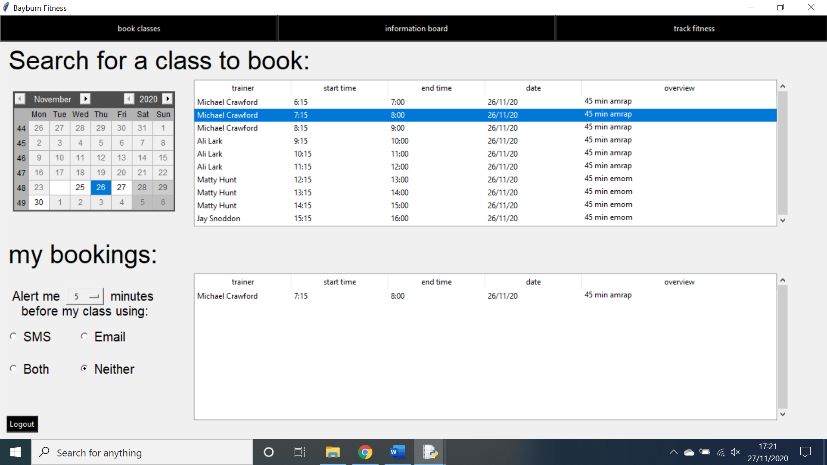**Outcome:** no change in database.

As shown above, a booking has been made for the 26th of November 2020 and the date has been moved forward to the 27th. This should result in the system removing the booking however it has not.

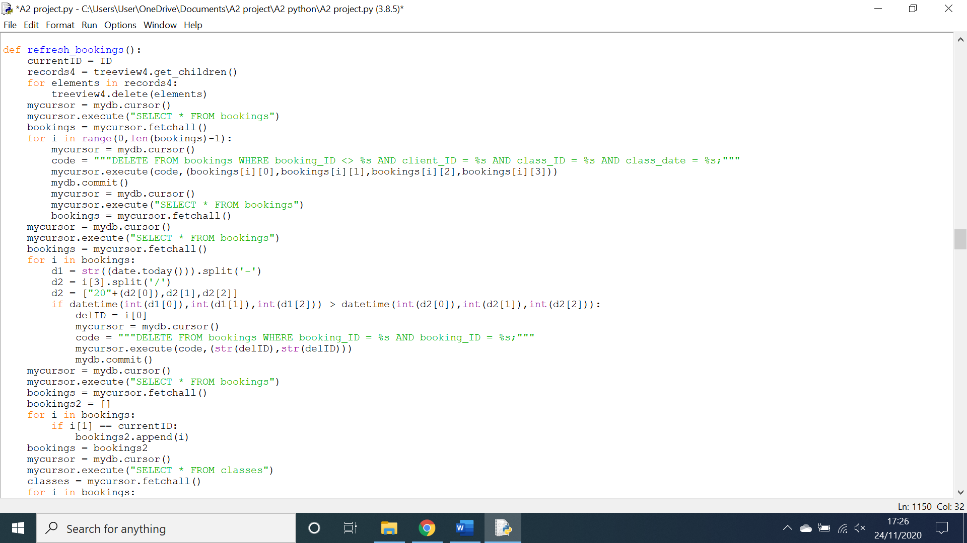

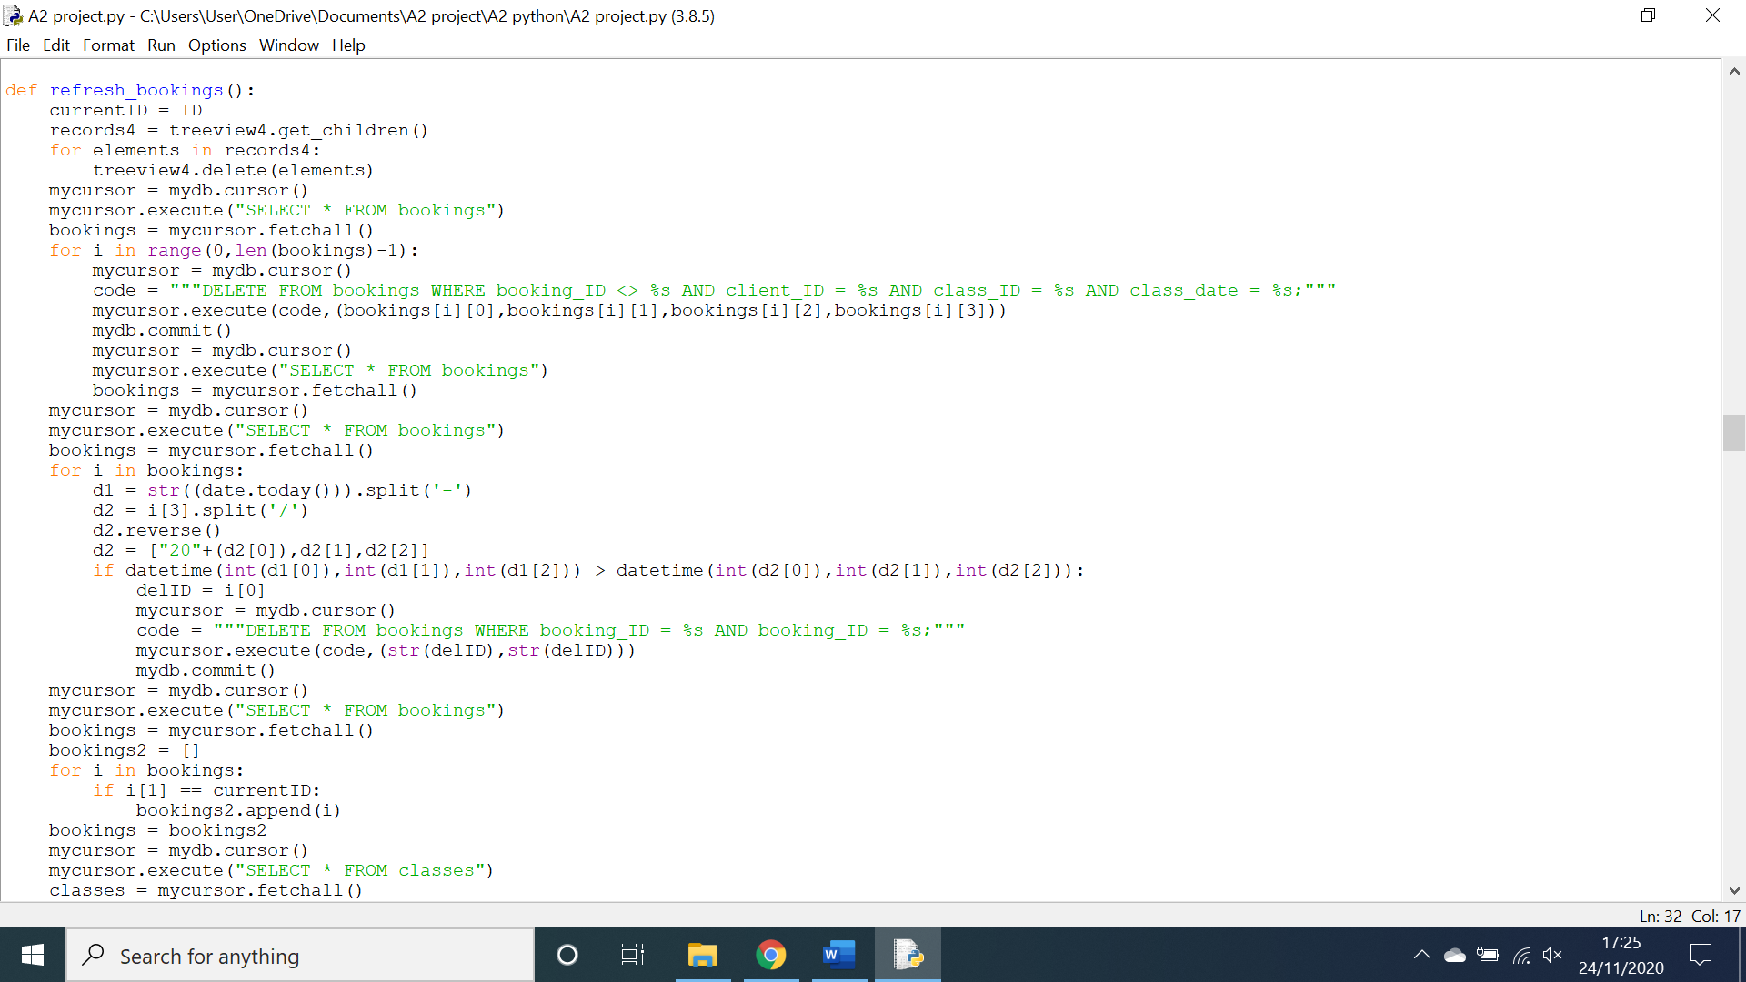this is the piece of code responsible for searching through bookings and deleting any that have already passes, it does this by comparing the current date to the booking date and if the current date is greater than the booking date it deletes the booking. However, when formatting the datetime object of the booking date I have forgotten that it is saved in the format day/month/year as apposed to the format required by the datetime module: year/month/day. This is easily remedied by reversing the list object d2.

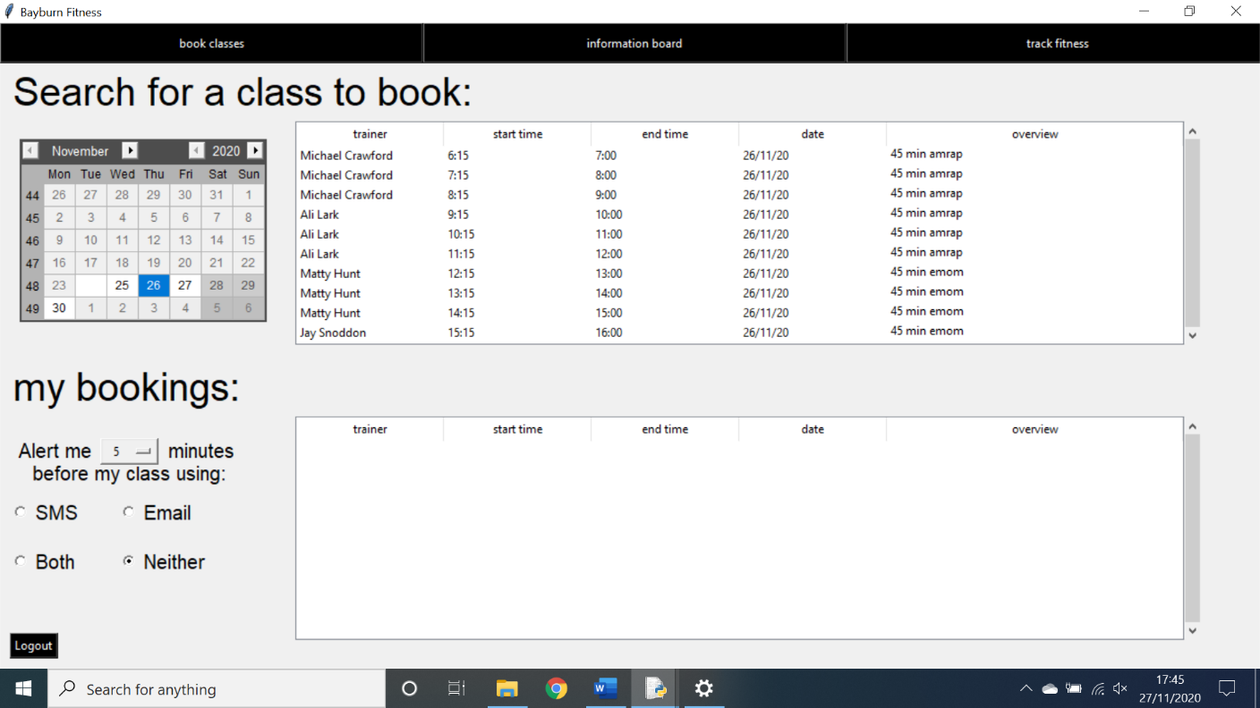Above is the remedied code that has had a reverse statement added into it. This produces the correct outcome as shown below.

As shown above the date has been set to the 27th and the booking has been deleted as required.

**Testing the clearing of login data:**

**Action:** logged into the system as a client and then logged out.

**Expectation:** the username and password field are blank upon return to the login screen.

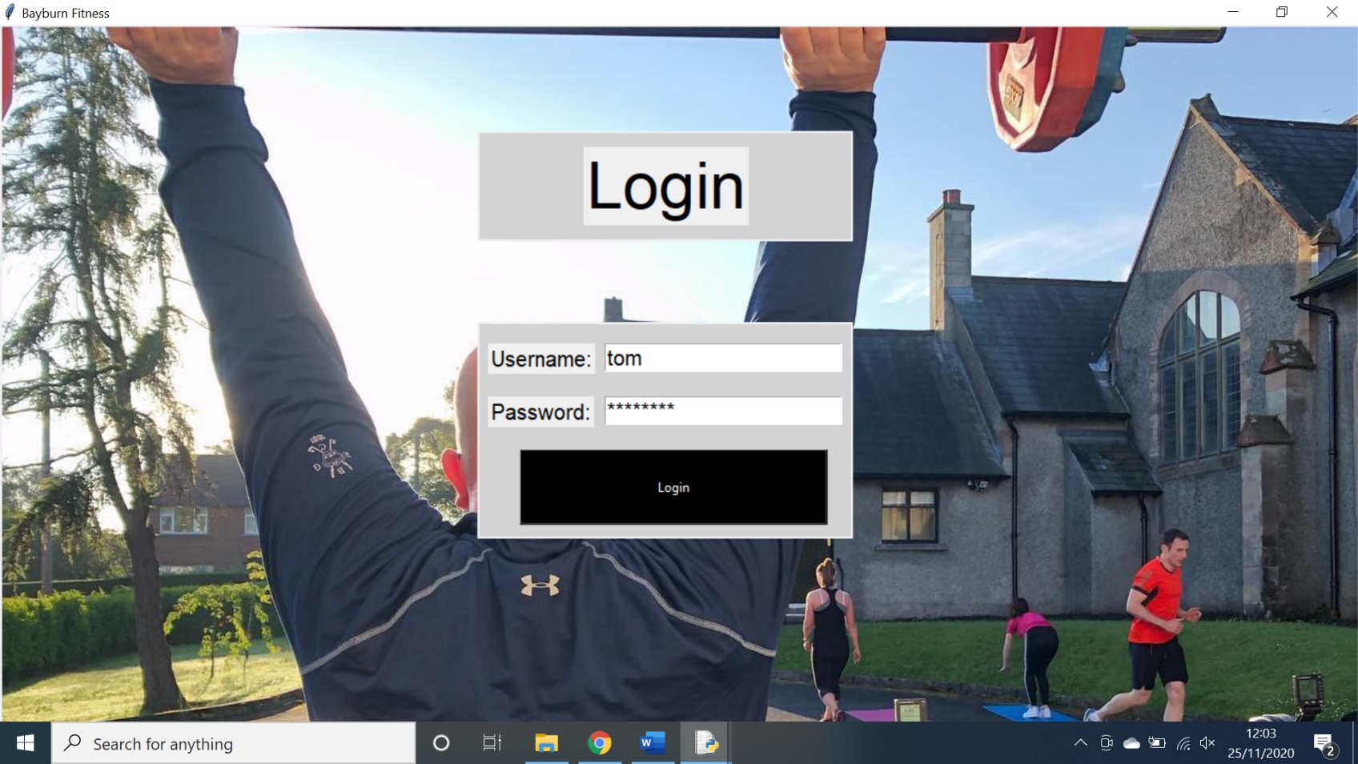**Outcome:** the username and password previously entered, remain in the entry boxes.

As shown above, the details where entered into the entry boxes and the login button was pressed. This brought the user to the client bookings screen. At this point the logout button was pressed and the user was brought back to the login screen.



As shown above, the entry boxes remain fill with the username and password of the user. This is a problem as it could results in an unauthorised user logging in as a manager if they logged out and then left the computer unattended.

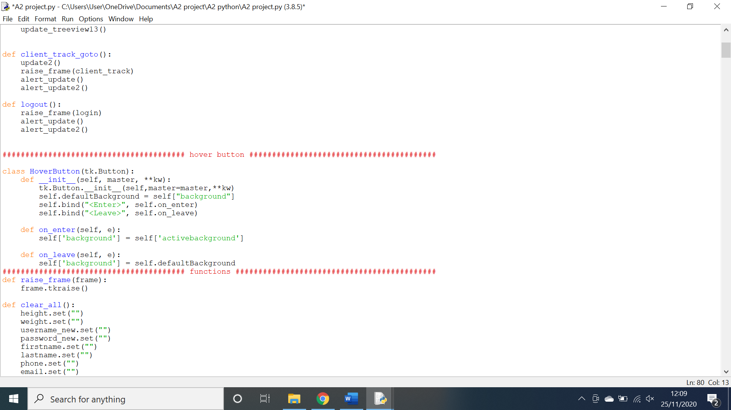As shown above, the code used for the logout button, does not clear the username and password fields. This is easily amended below.

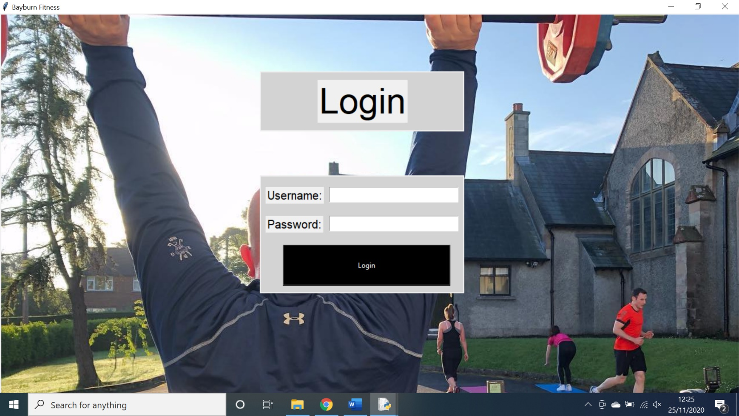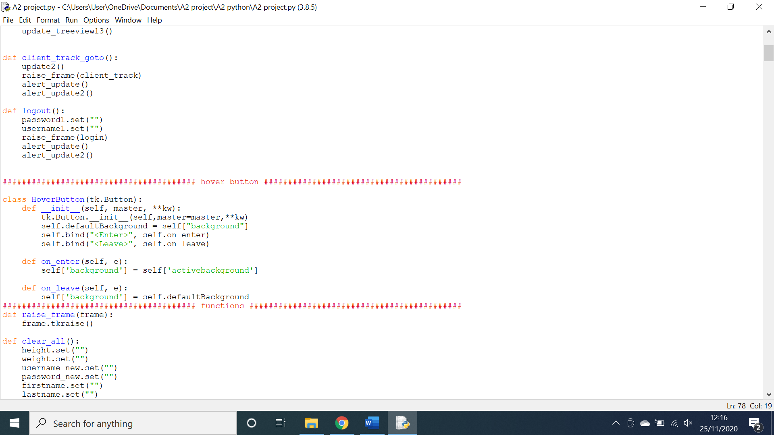As shown above, two lines of code have been added in order to set the entry boxes containing the username and password fields to a blank string. This results in blank entry boxes being shown every time a user logs out.

As shown above, I logged in as a client and then logged out and clearly the entry boxes have been cleared.

**Adding a canvas to the login screen:**

**Action:** Added a canvas to the Login screen using Tkinter.

**Expectation:** a canvas would appear behind the title and entry boxes.

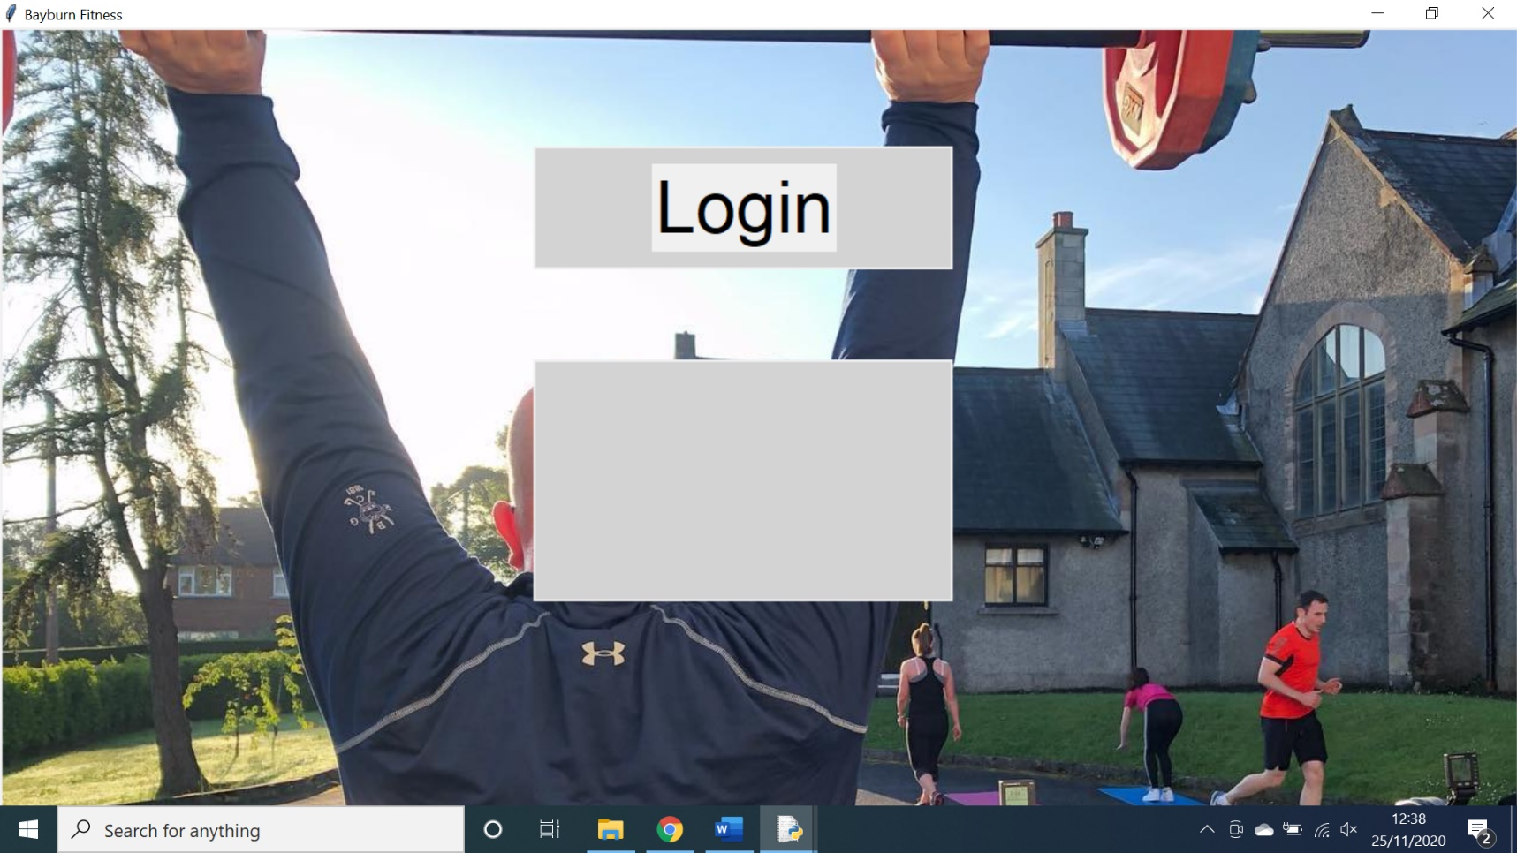**Outcome:** The canvas was generated in front of all previously generated labels, boxes and entry boxes.

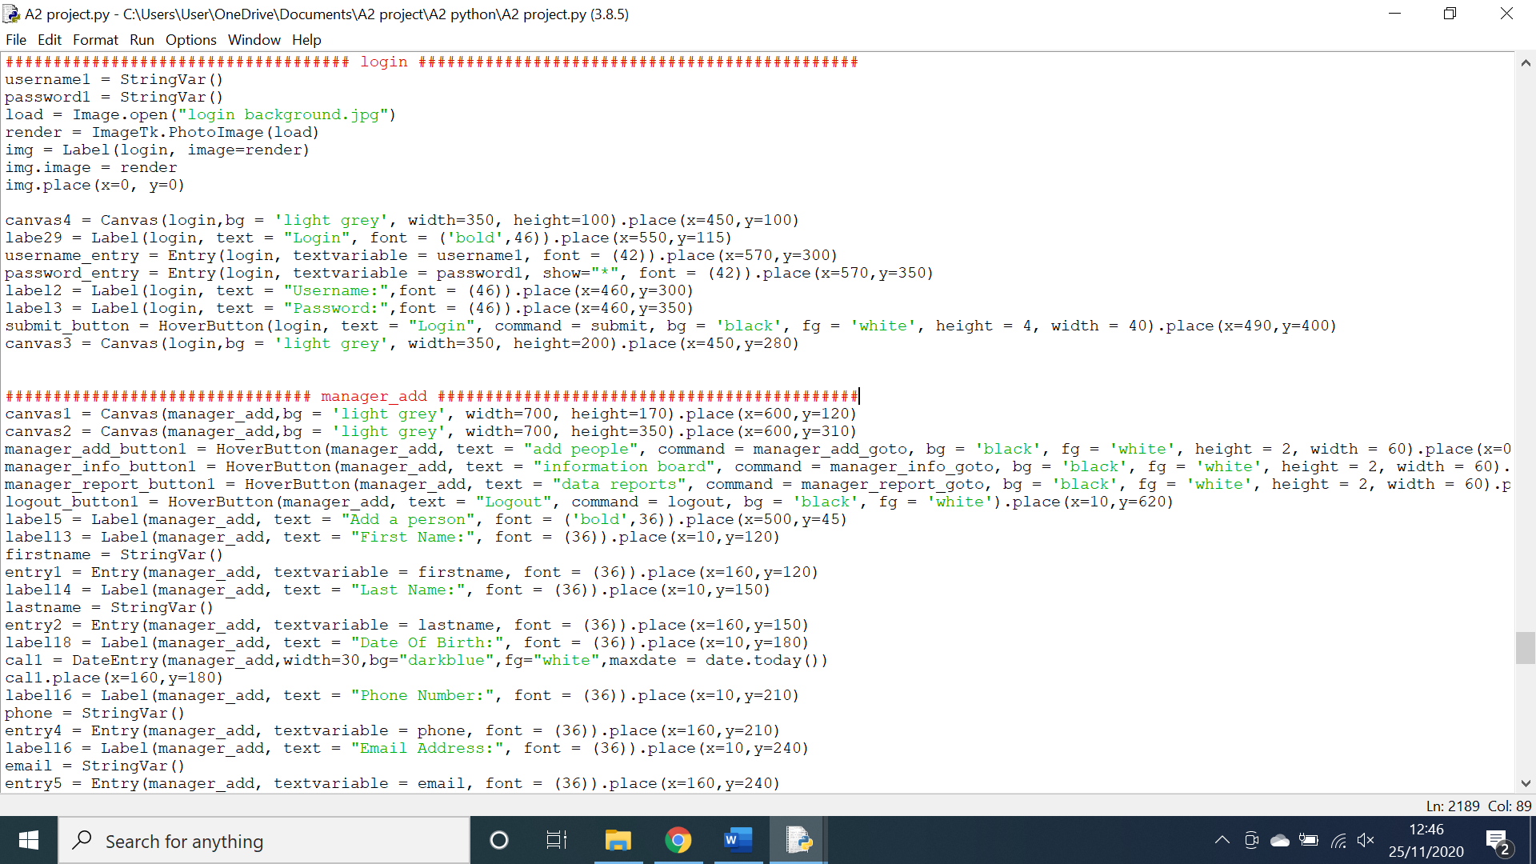As shown above the canvas has been generated on the login screen, however it has covered all previously generated labels, buttons and entry boxes. This is a problem as it looks unpleasing and also blocks the user from the login functionality

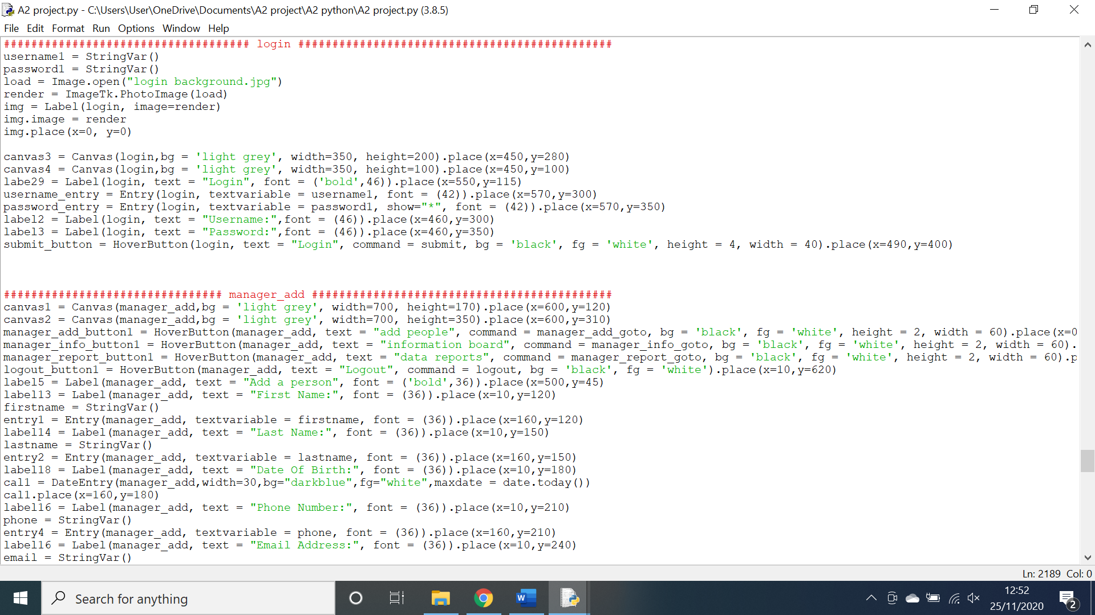As shown above the code for the login screen setup generates the canvas after all other elements have been generated. This is simply the improper order and can be easily amended below.

**Testing the adding of login data to the database:**

**Action:** I input data into the add user screen and clicked enter as if I was creating a client.

**Expectation:** The user info would be added to the database.

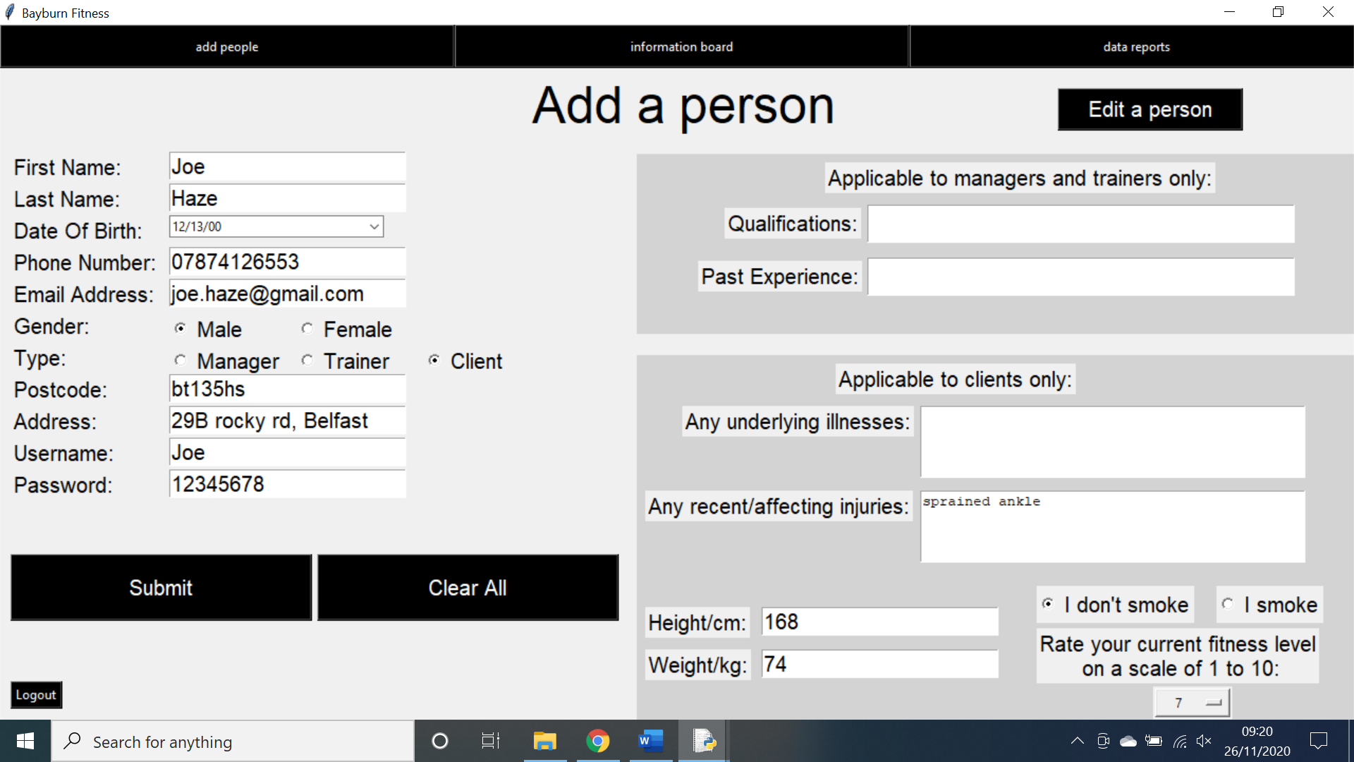**Outcome:** The data was added to the login table in the database but not the clients table.

As shown above, all the data was inputted into the system and the submit button was pressed. Upon doing this an ID was generated and the Username and password was added to the login table however the rest of the details where never added to the clients table.

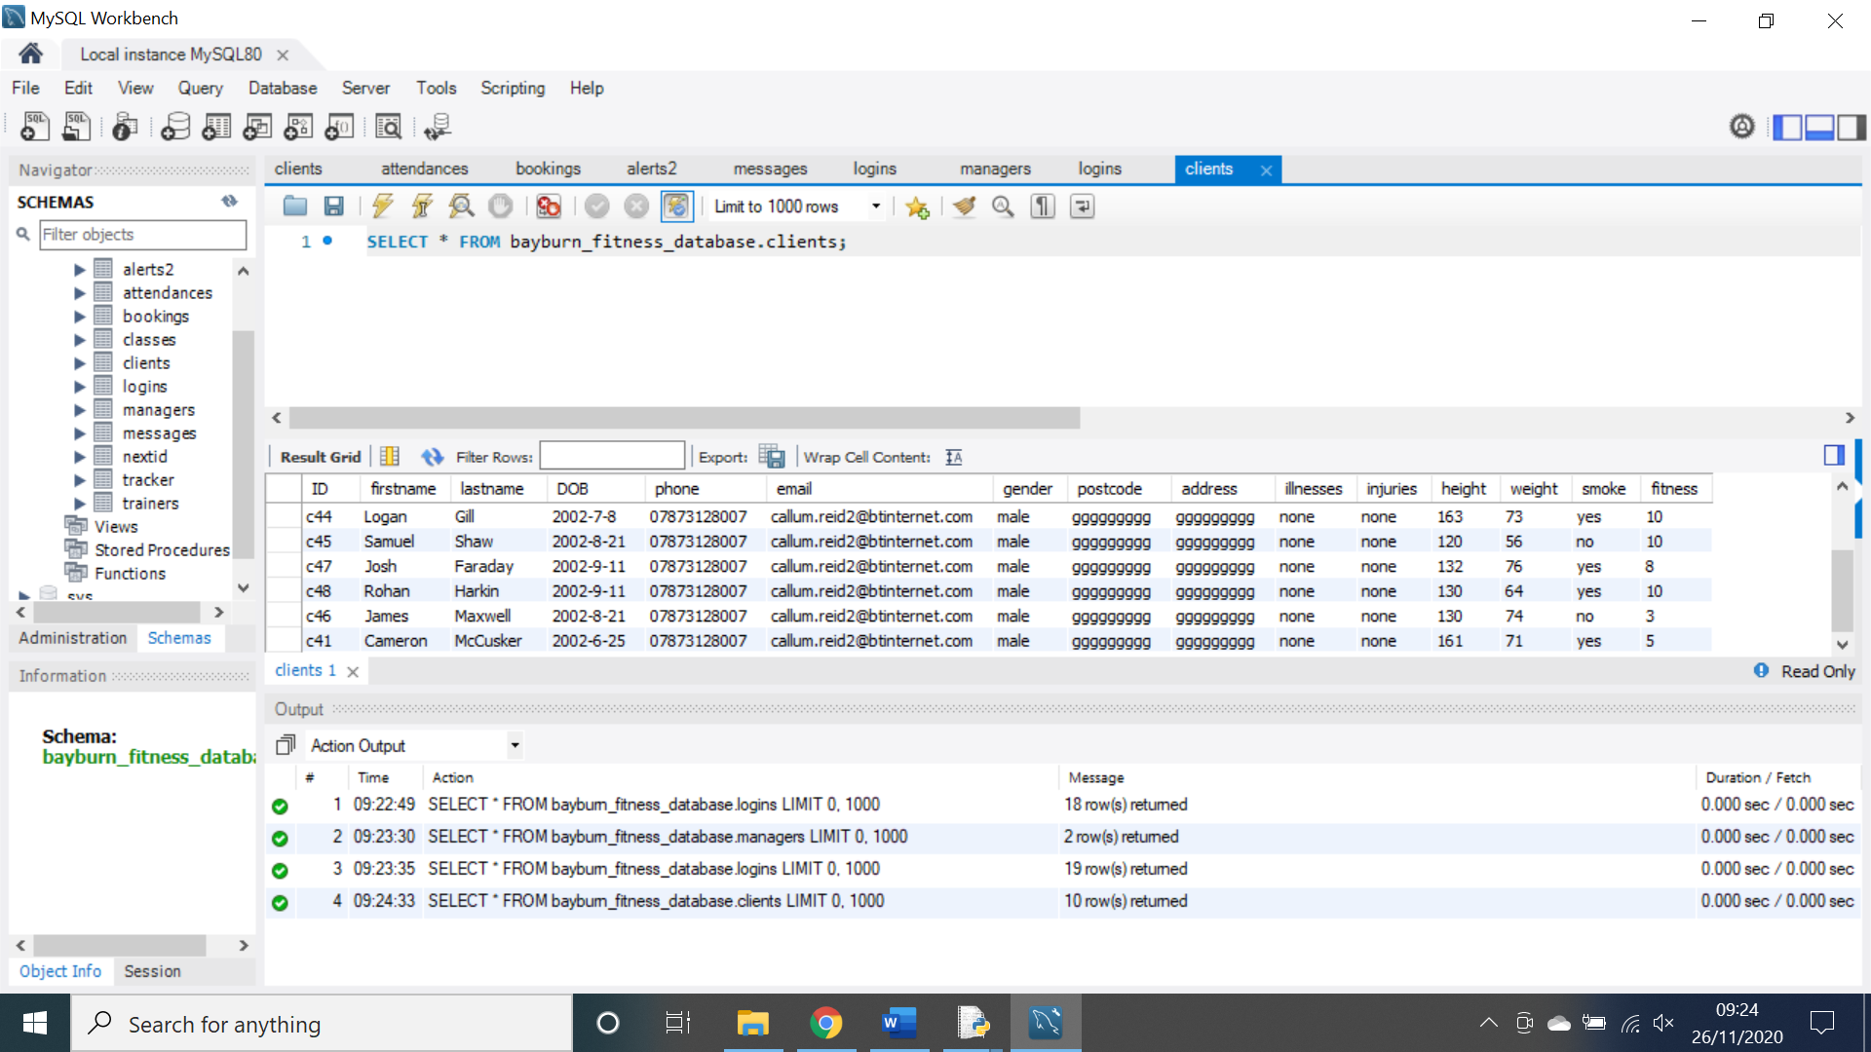

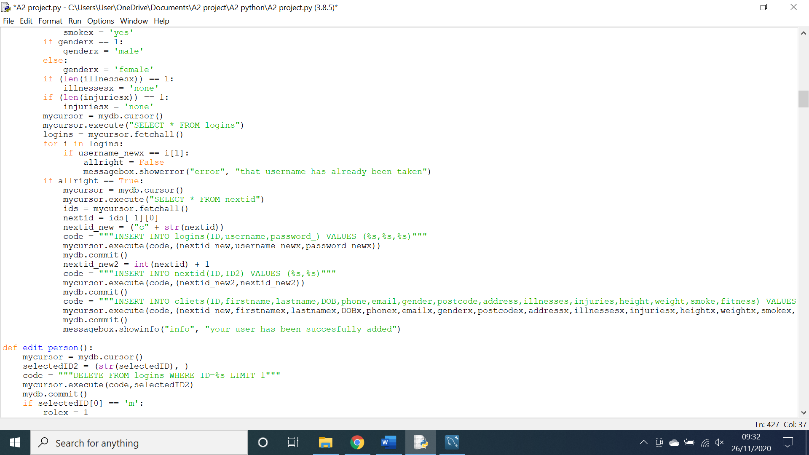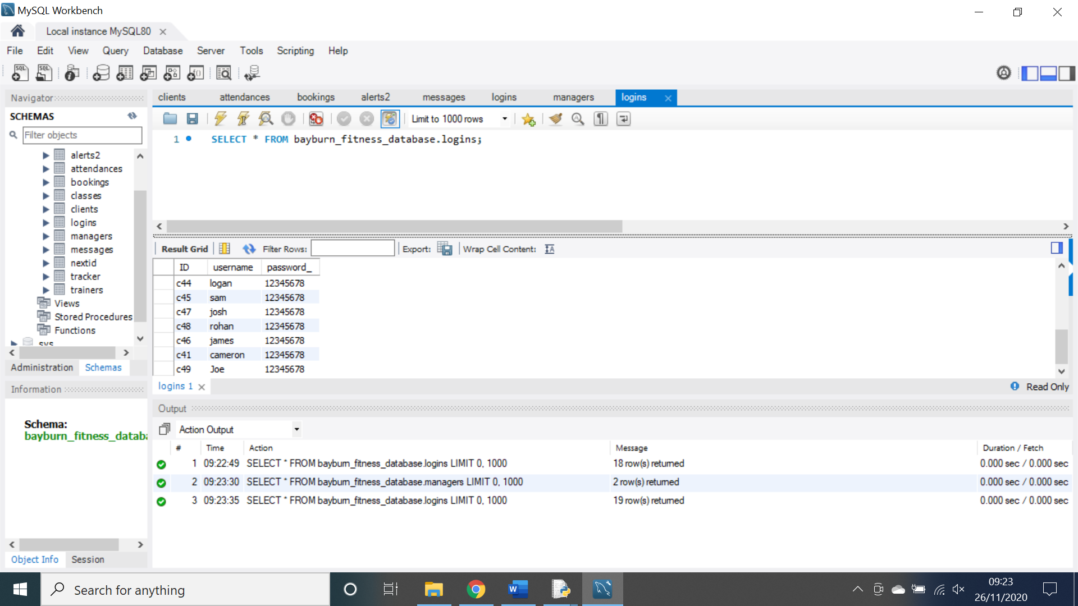As shown above, the data has been added to the logins table below the last client however, it has not been added to the clients table, this is a problem as it means client information will not be able to be accessed at a later date.

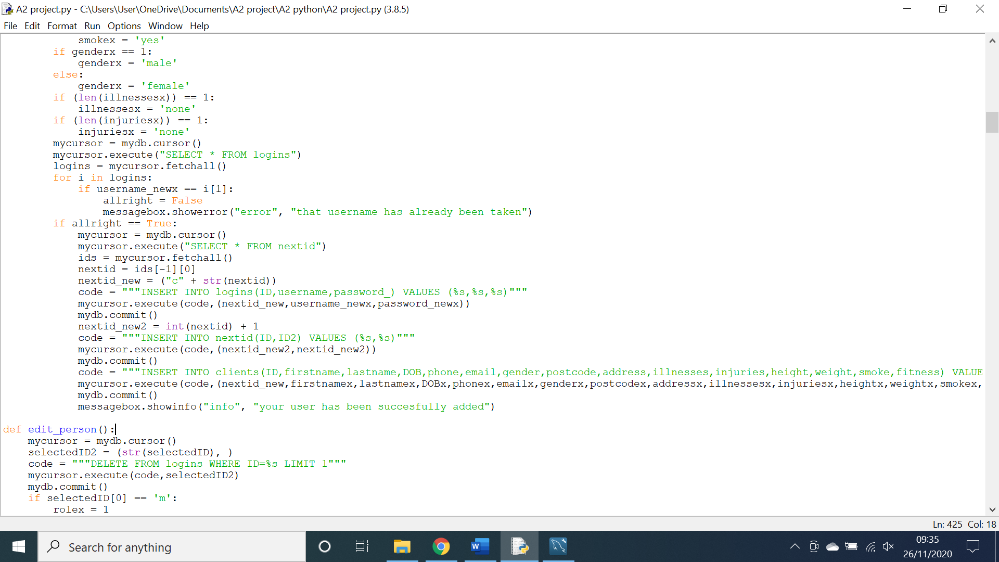As shown above, there is a simple spelling mistake in the SQL statement as it refers to the table name of “cliets” instead of “clients”. This is easily remedied as shown below.

As shown above the spelling mistake has been corrected.

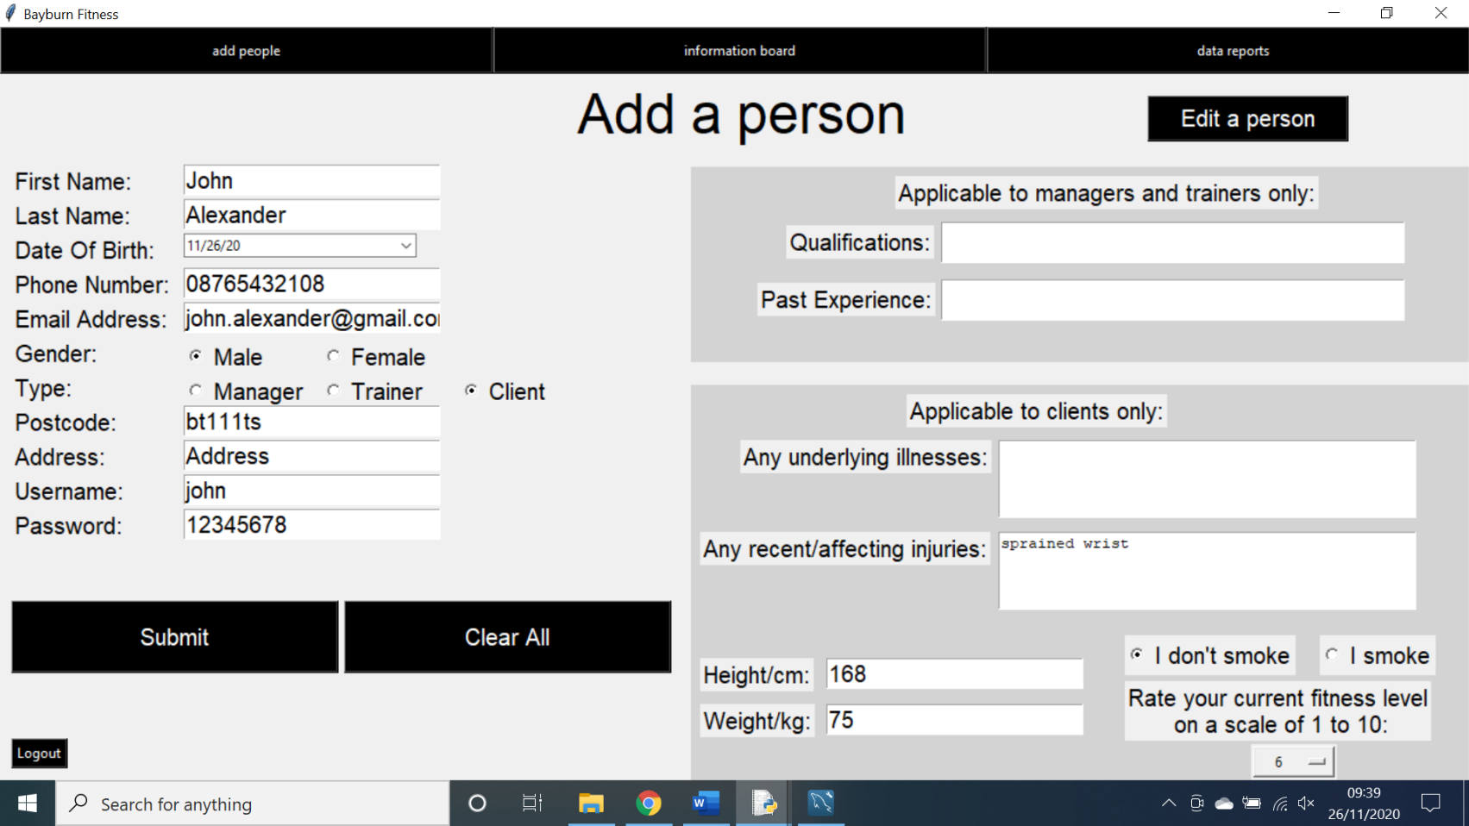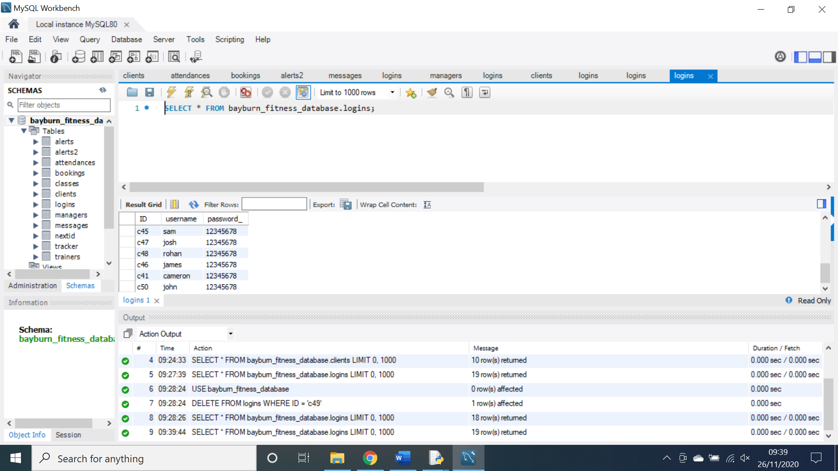

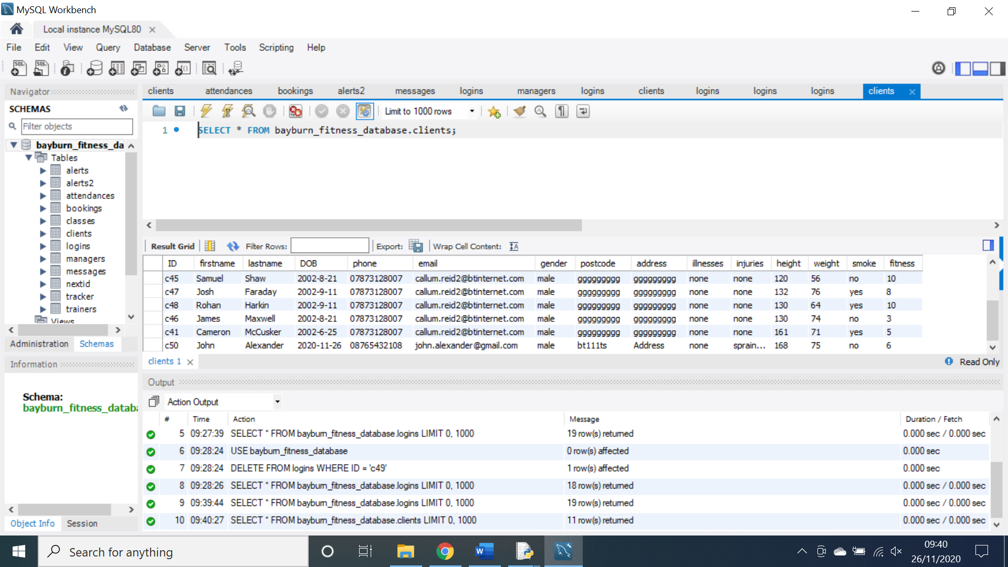

As shown above, when the test was repeated, all data was successfully added to the database.

**Testing the validation of class details:**

**Action:** I added class information into the system and submitted it even though the time in minutes was a string as opposed to an integer.

**Expectation:** The system would generate an error message to show this mistake.

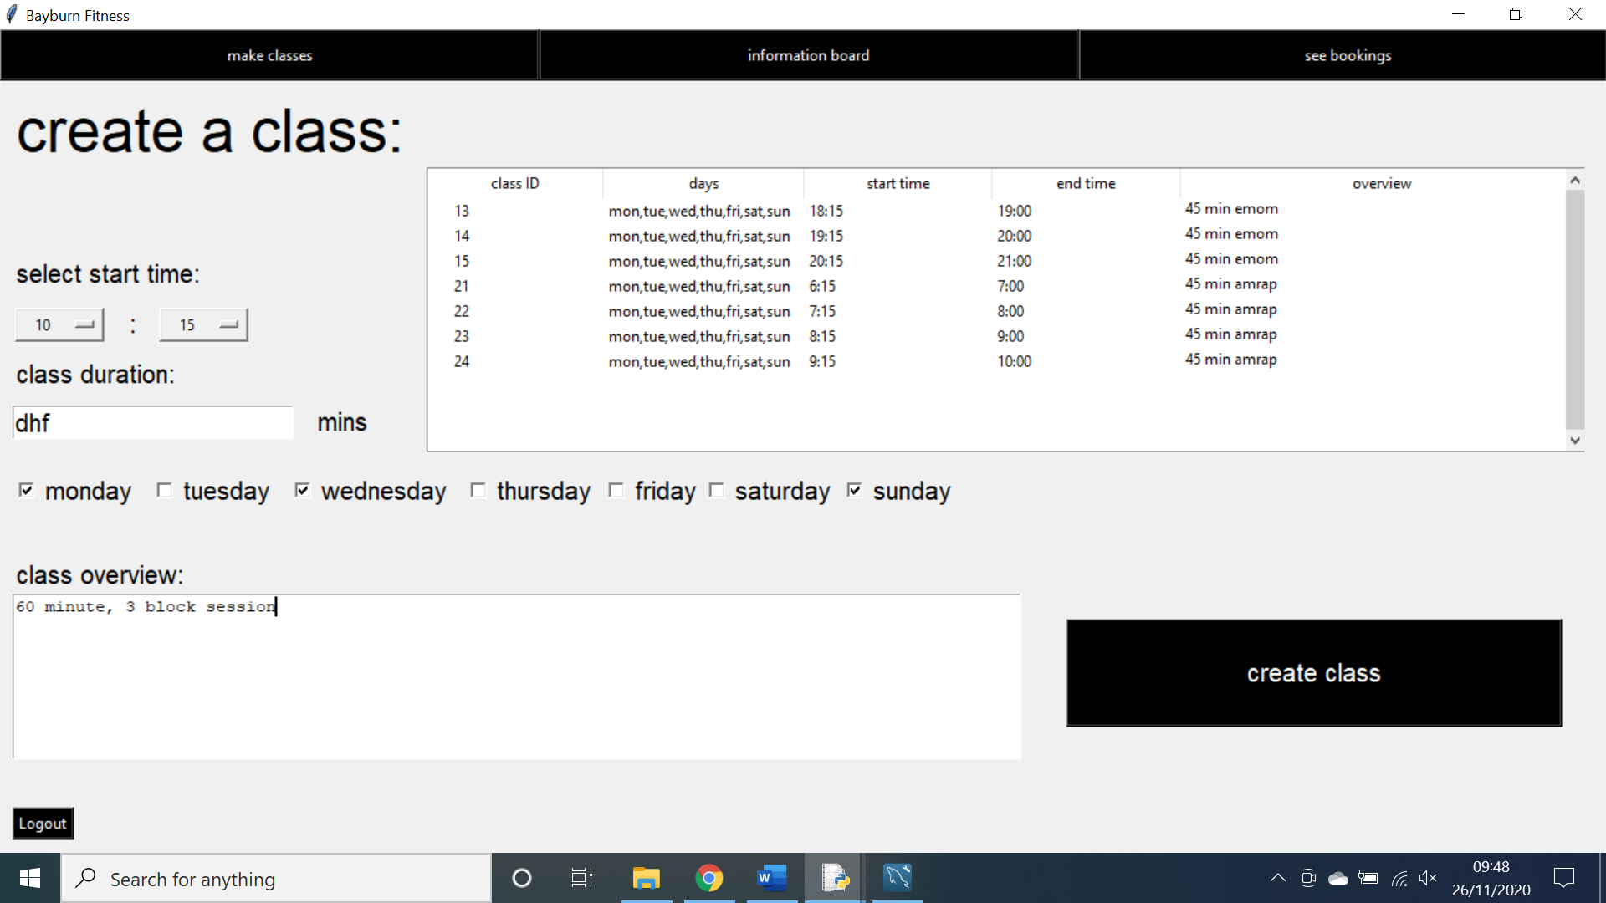**Outcome:** The system tried to add the data to the database and came to an error without notifying the user.

As shown above, the system does not present an error message however the class has not been created which can deduced by the fact that the treeview has not updated. This is a problem as the user may not notice that the code has not added their class and this could lead to problems later.

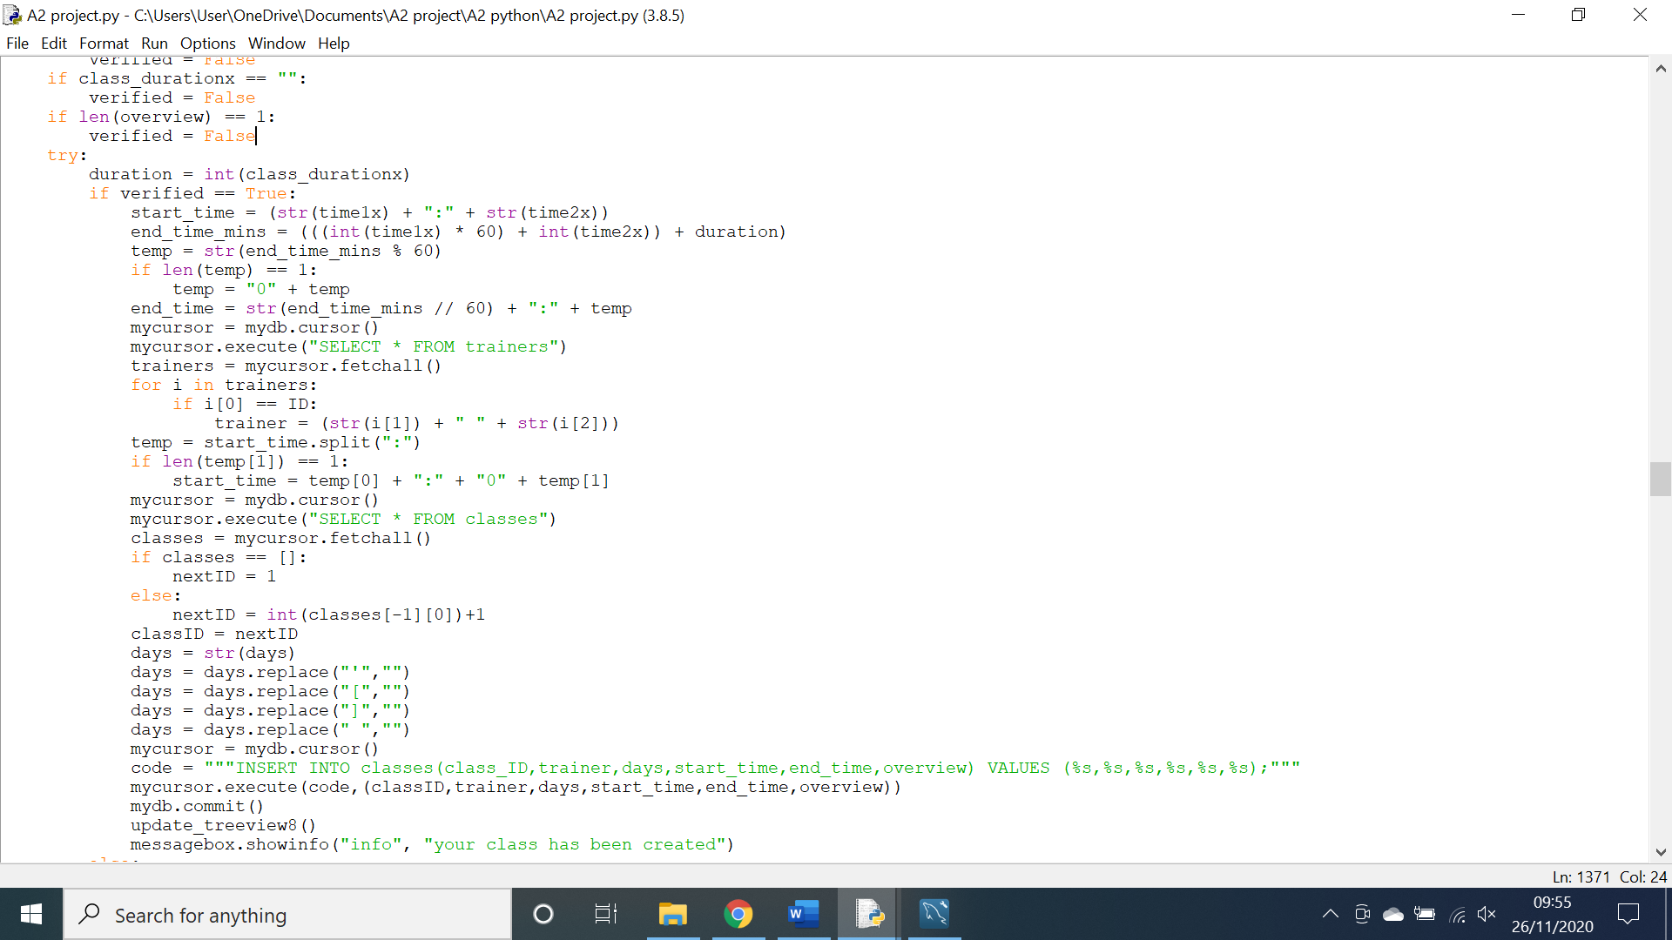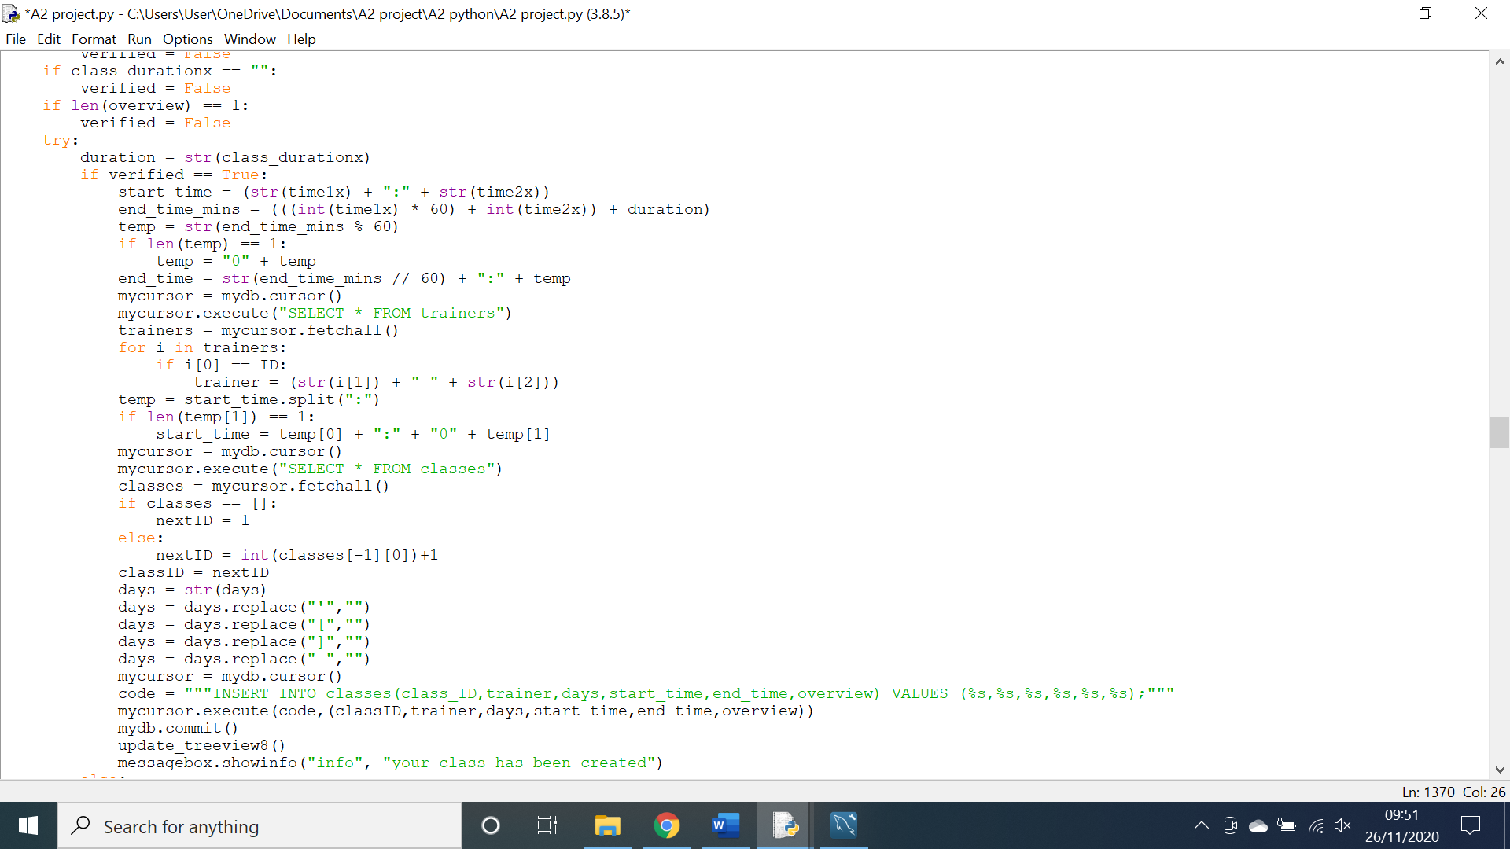the code above is the offending code, it attempts to change the variable into an integer and if it cannot it will generate an error message. However, I have mistakenly tried to cast it is a string instead of an integer.

This is the amended code; I have corrected it so that it casts the variable as an integer and now the code generates an error message as shown below.

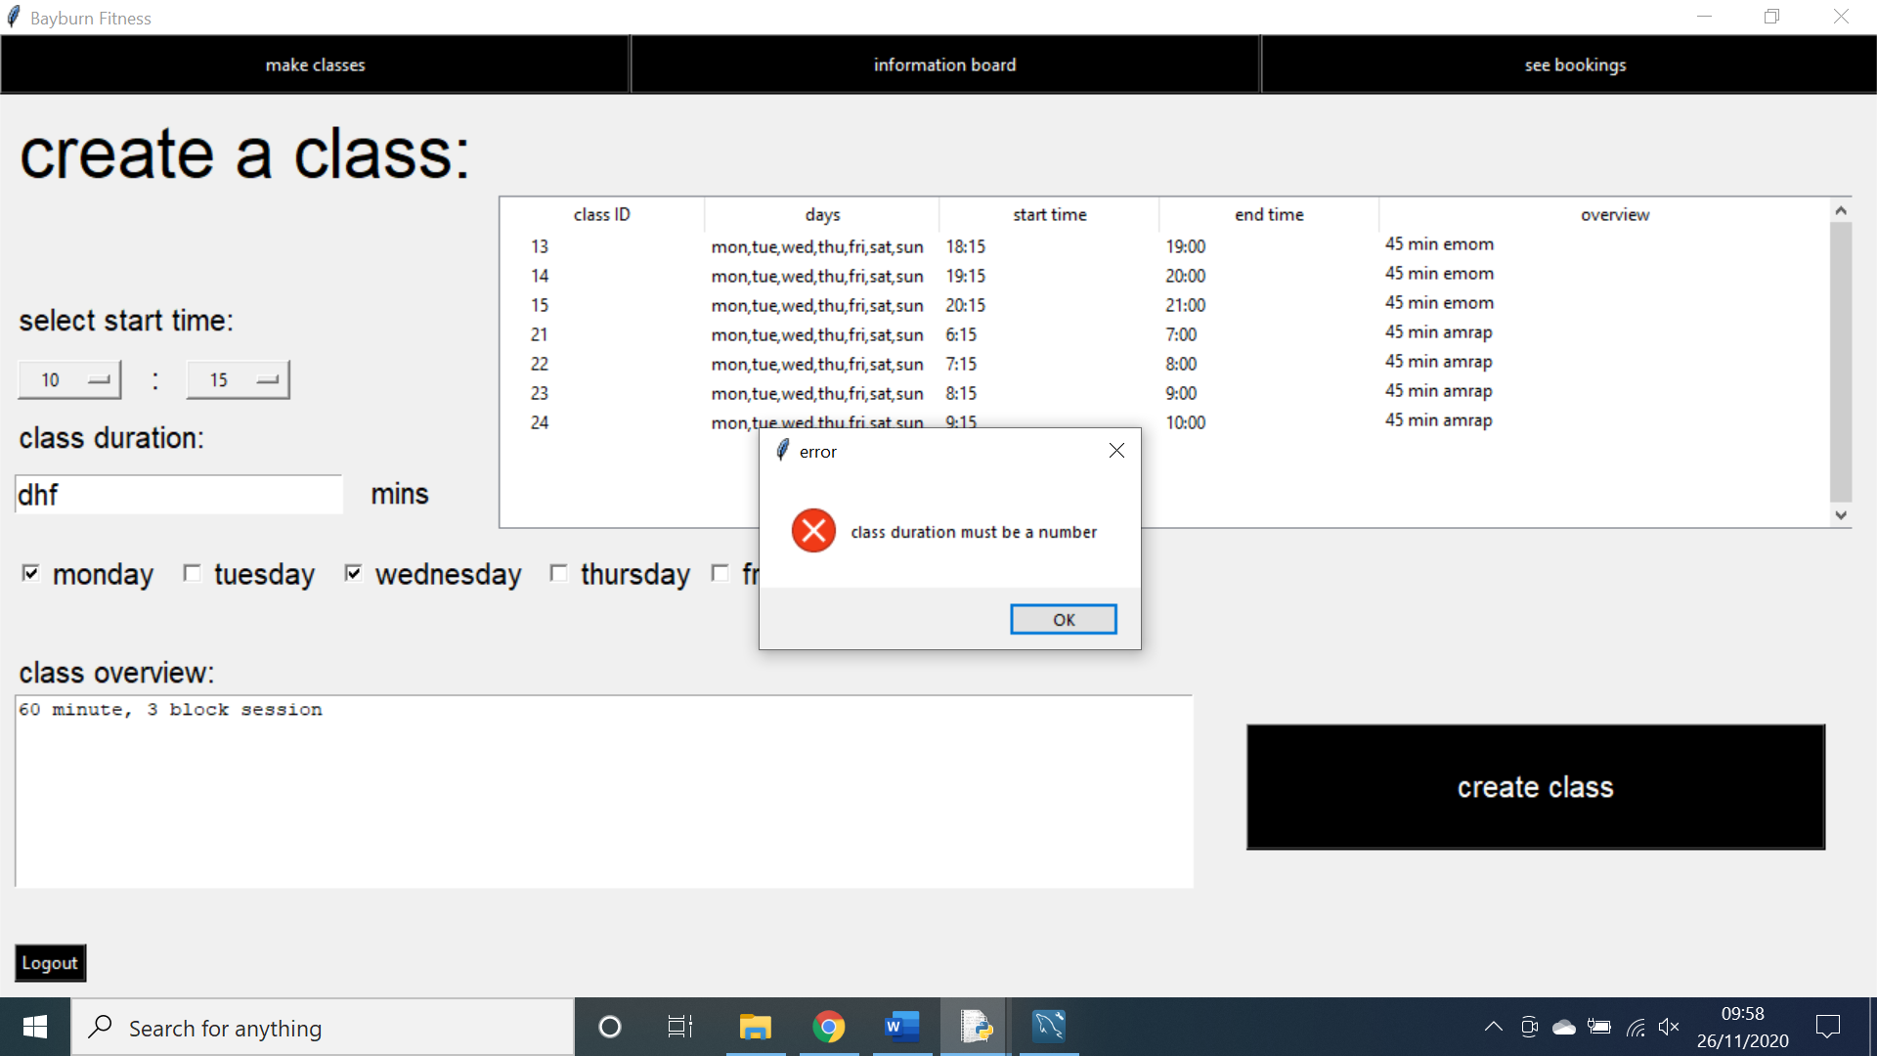**Testing the interactive treeview for deleting classes:**

**Action:** I clicked on one of the records on the classes treeview in an attempt to delete it.

**Expectation:** A popup message would appear and offer to delete the class.

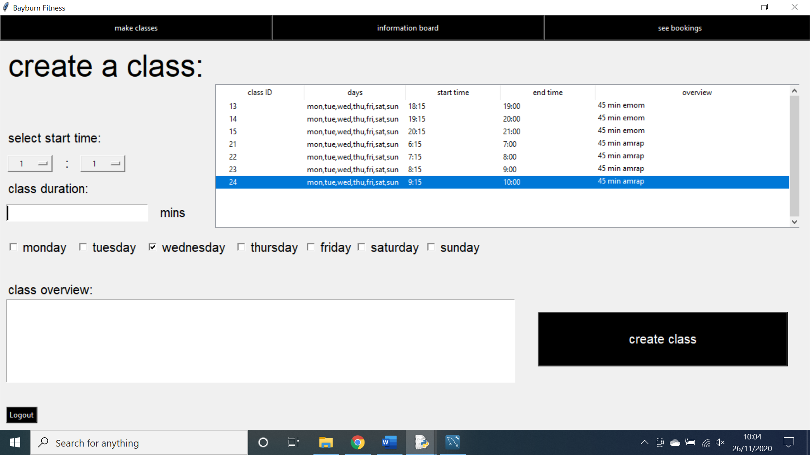**Outcome:** No message was generated.

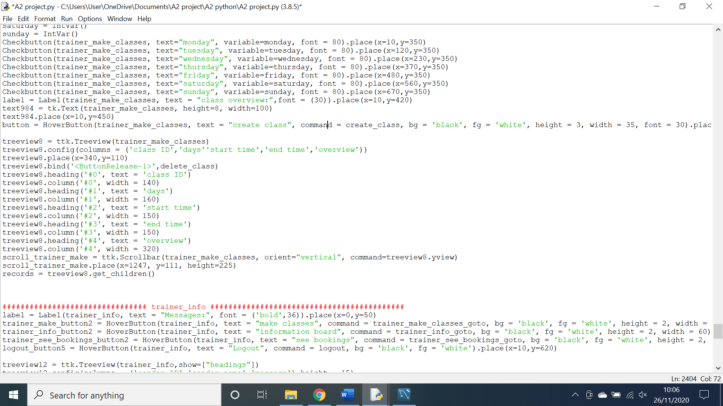As shown above the record in the treeview was clicked but no message was generated, this is a problem as it means that trainers cannot delete classes.

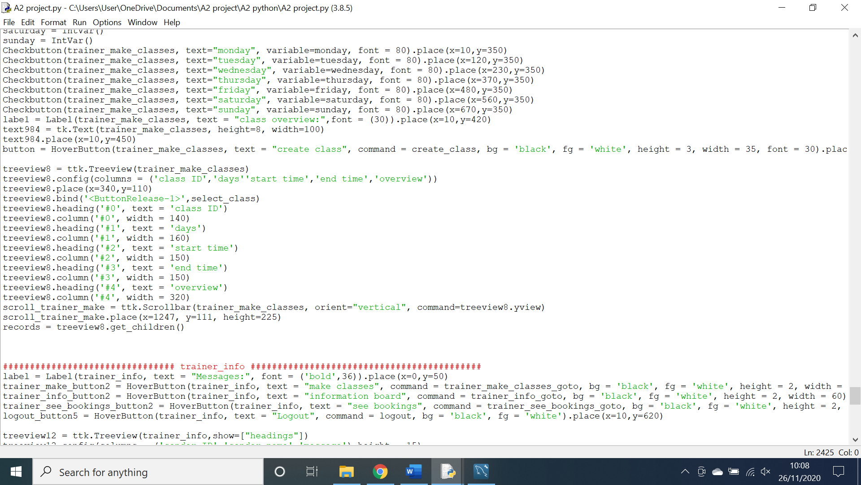As shown above, when creating the treeview I bind the selection to a function called delete class. This is the incorrect function name and actually does something else in the system. As such the bind is unfunctional.

This is the amended code where I have changed the bind to the correct function and now the code works as intended.

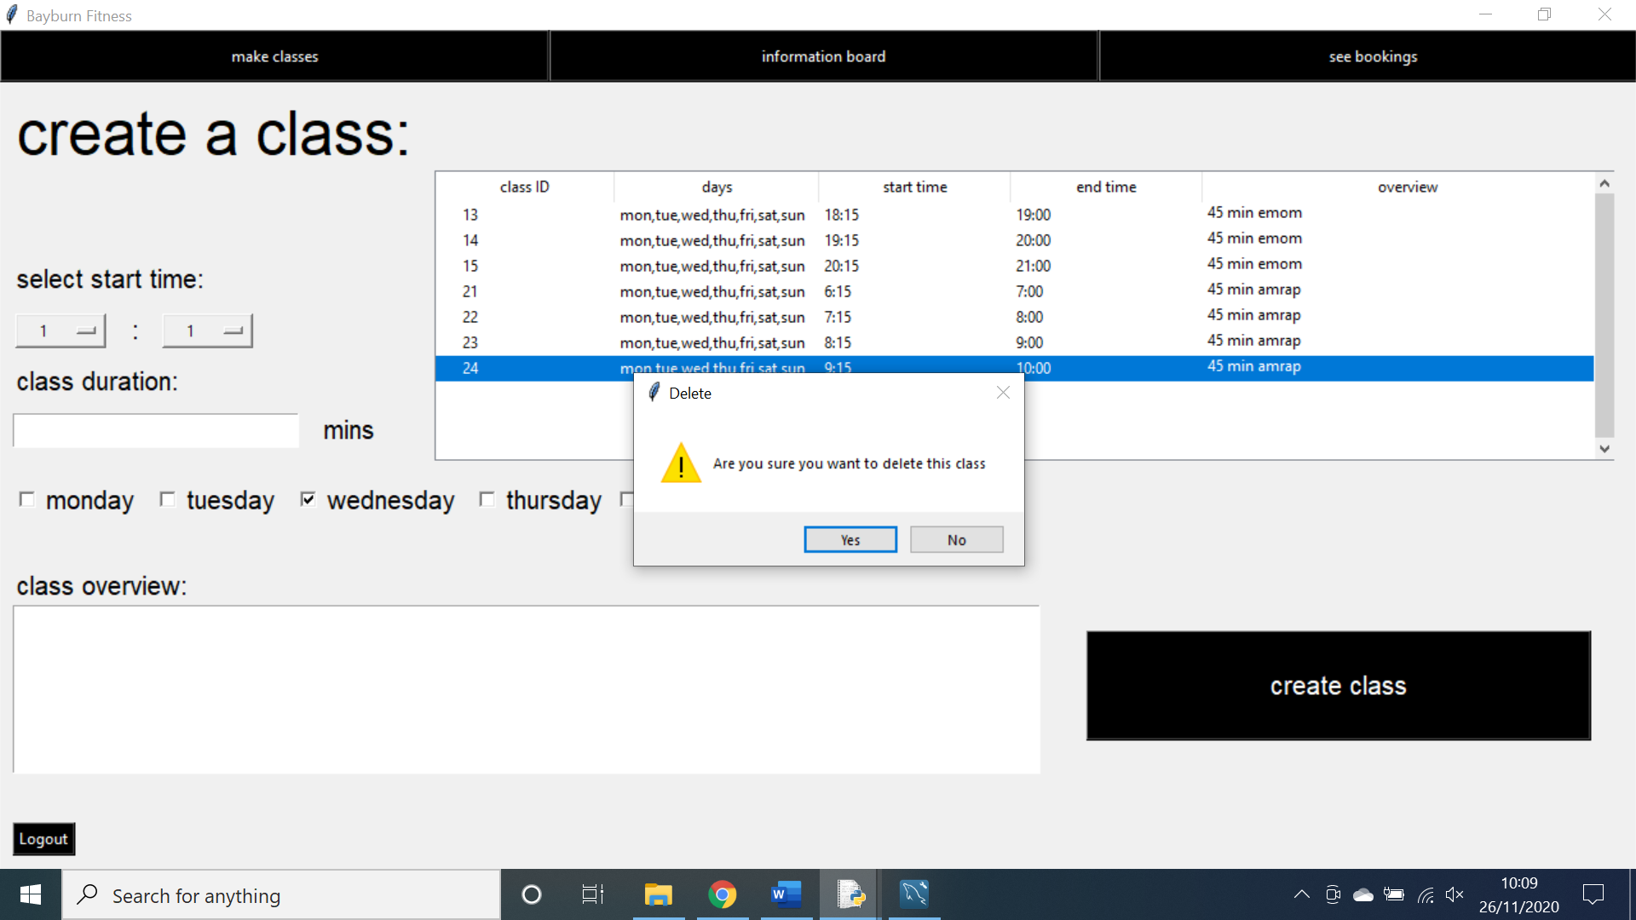**Testing the updating of the messages treeview:**

**Action:** I sent a message using the message system.

**Expectation:**  the message would appear on the treeview.

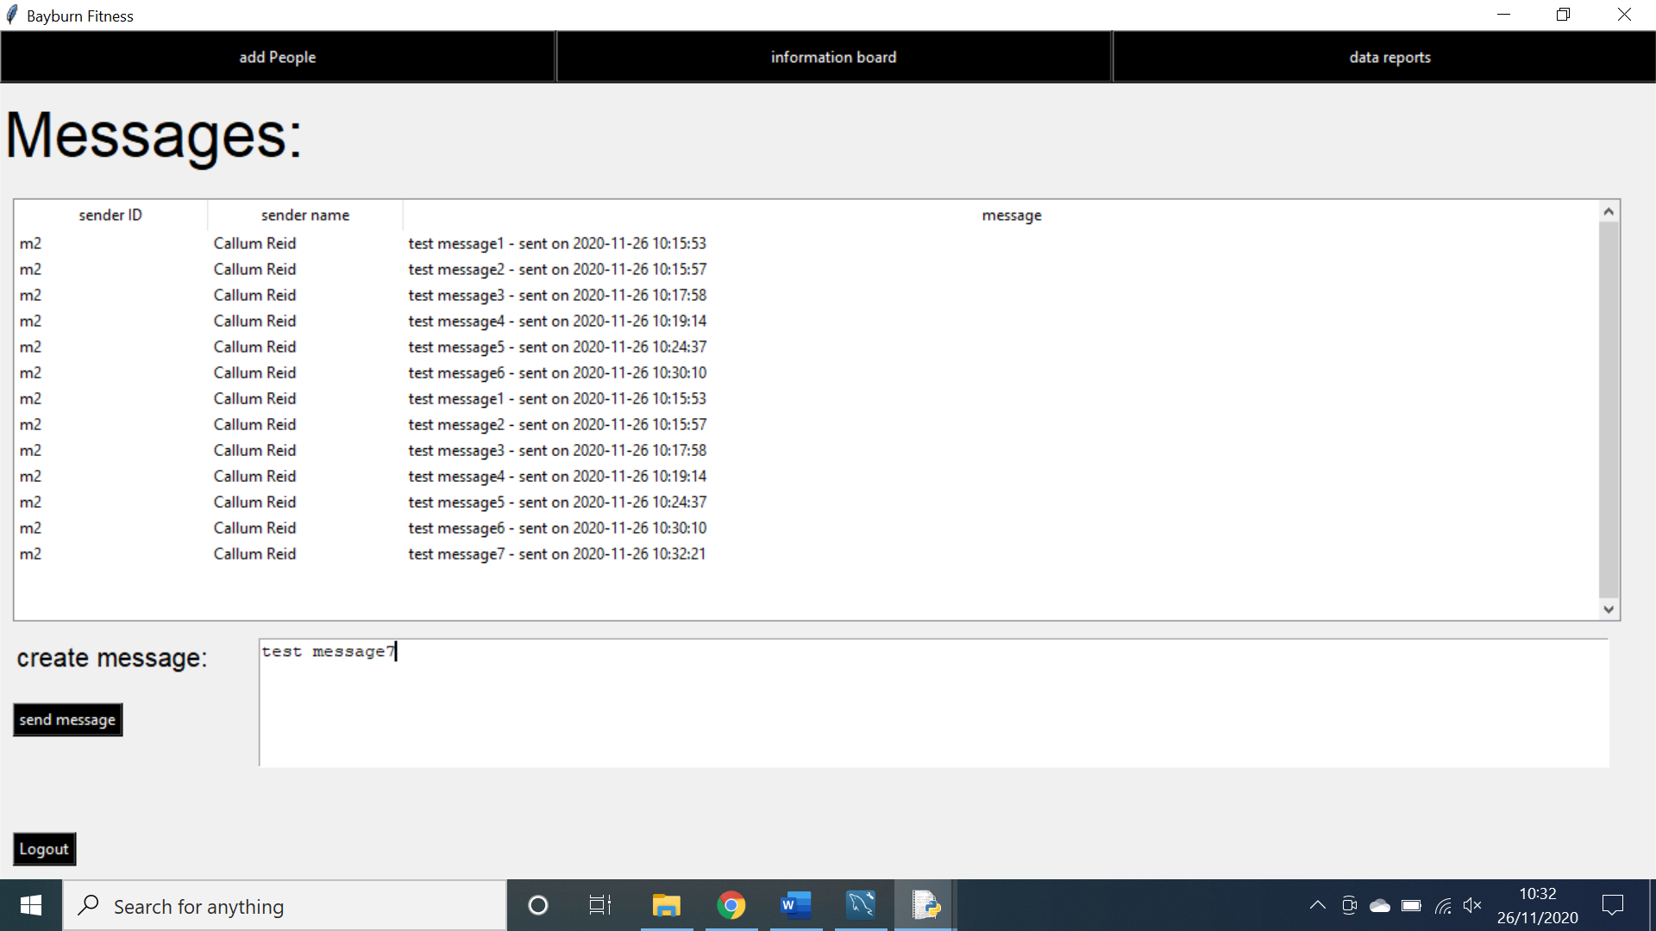**Outcome:** the message appeared however it also duplicated all previous messages and readded them to the treeview.

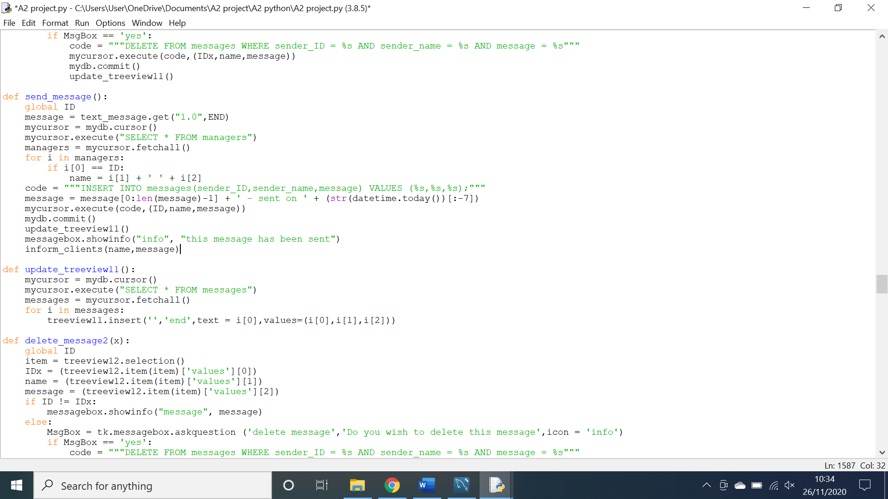As shown above the messages duplicate when a new one is added. This is a problem as it seriously confuses the user.

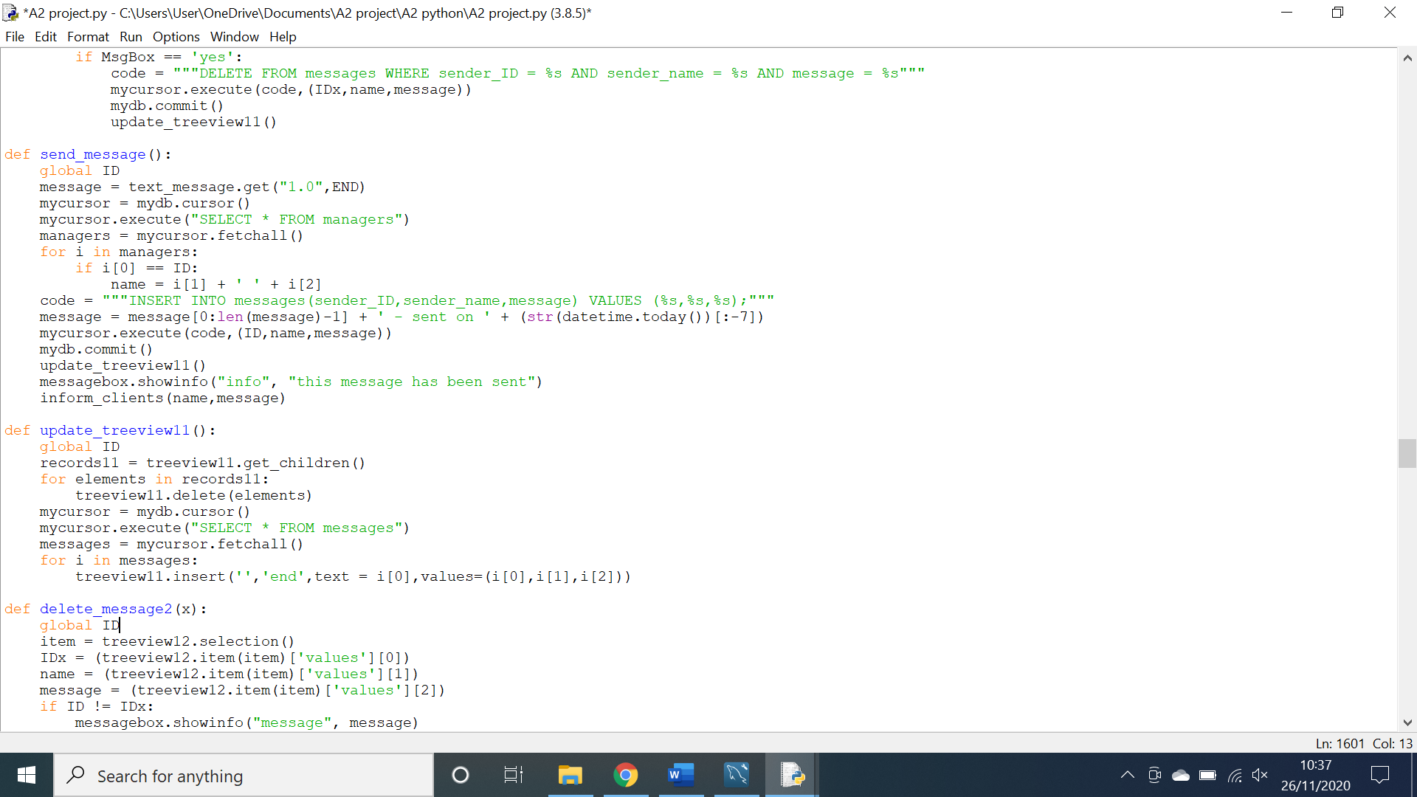The code above is responsible for populating the treeview of messages however, it does not delete the previously added messages meaning it can duplicate them.

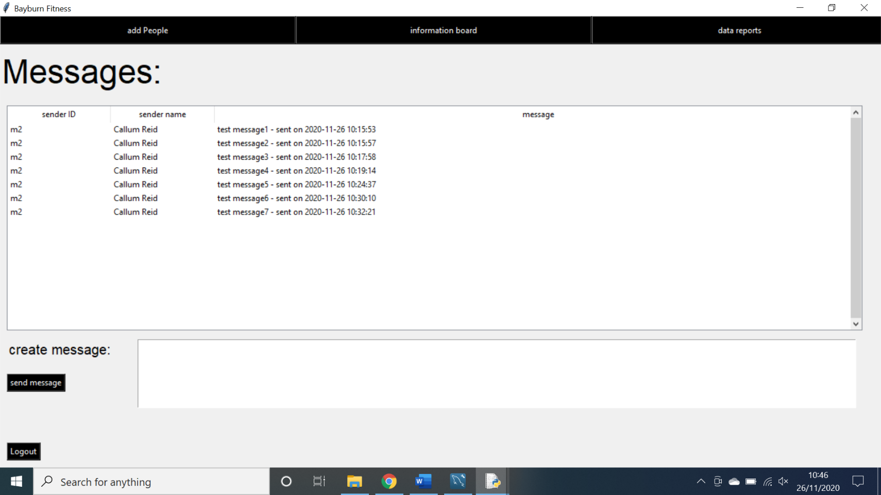Above is the amended code where I have added code to delete anything previously added to the treeview before adding more data.

**Testing SMS messaging:**

**Action:** sent a message as a manager to the information feed.

**Expectation:** An SMS message is sent to any client that has selected SMS as a notification option.

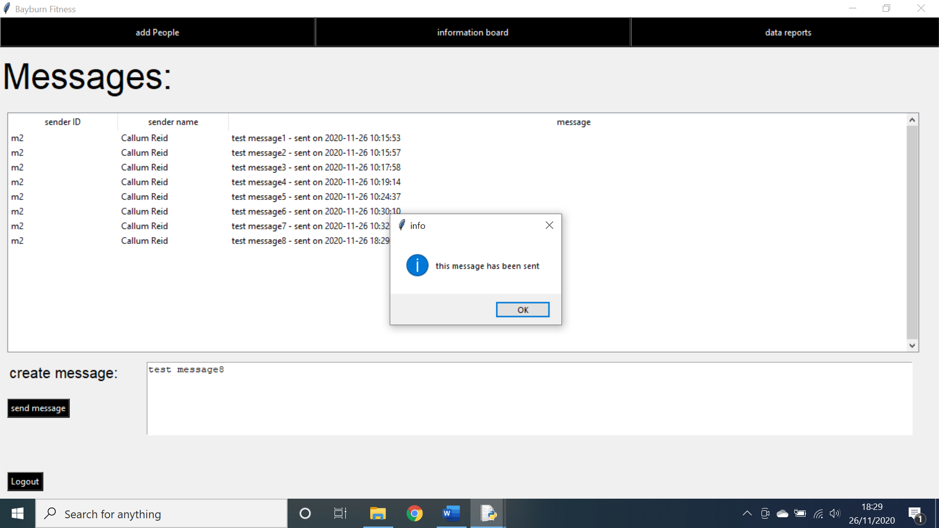**Outcome:** No SMS message was sent.

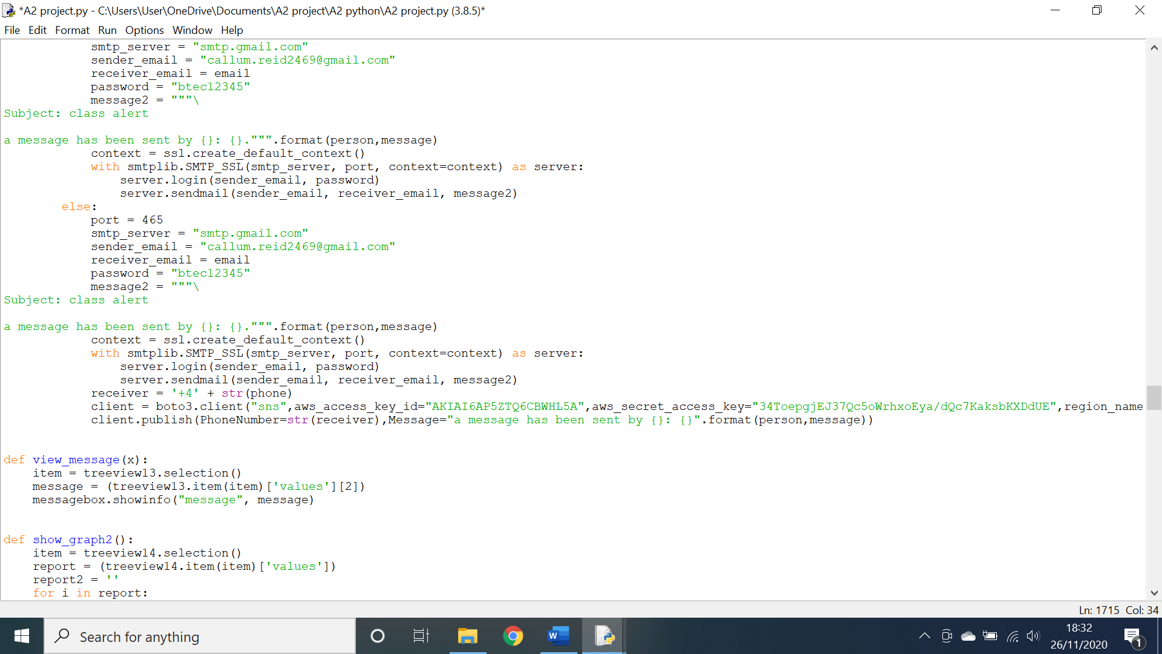As shown above, the message was sent by a manager however an SMS message was never sent. This is a problem as it means clients will not be notified of when a message is sent and could result in information never reaching them.

The above code is the code which is sending the SMS messages. As you can see, when the phone number is being formatted it is supposed to add “+44” to the front however it is only adding “+4”.

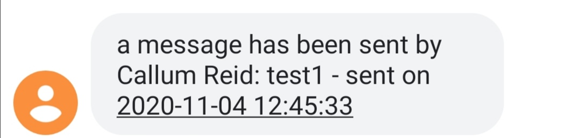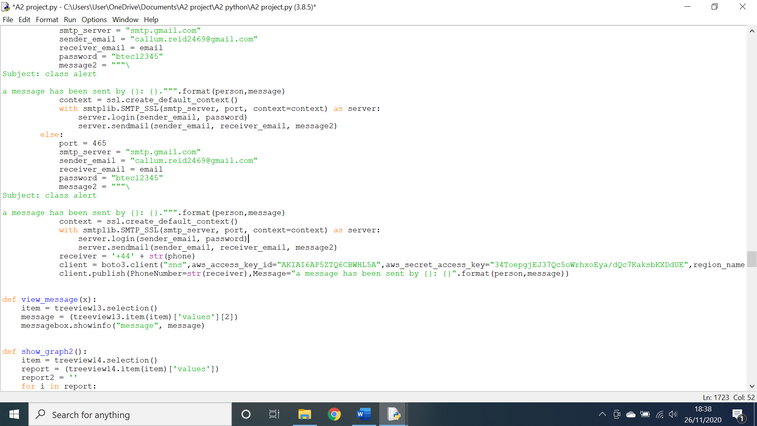Above is the amended code where I have corrected the previous typo.

As shown above, the code has successfully sent a text message to my phone.

**Testing automatic sending of emails:**

**Action:** A message was sent by a manager to the information board

**Expectation:** an email would be sent to all clients who have selected email as their notification option.

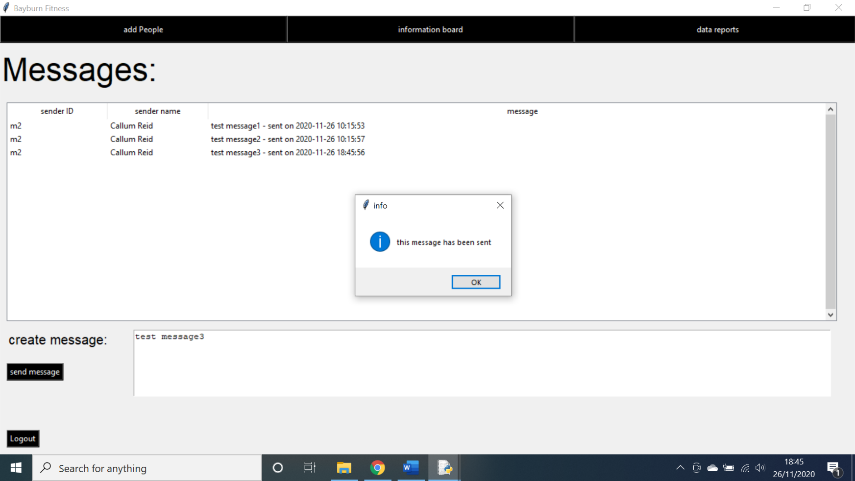**Outcome:** No email was sent

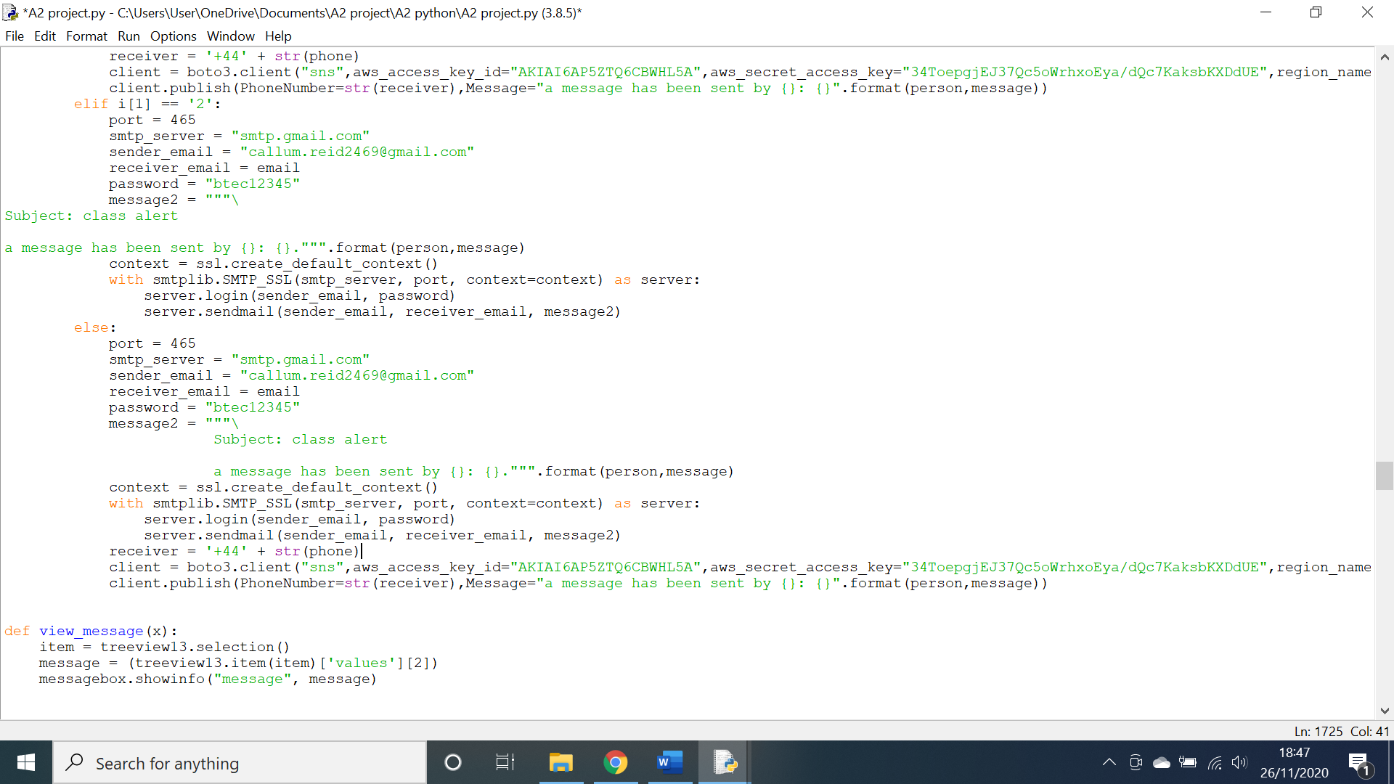As shown above, a message was sent by a manager to the information board however, no email was received by any clients. This is a problem as it means clients will not be notified of when a message is sent and could result in information never reaching them.

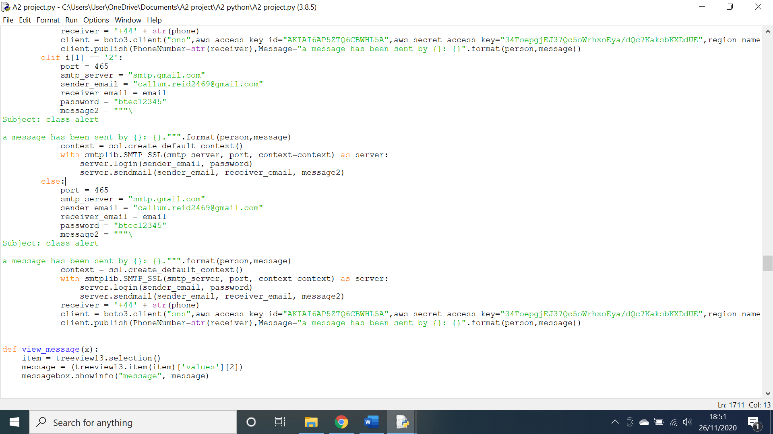The code above is responsible for sending emails to clients when a message is sent. The problem is that when formatting the email, the string must be in line with the edge of the screen as opposed to the function.

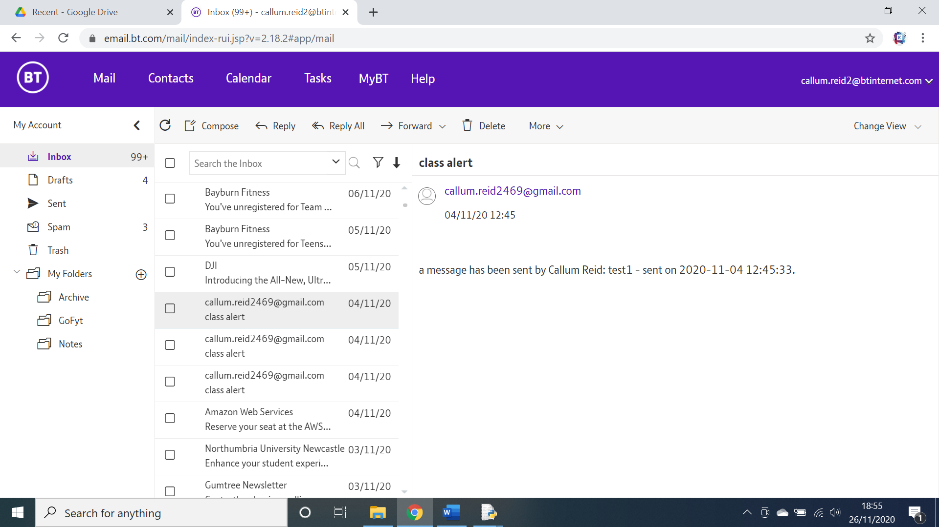Above is the amended code which shows the text has been correctly aligned. And as seen below, the code successfully sends an email to clients.

**Testing word document generation:**

**Action:** An exercise was selected and the generate report button was pressed.

**Expectation:** a file dialogue box would open and let me save the file to a specific area.

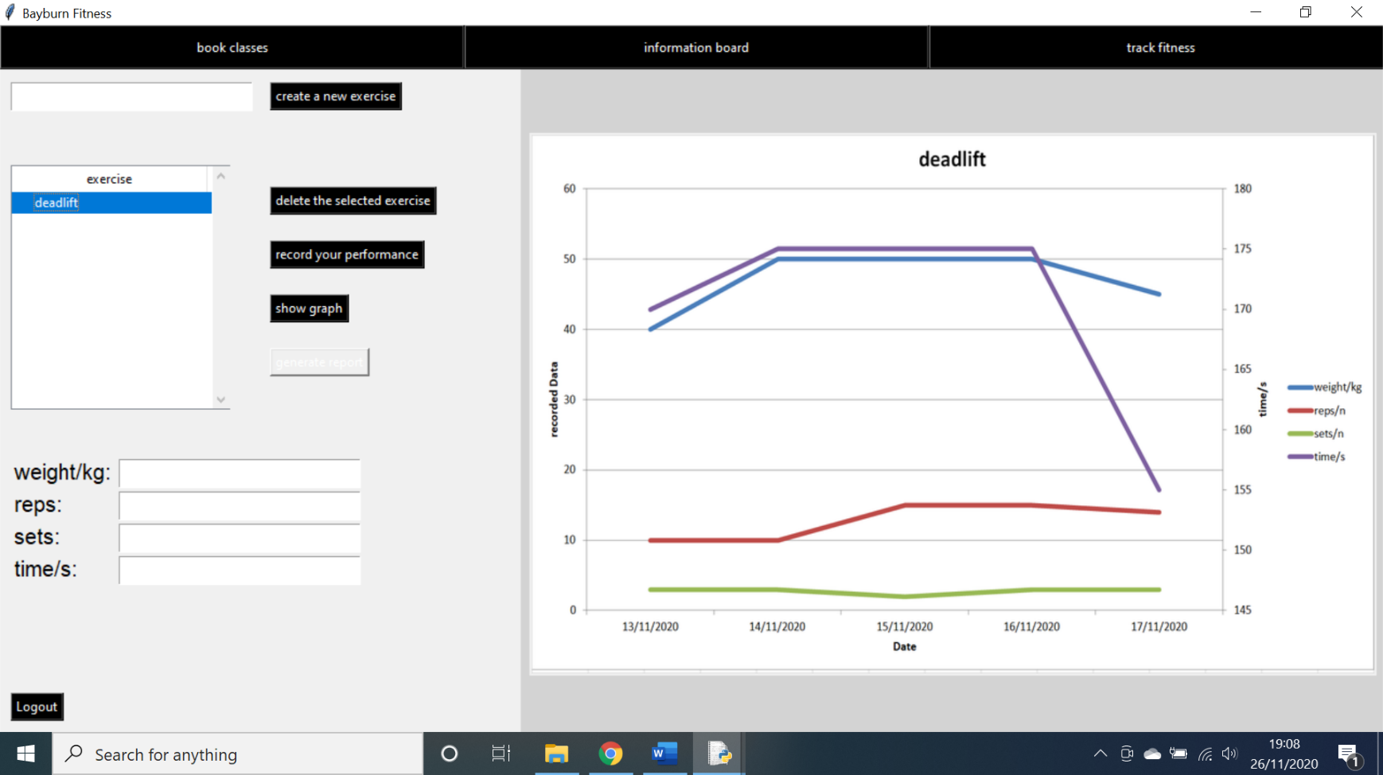**Outcome:** No file dialogue box was opened.

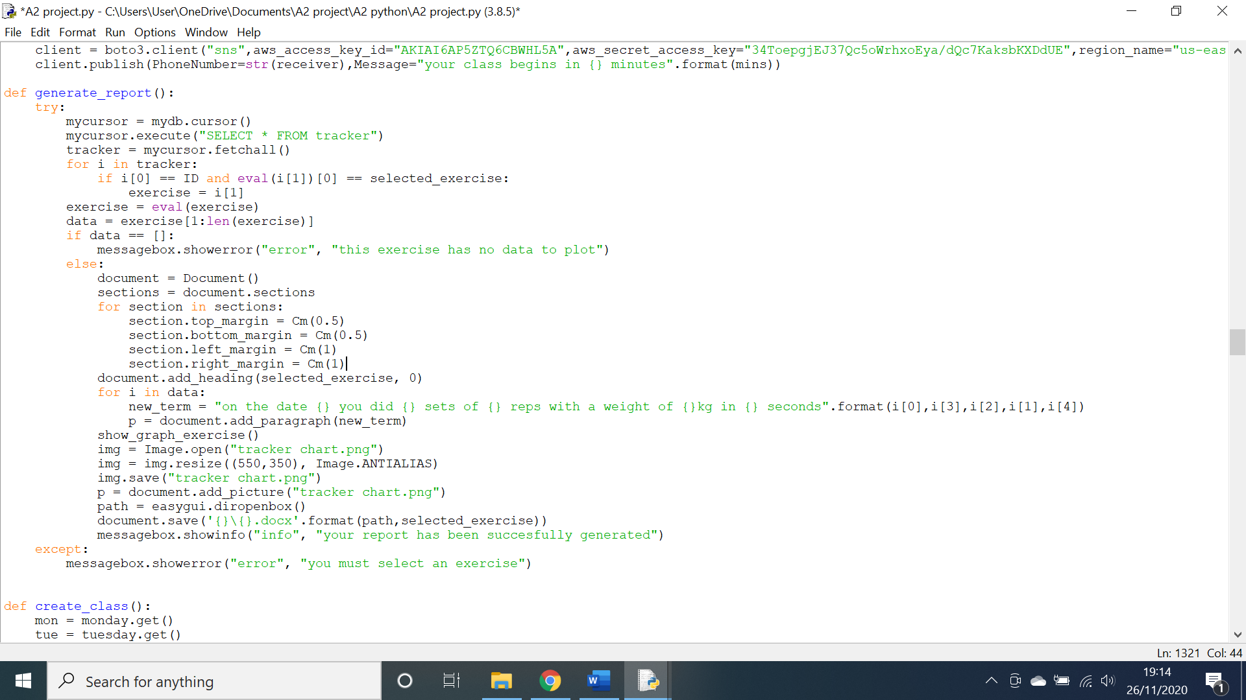As shown above, the button was clicked however no dialogue box was opened. This is a problem as it means there is no way of saving the generated report.

The above code is responsible for the creation of the file dialogue box and the saving of the document. However, the file dialogue box did not open as I had not imported the library “easygui”. Once I did this the file dialogue box opened correctly.

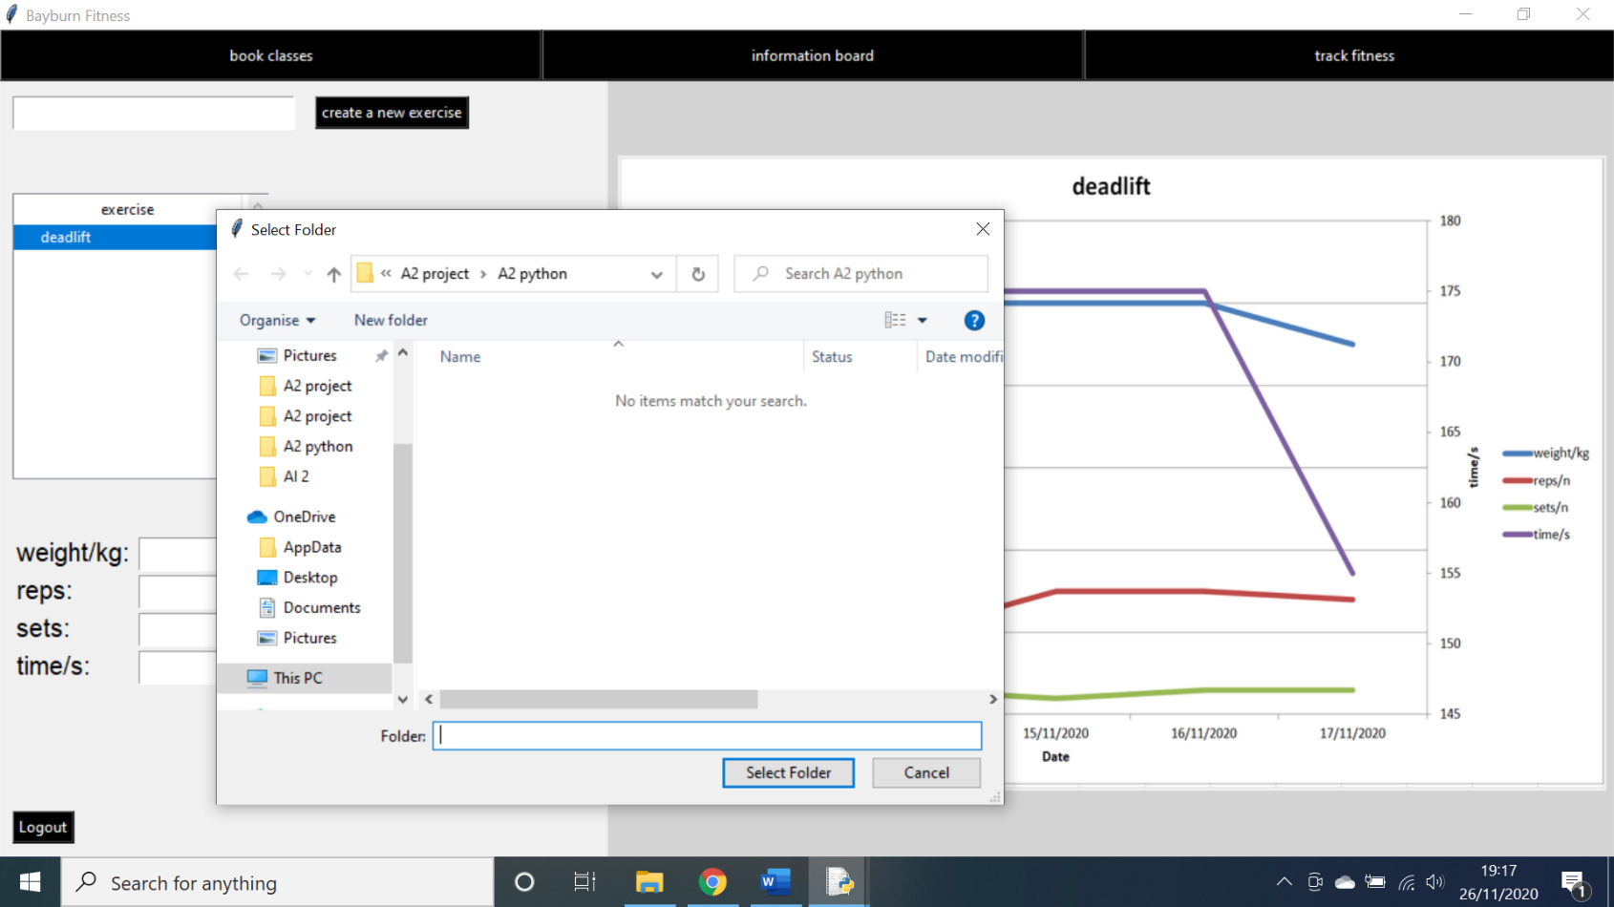

**Testing for the creation of a chart:**

**Action:** I attempted to generate a chart via the manager reports screen.

**Expectation:** A bar chart would be generated.

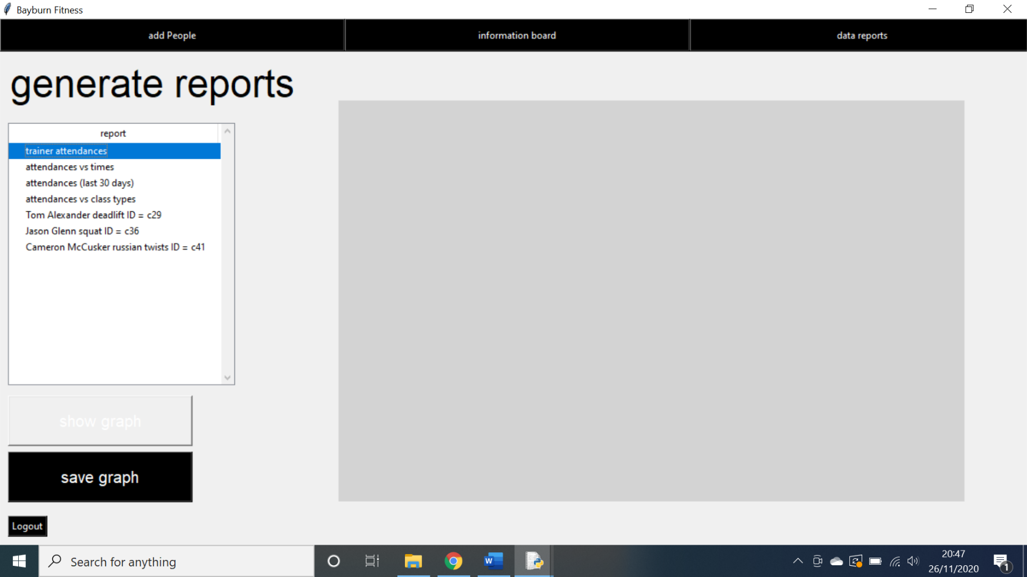**Outcome:** No chart was generated.

As shown above, when a report is selected and the show graph button is clicked, there is no graph generated. This is a problem as graphs are required for the manager to accurately make improvements to the company.

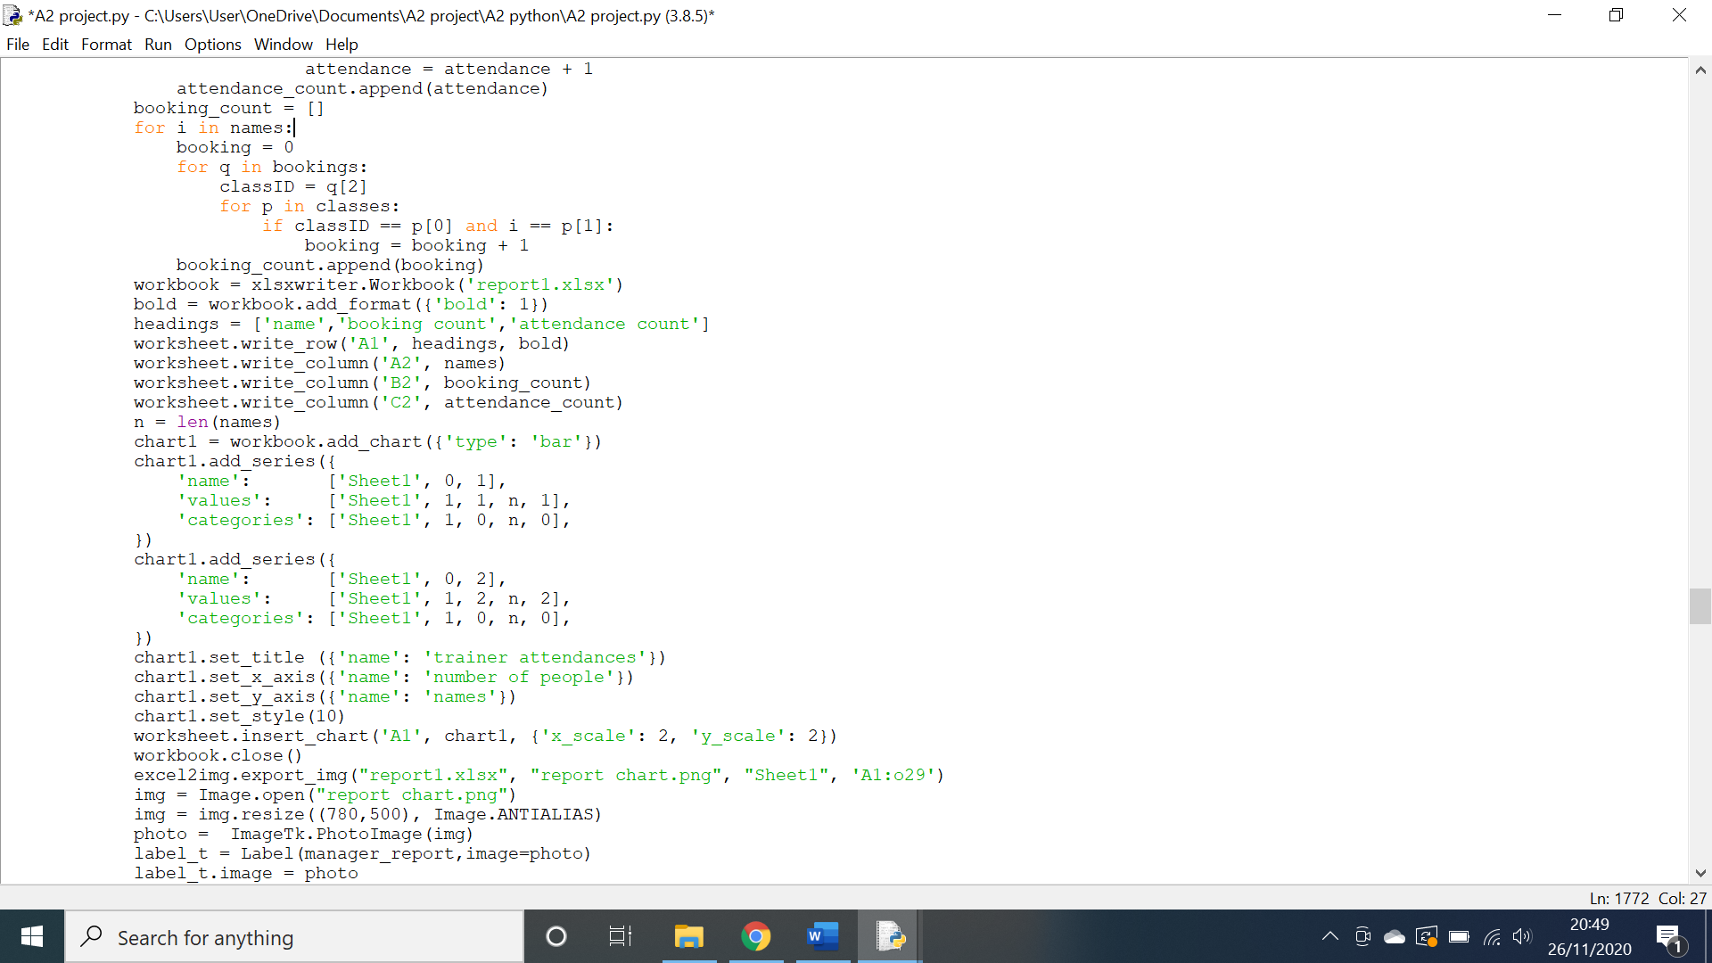

Above is the code responsible for generating an excel file that then creates a chart and has that chart extracted and placed on the screen. The code above is missing one key line in order to set up the excel file correctly by adding a worksheet. This line has been successfully added in the code below.

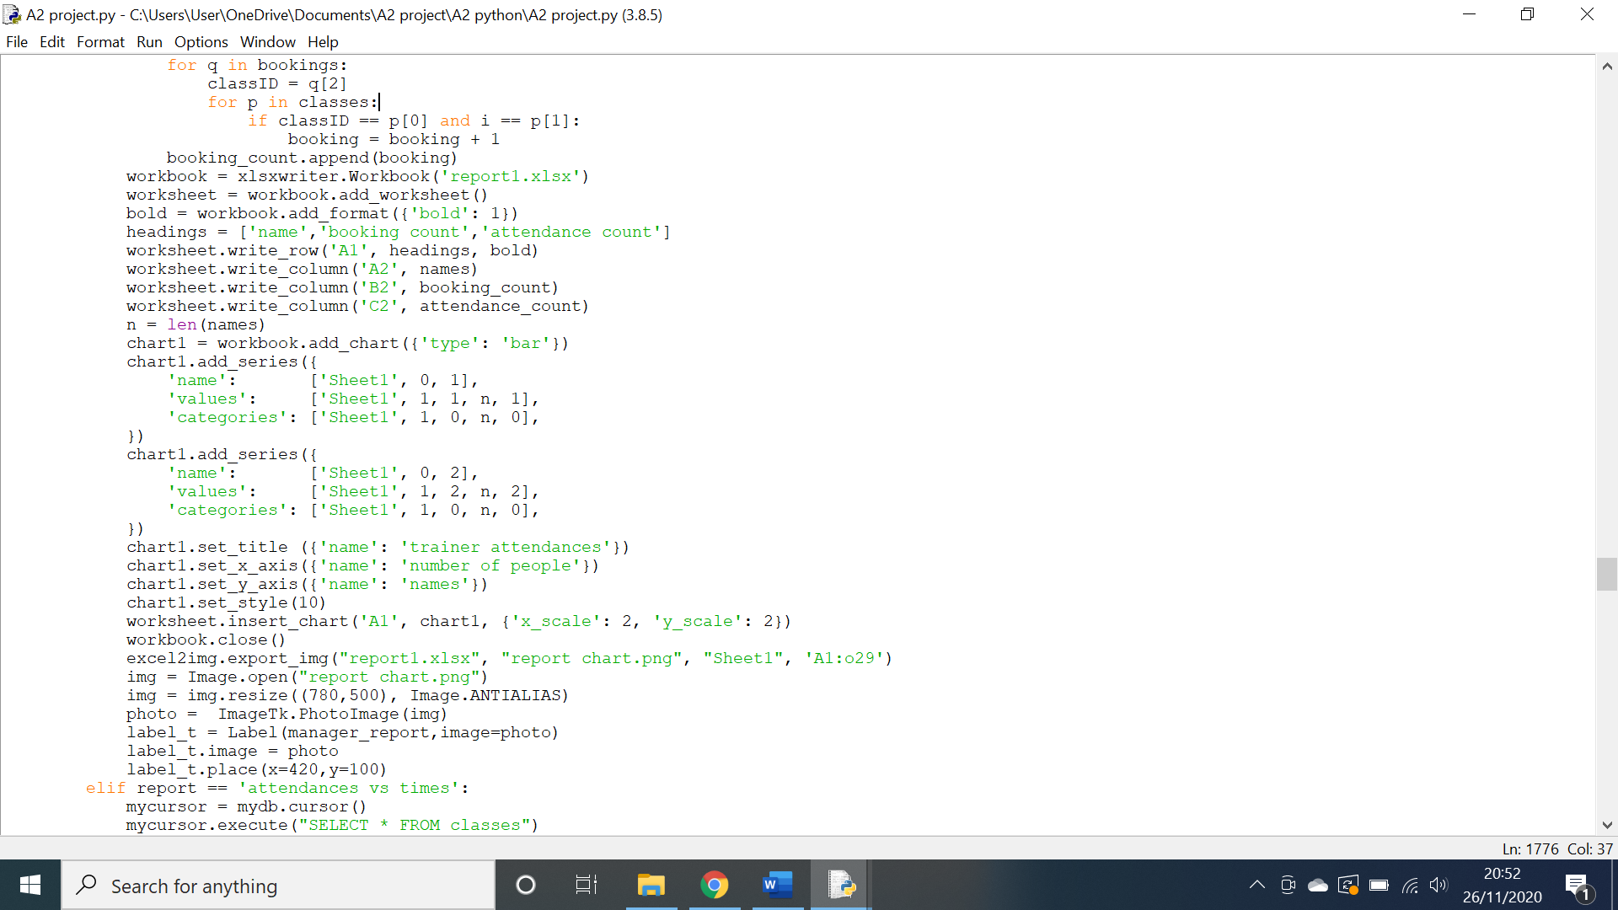

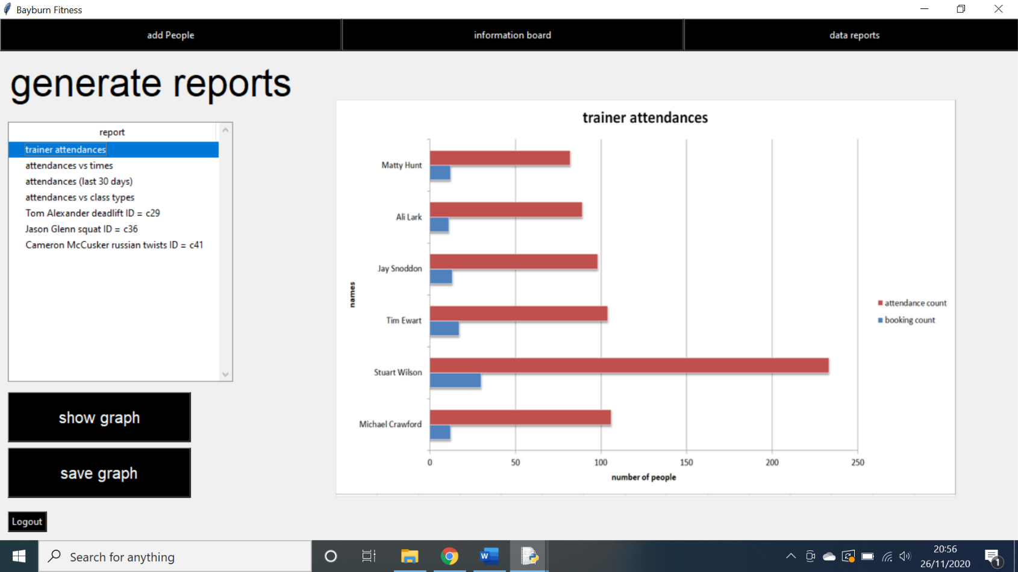As shown in the code above, the correct amendment has been made and the program will now create a worksheet in the excel file, this allows the system to generate a graph as shown below.

**Testing referential integrity when deleting a client:**

**Action:** A client was deleted from the system.

**Expectation:** The client’s information was deleted from both the login and the clients table in the database.

**Outcome:** The information was deleted from the clients table but not the login table.

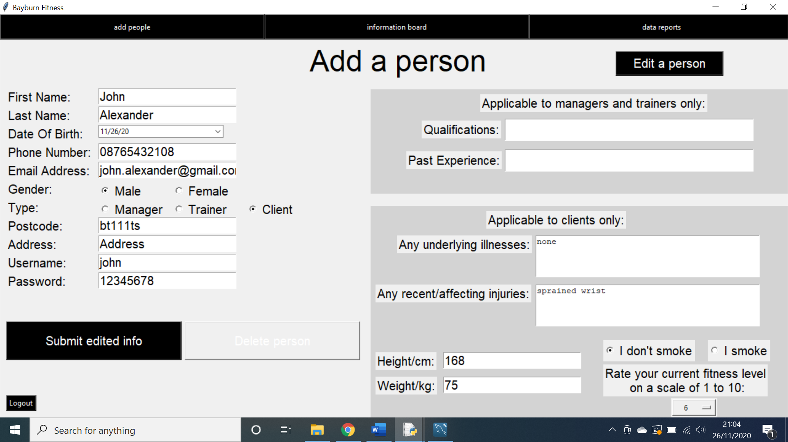

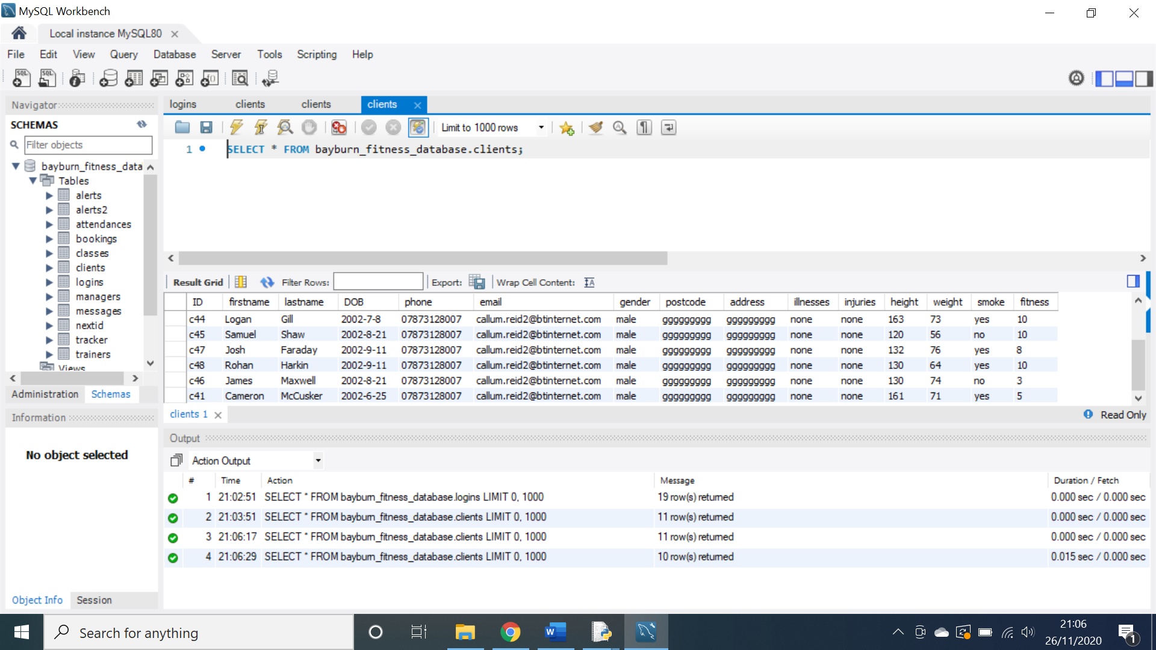

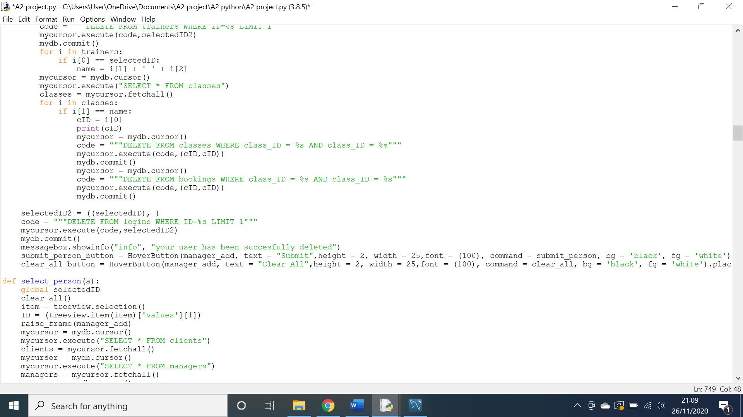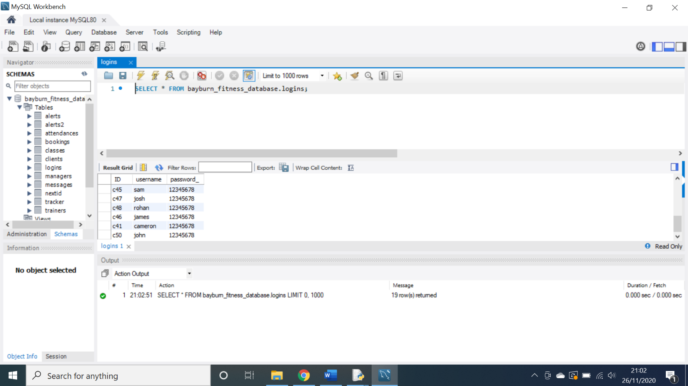As shown above, the information was deleted from the clients table but not the logins table. This is a problem as it reduces referential integrity and could cause problems with the rest of the system.

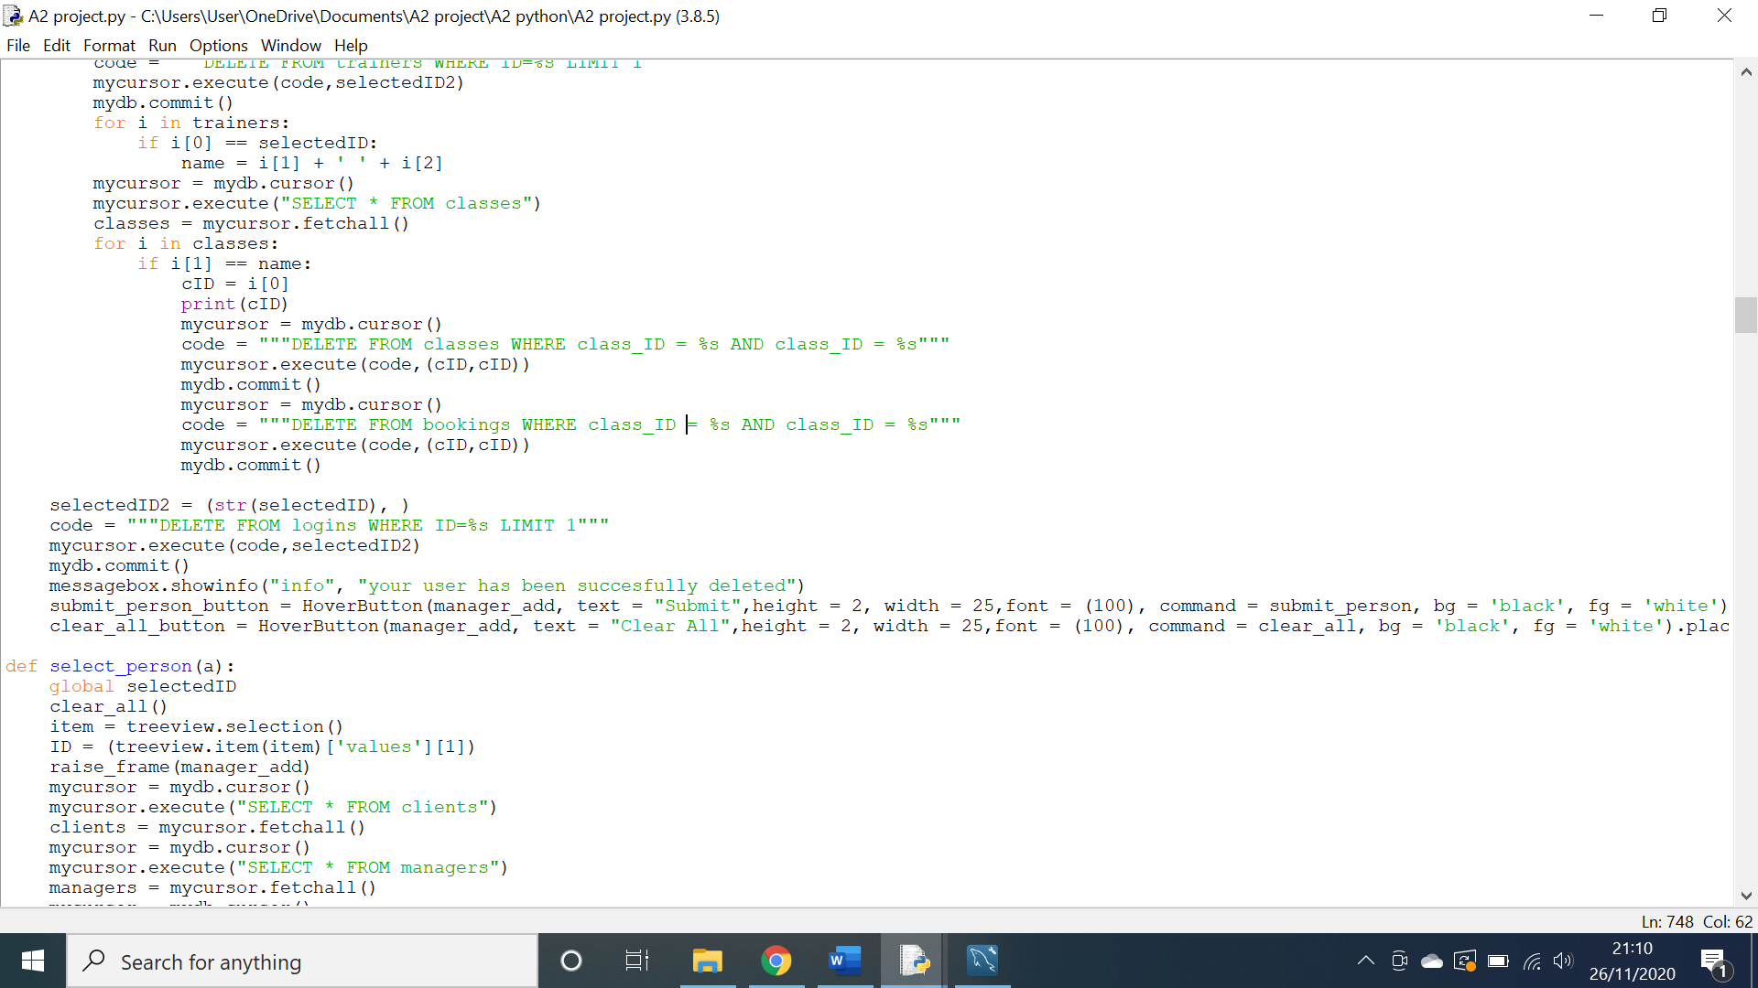Above is the code responsible for deleting a user from the login table. The reason this code has failed is because I have not casted the selected ID as a string. This is amended in the code below.

As shown above, the offending code has been rectified and the system now deletes information fully as shown below.

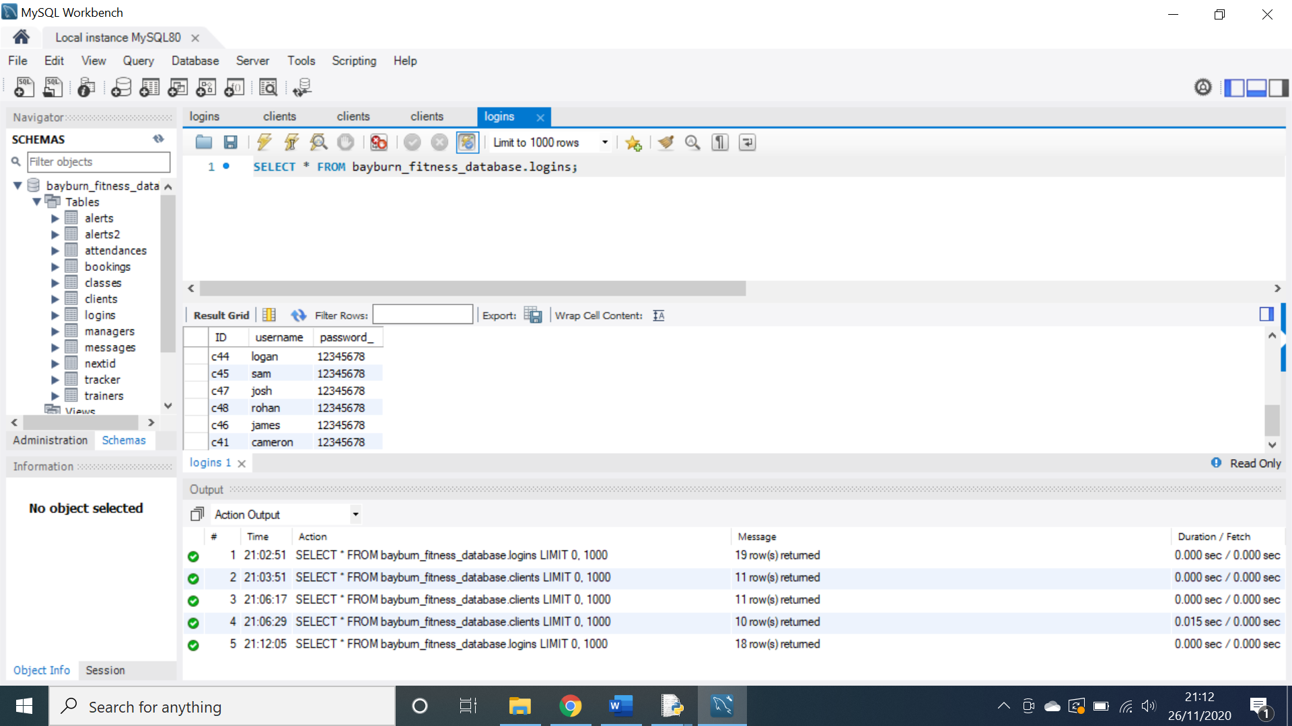

**Testing a popup error message:**

**Action:** I inputted the incorrect data for the login screen.

**Expectation:** An error message to be generated by the system, informing me of my mistake.

**Outcome:** No error message.

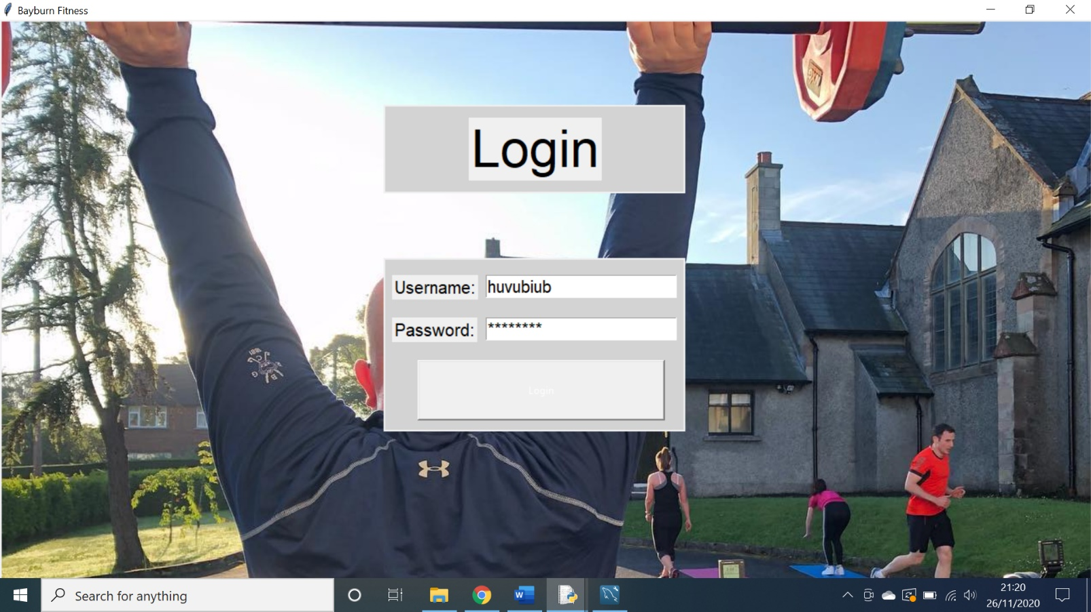

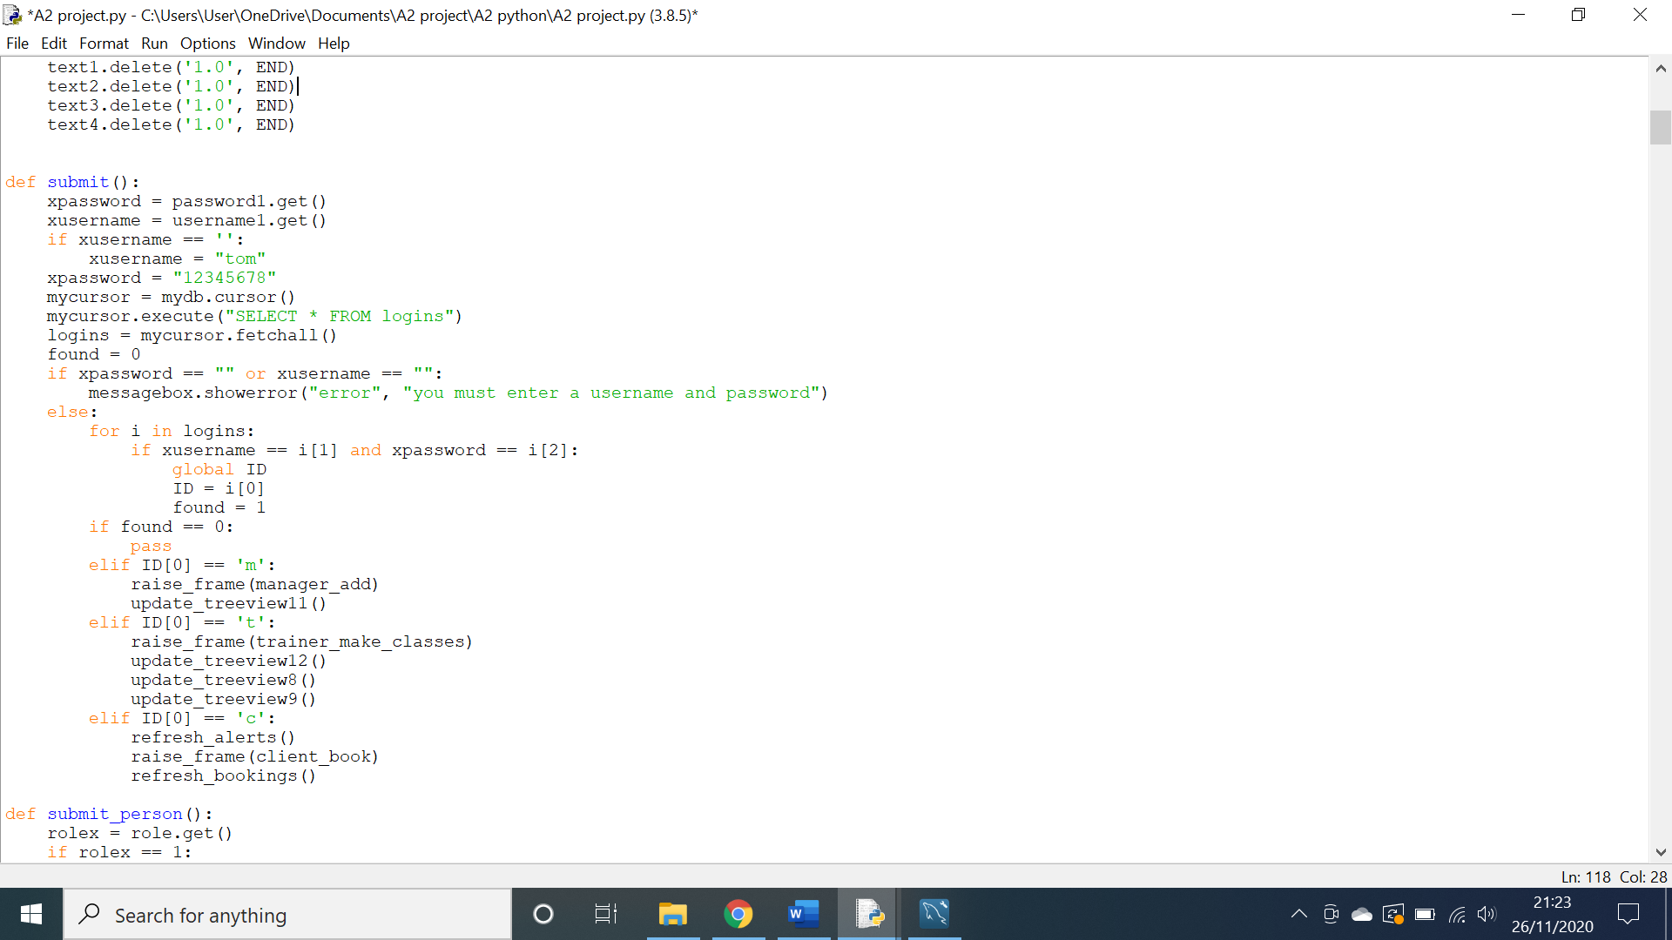As shown above, incorrect data was entered into the username and password fields and the login button was clicked however, no error message was generated by the system. This is a problem as the user may not be aware of their mistake.

The code above is responsible for the login mechanic of my system. The problem is that the system simply ignores login details if they are incorrect. A message box mechanic has not yet been implemented. This is rectified the code below.

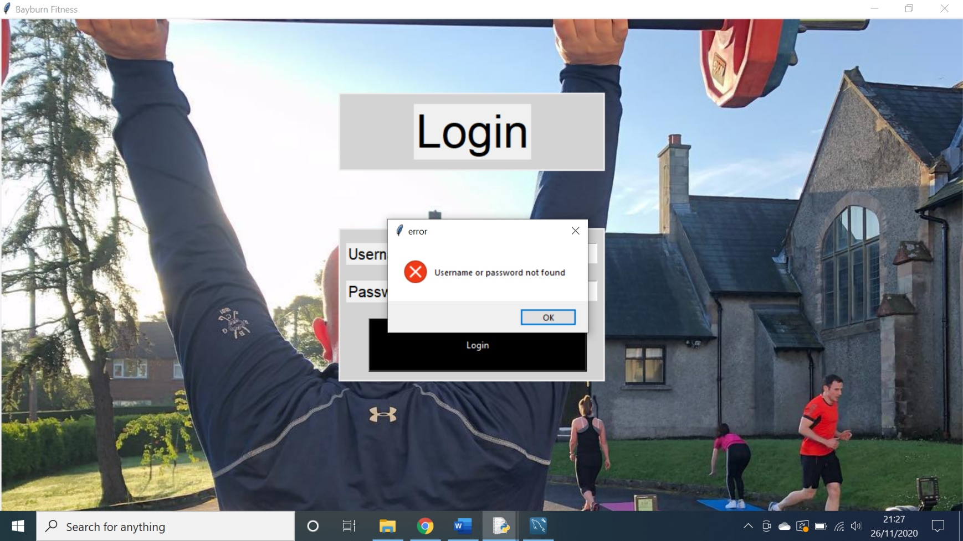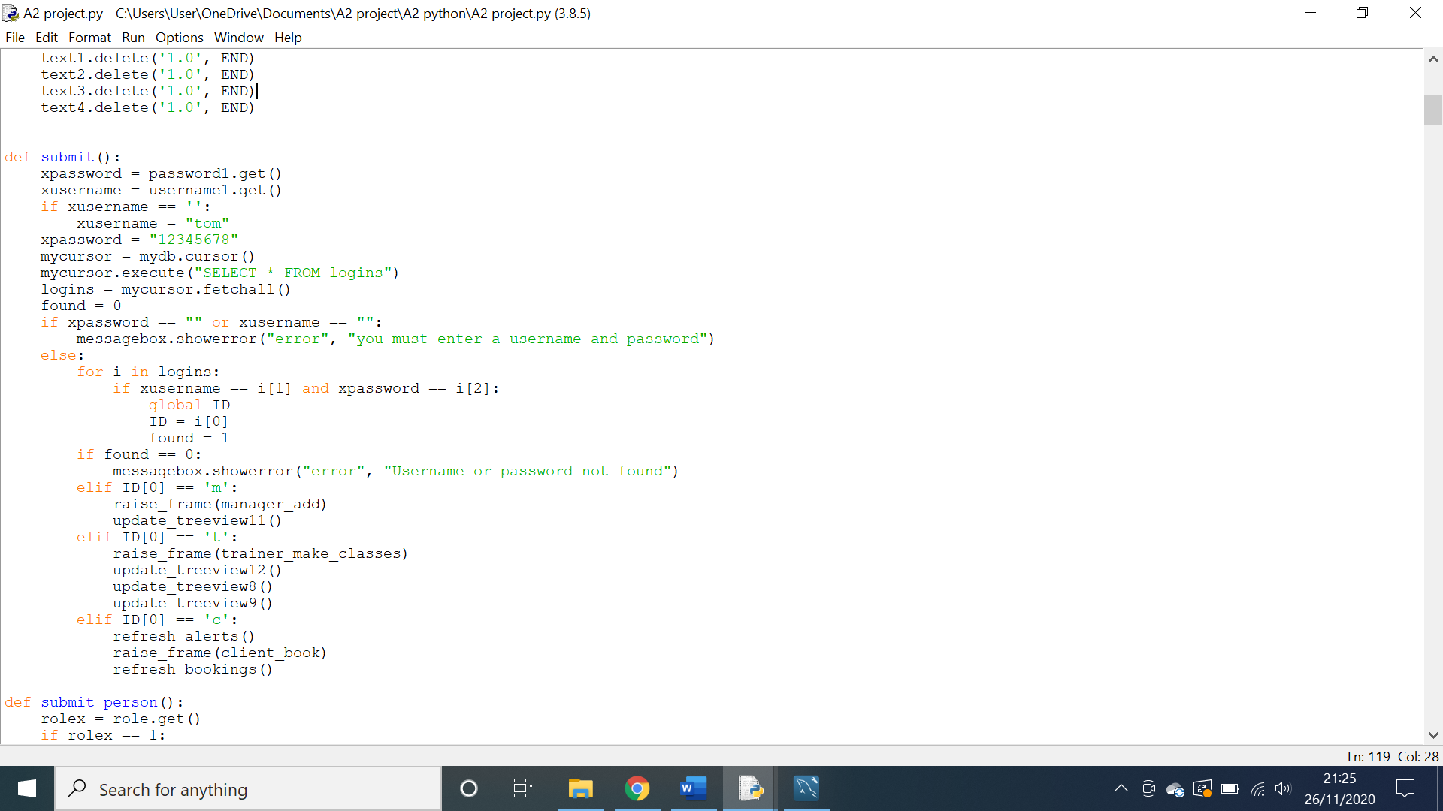This code correctly generates an error message when incorrect data is entered into the login fields as shown below.

**Testing screen navigation:**

**Action:** attempted to navigate to the client track screen using the button on the top of the screen.

**Expectation:** the client track screen would be raised.

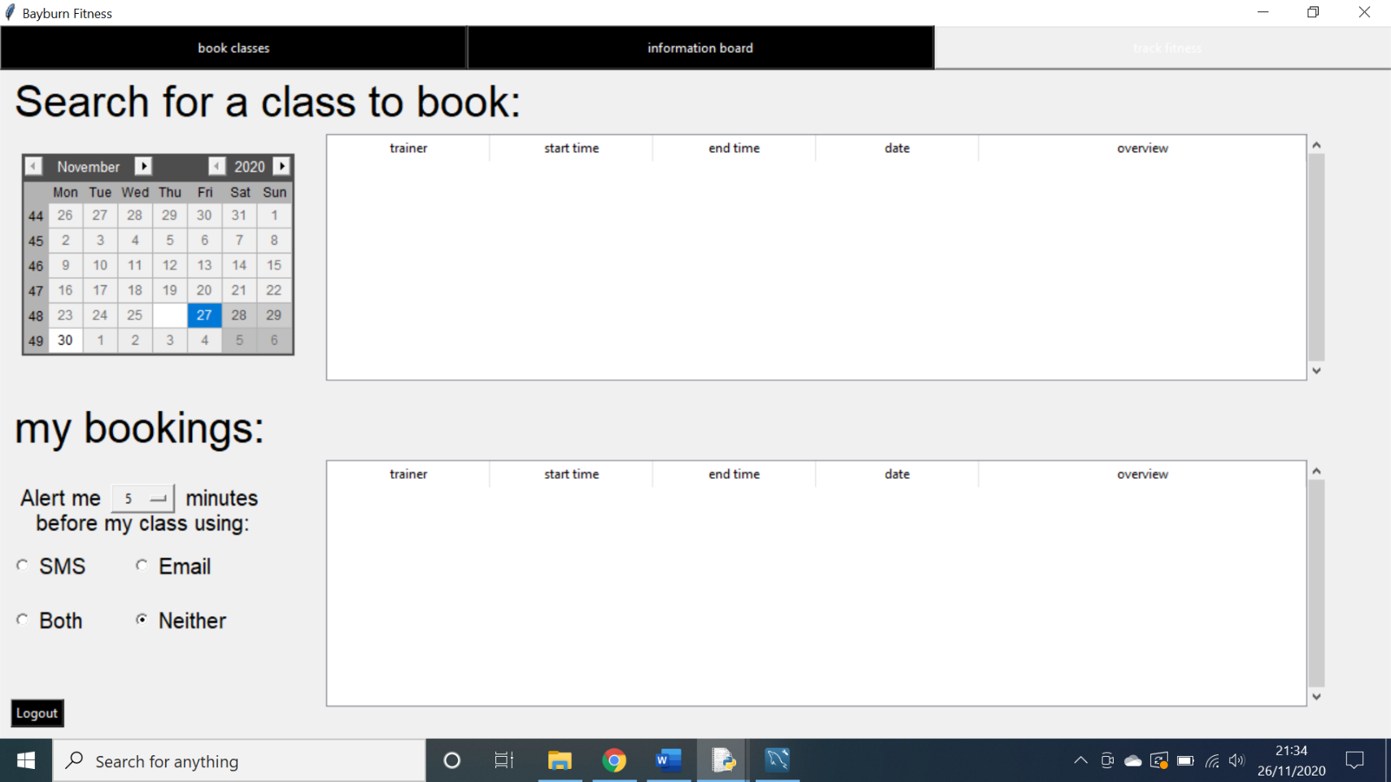**Outcome:** No change in screen.

As shown above, I clicked the track fitness button however there was no change in screen, this is a problem as it means the user cannot access the functionality of the fitness tracker.

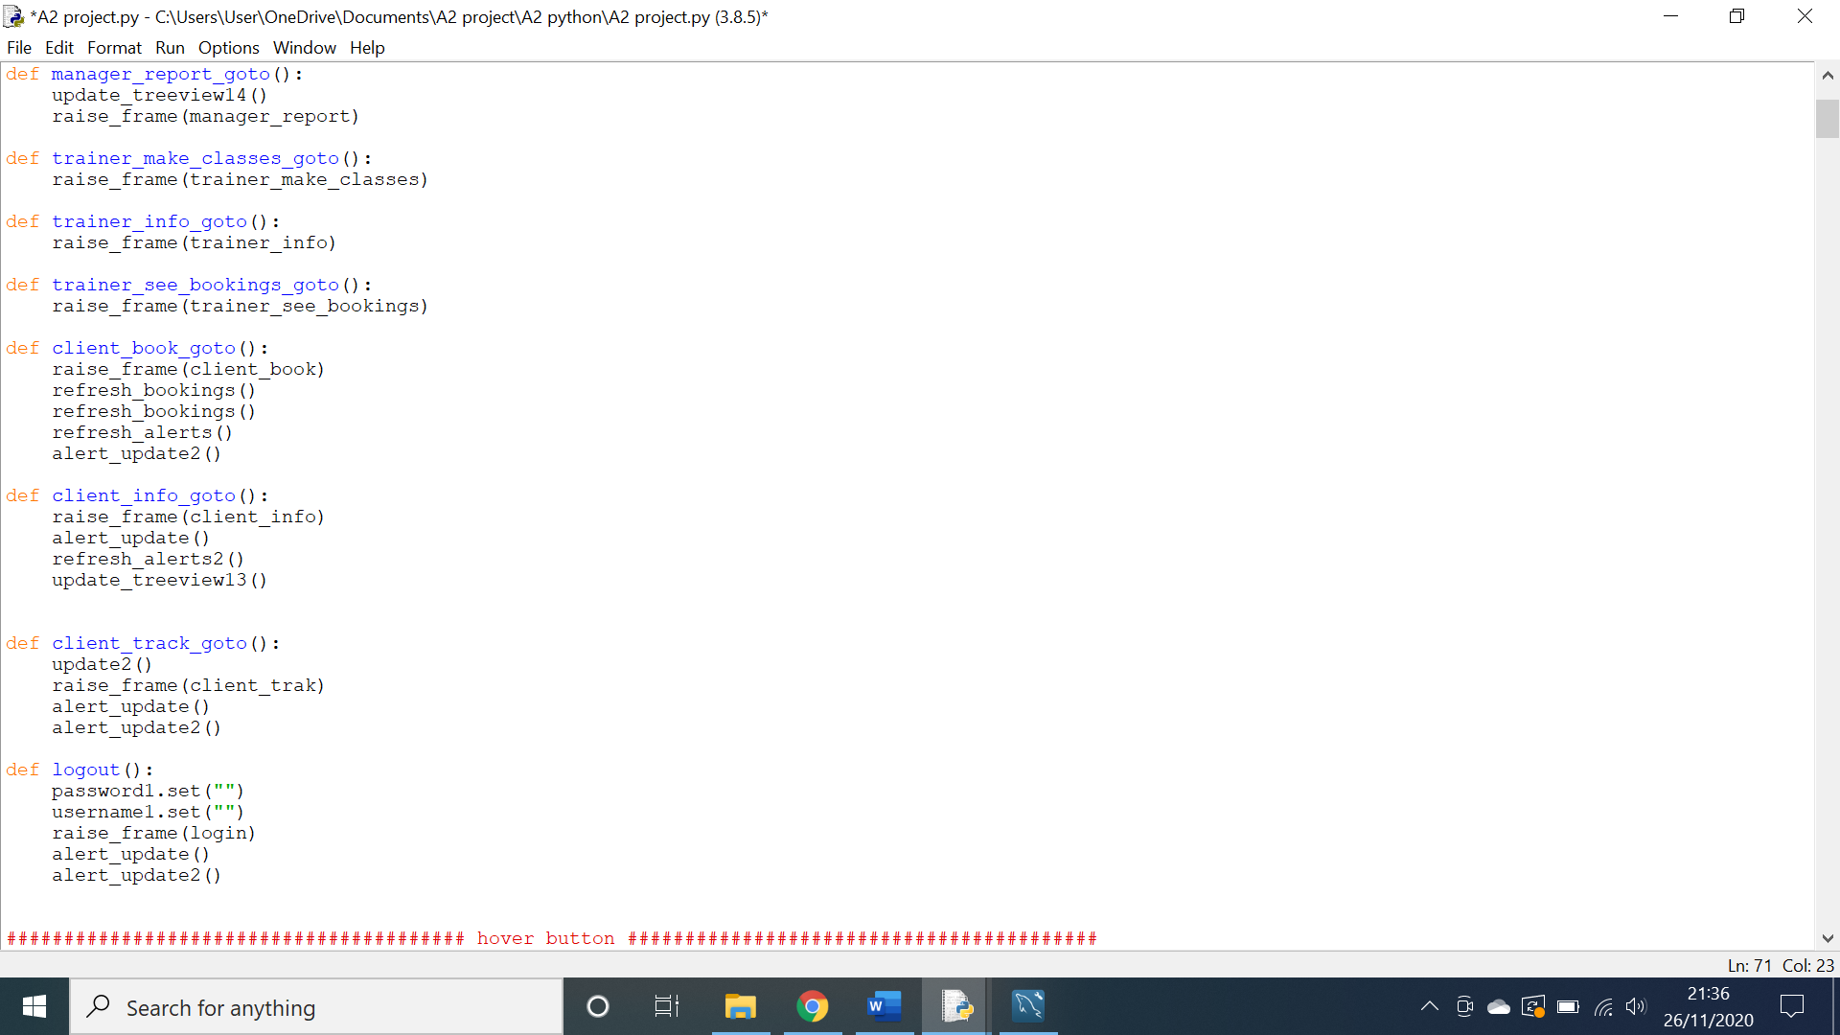

The code above is responsible for bringing the user to the client track screen. However, there is a simple typo in the raise frame statement that has been corrected in the code below.

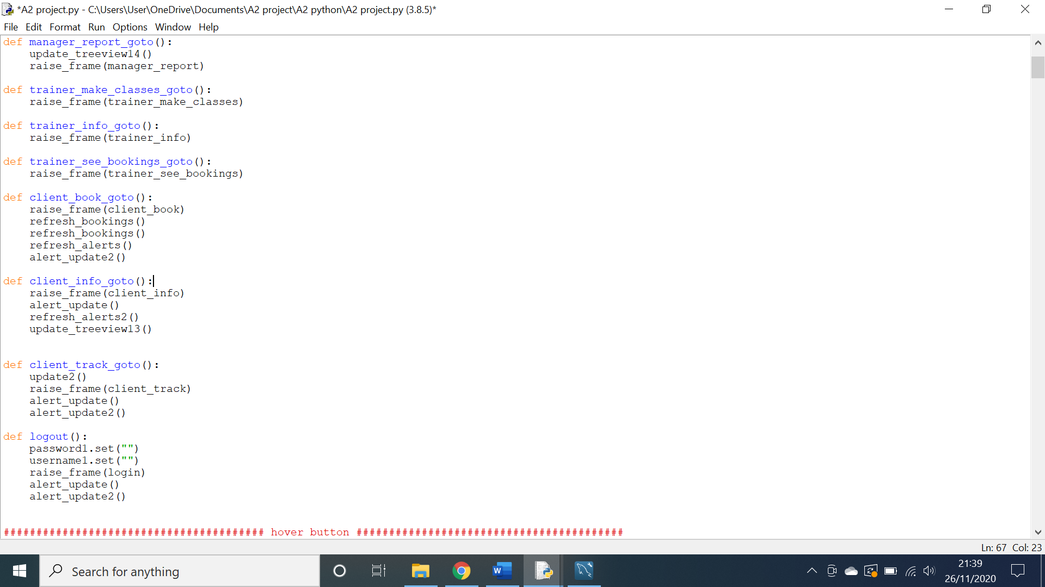

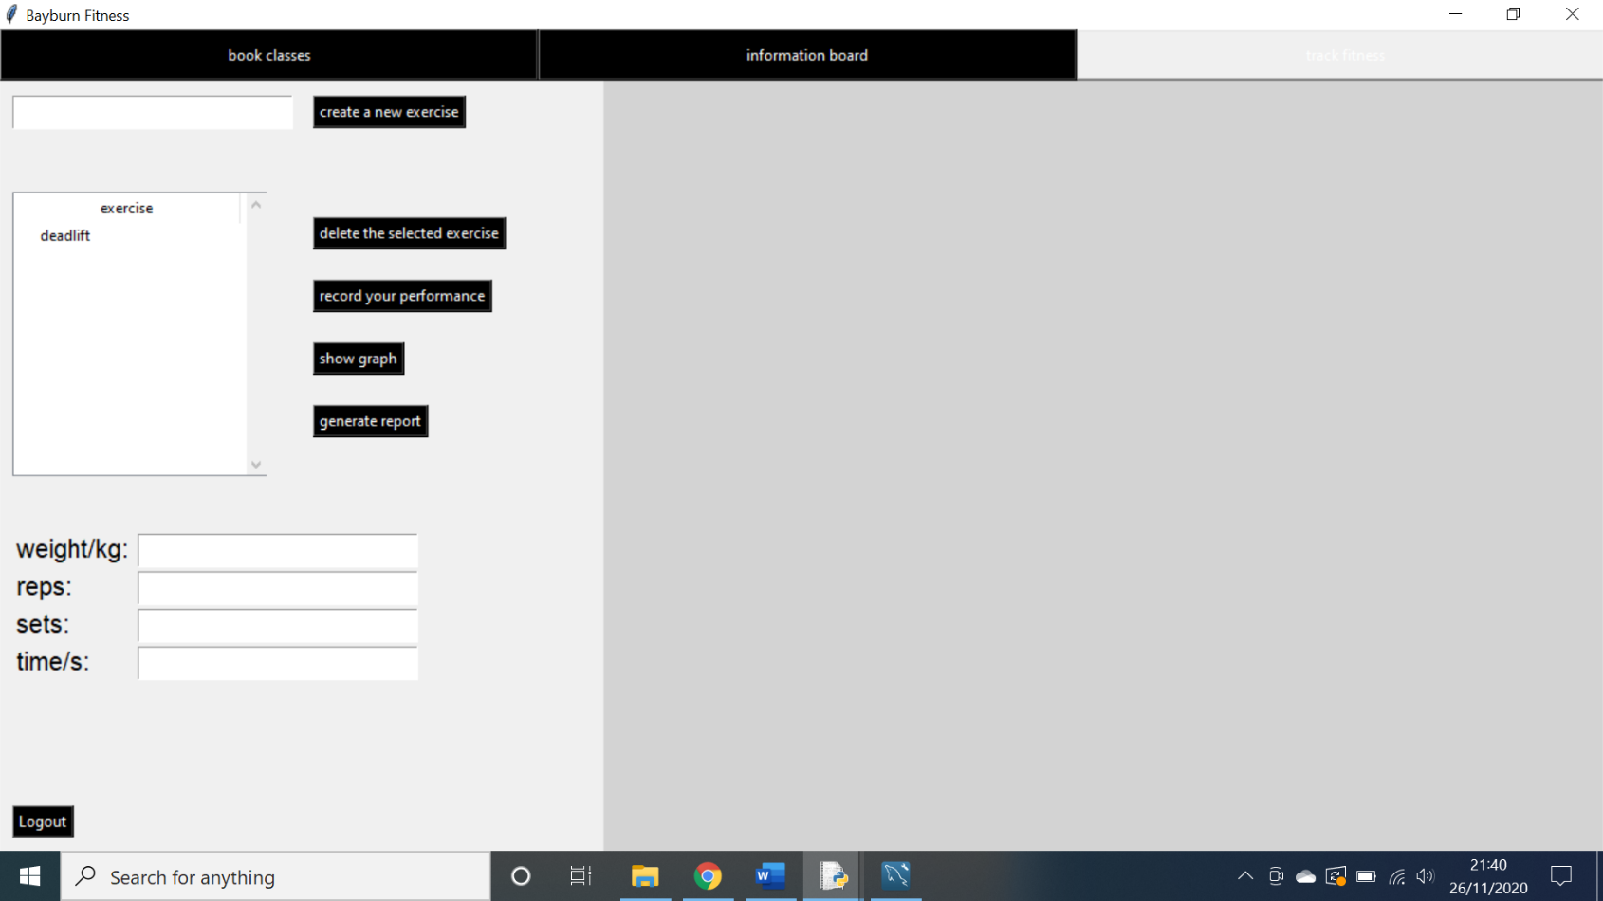This code successfully transfers the user to the client track screen as shown below.

**Testing Automatic alert system:**

**Action:** An appointment was booked by a client and the system time was changed to 5 minutes before.

**Expectation:** An alert is sent to the client.

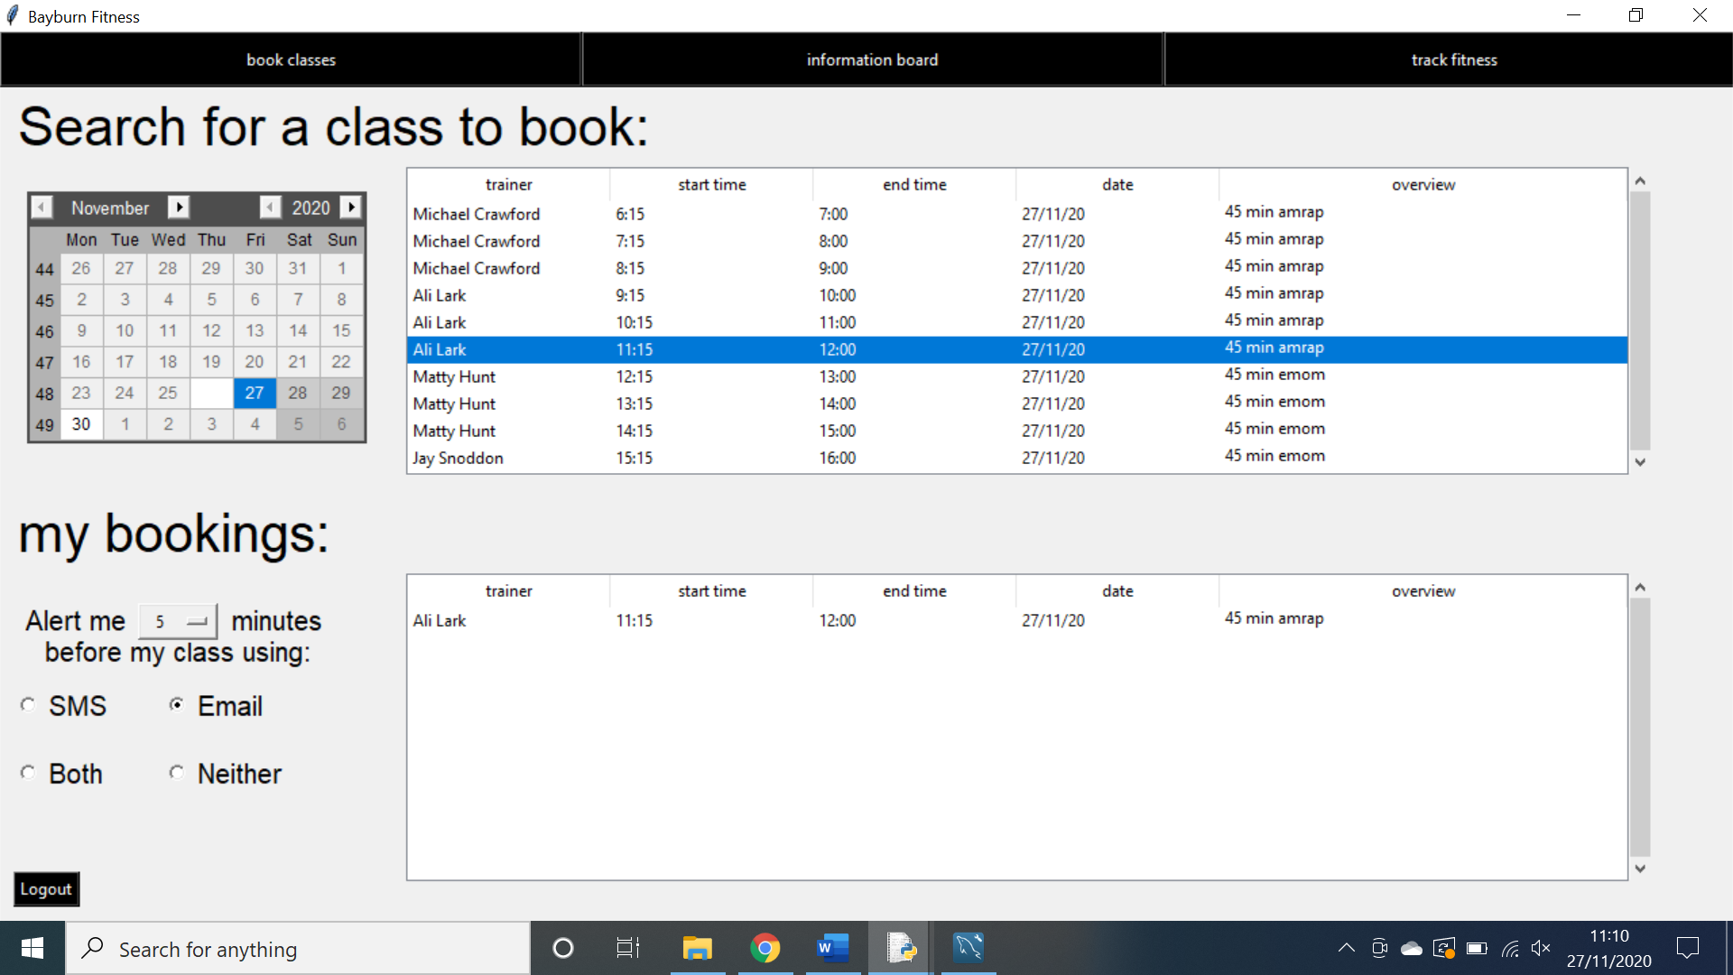**Outcome:** No alert was sent.

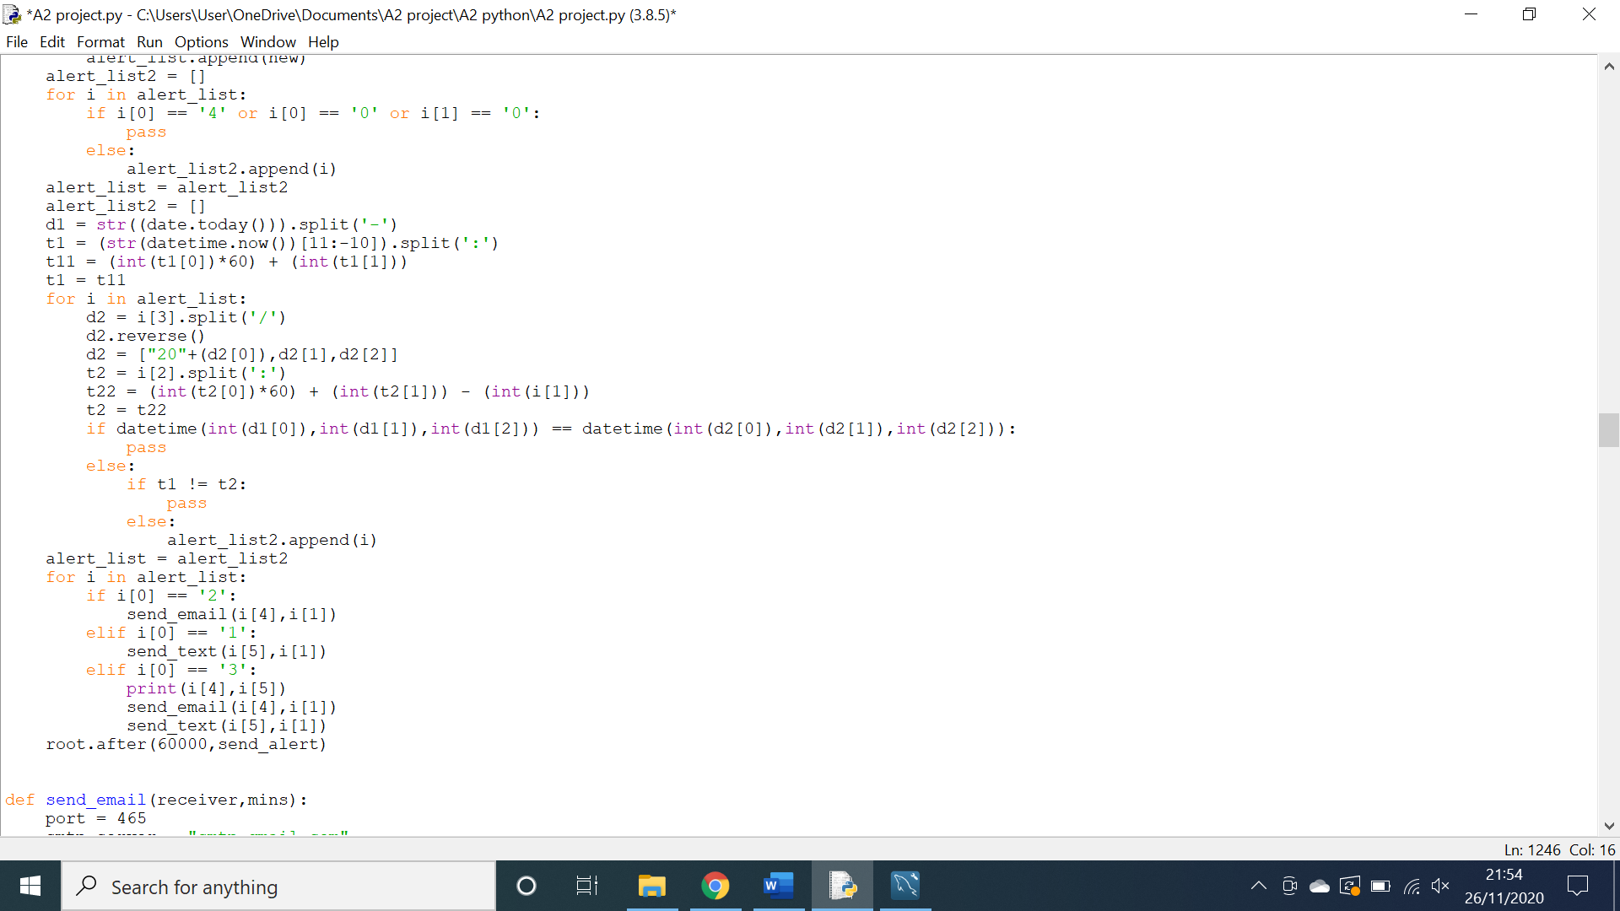As shown above, the class has been booked and the date and time is 5 minutes before the class however, no email was sent. This is bad as if no notification is sent to clients then they risk missing their classes.

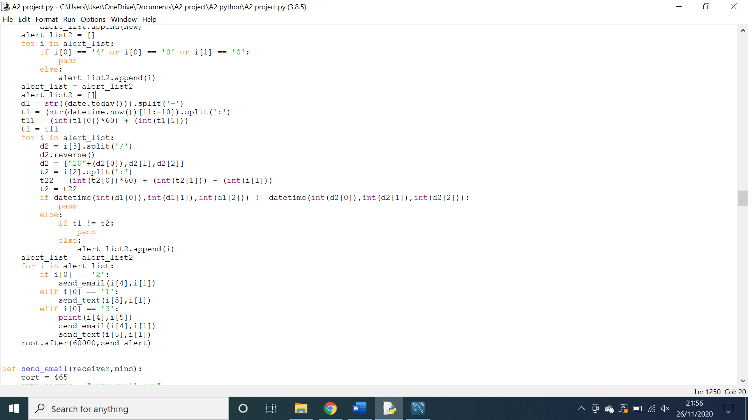The above code is responsible for sorting through dates and times to check to see if they match the one we are looking for however, the system is currently passing by any dates that match when in fact it should be doing the opposite. This is rectified in the code below.

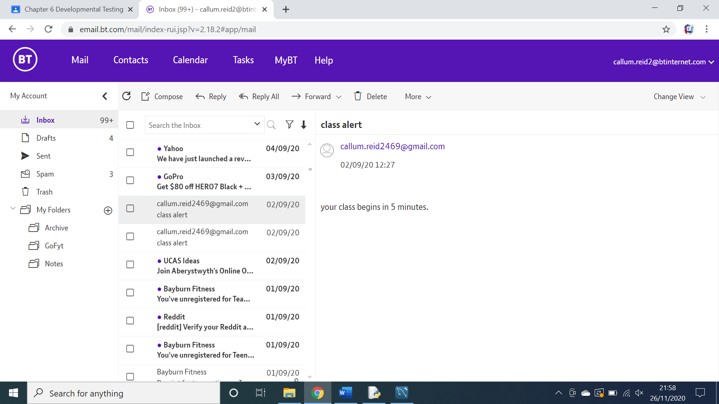The code above correctly identifies the date and time and allows the system to send alerts correctly as a result. This is shown below.

**Testing the account search feature:**

**Action:** Data was entered into the search boxes on the search screen**.**

**Expectation:** The treeview would be correctly refined to show the right data.

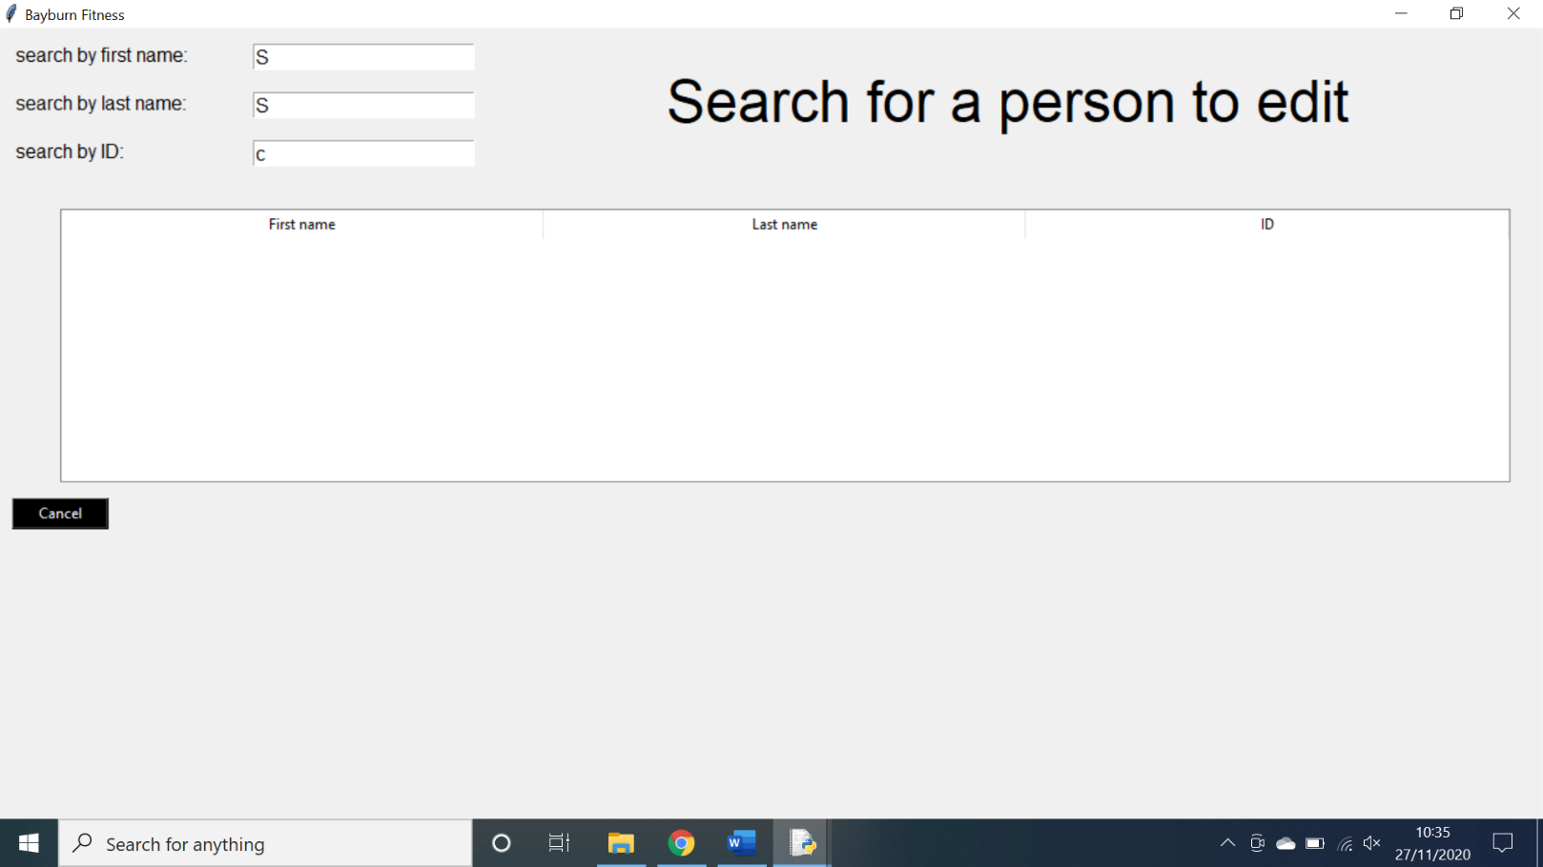**Outcome:** The treeview displayed no data.

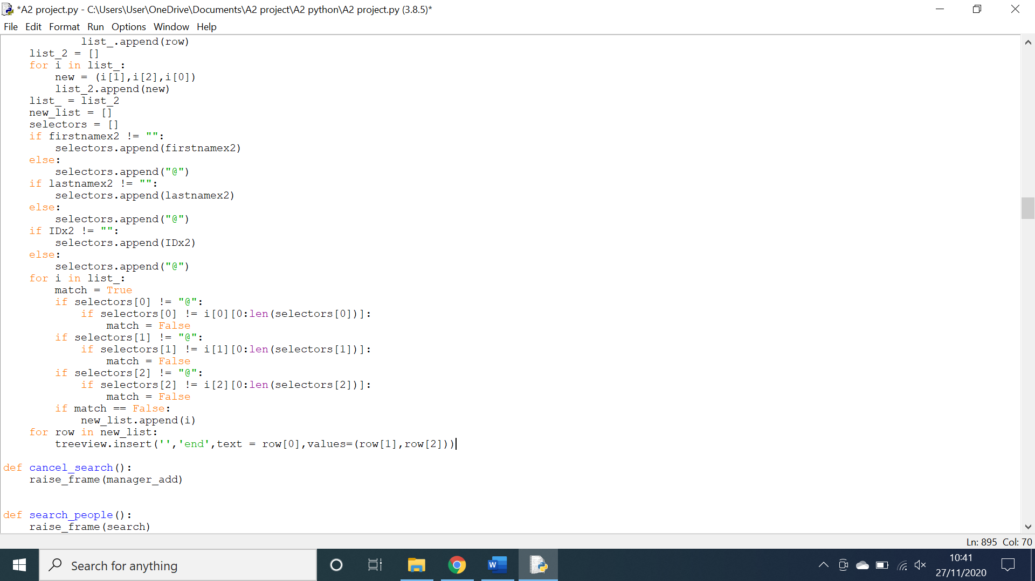As shown above, the fields have had data entered into them, but no data was entered into the treeview. This is a problem as it means no user can have their data deleted or edited.

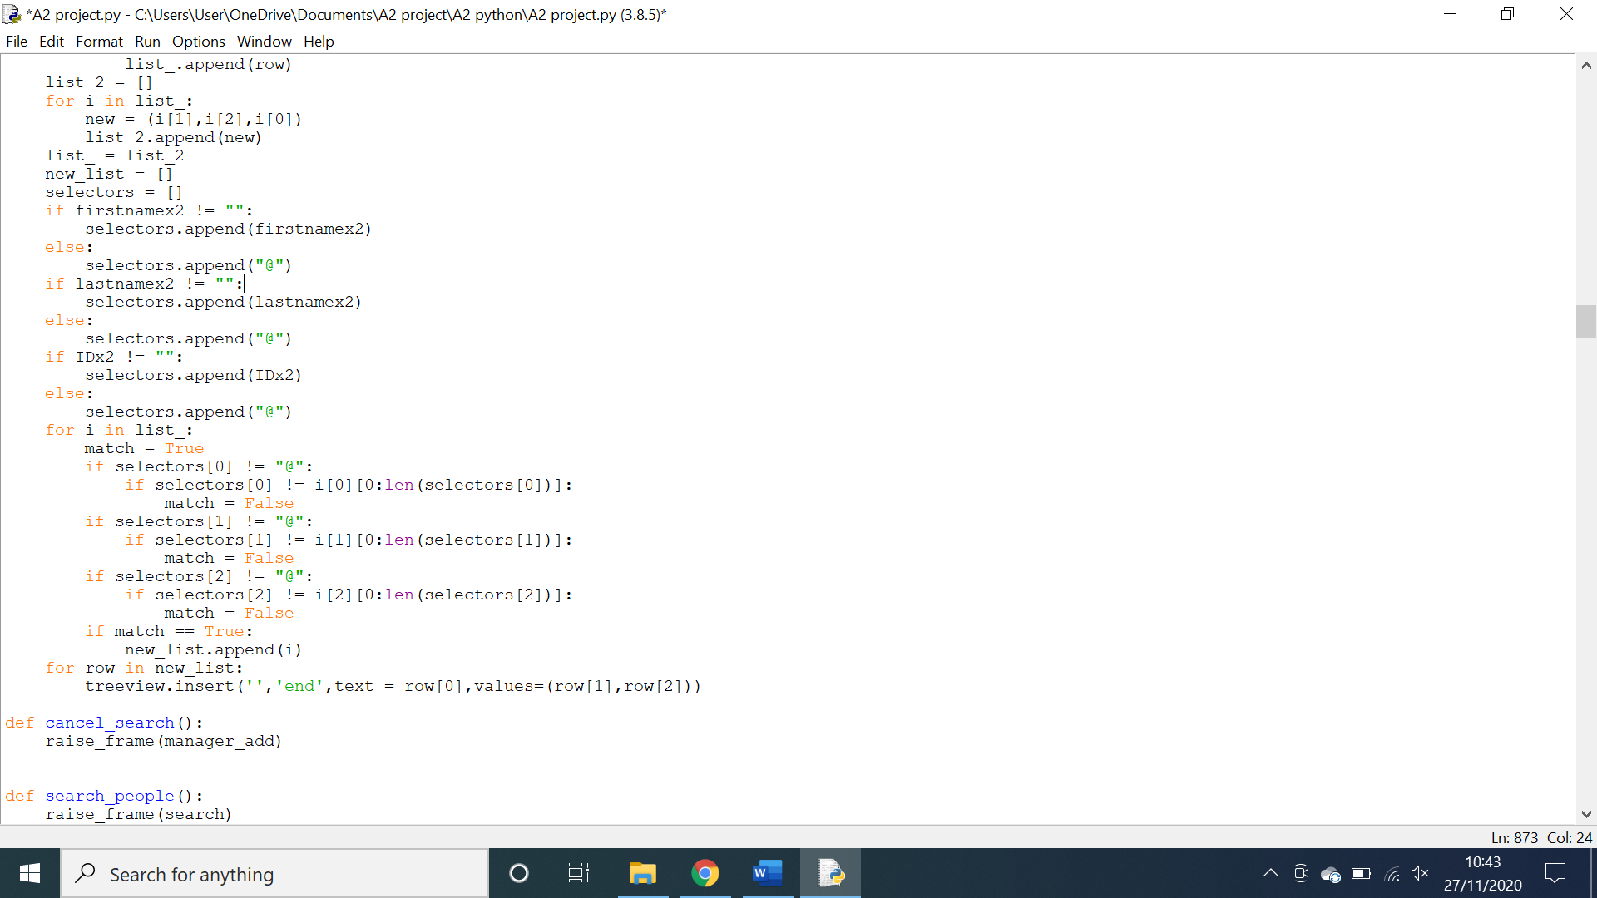Above is part of the code responsible for refining the search. The problem is that the code is not discarding parts of the search that do not match. This problem is easily amended in the code below.

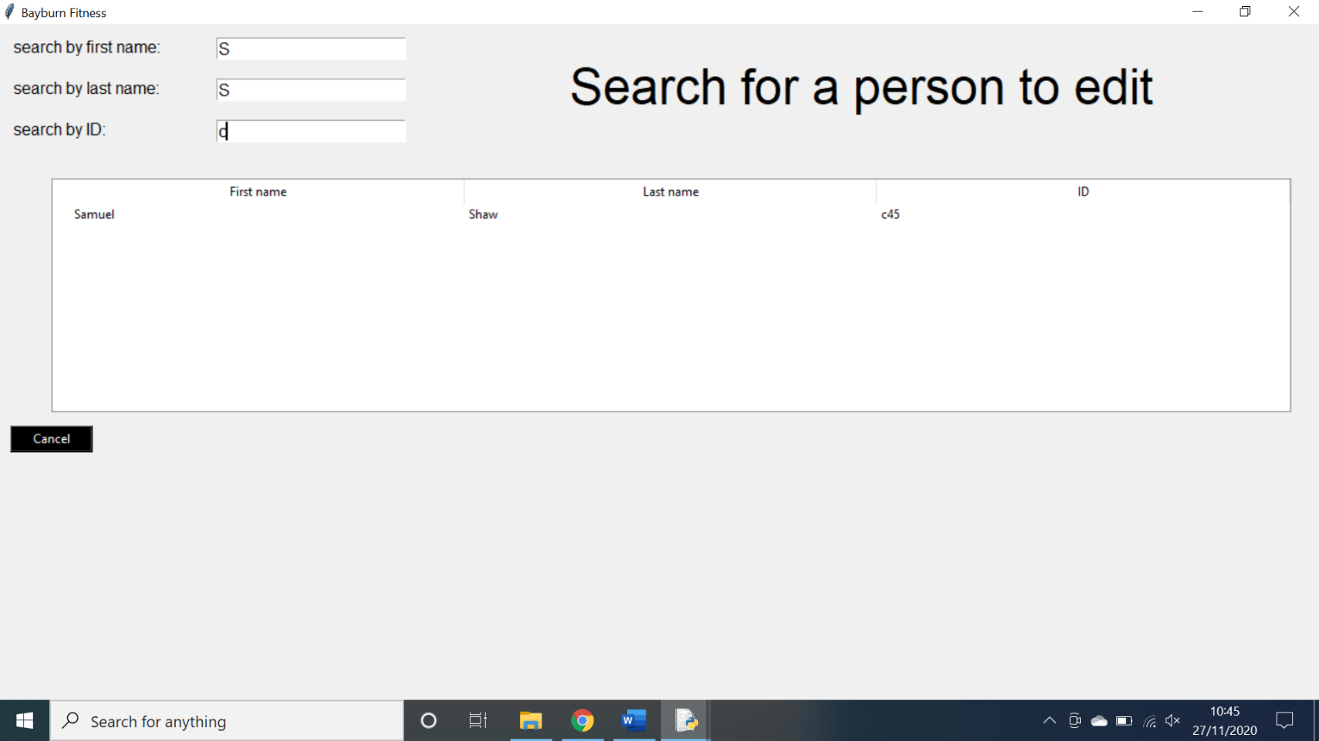Above is the amended code that successfully refines the search to the desired output as shown below.

**Testing the deletion of an exercise:**

**Action:** An exercise was selected on the fitness tracker and then deleted.

**Expectation:** The exercise would be deleted from the database.

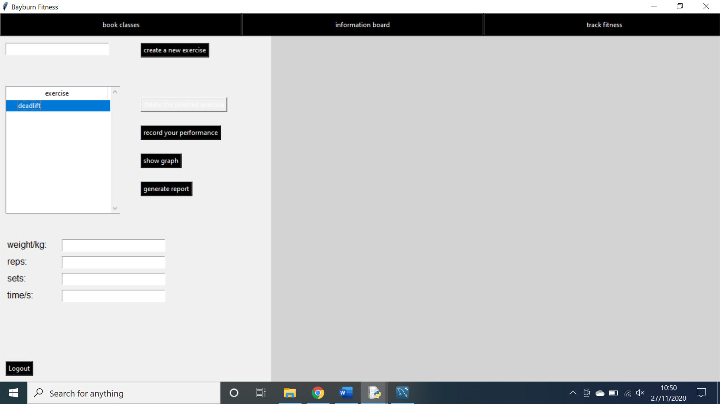**Outcome:** The exercise was not deleted from the database.

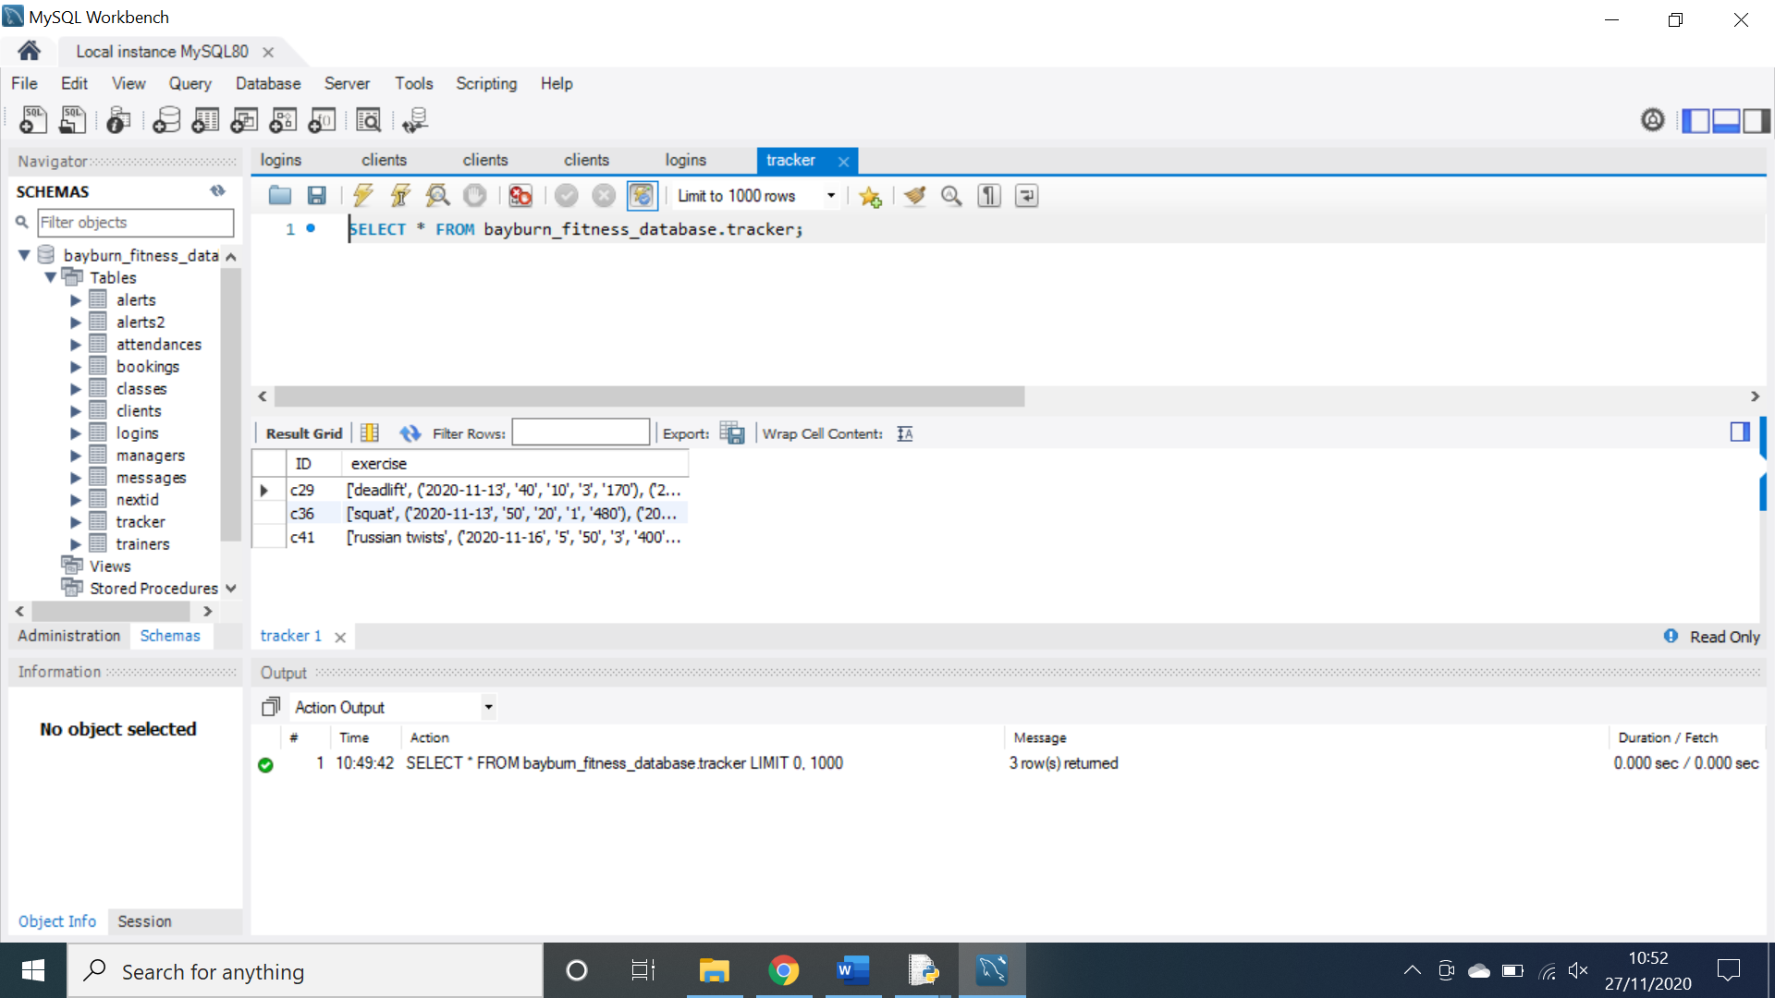

As shown above, the exercise “deadlift” was selected and the delete button was pressed. However, the exercise was not deleted from the database. This is a problem as it means that no client will be able to delete their exercises.

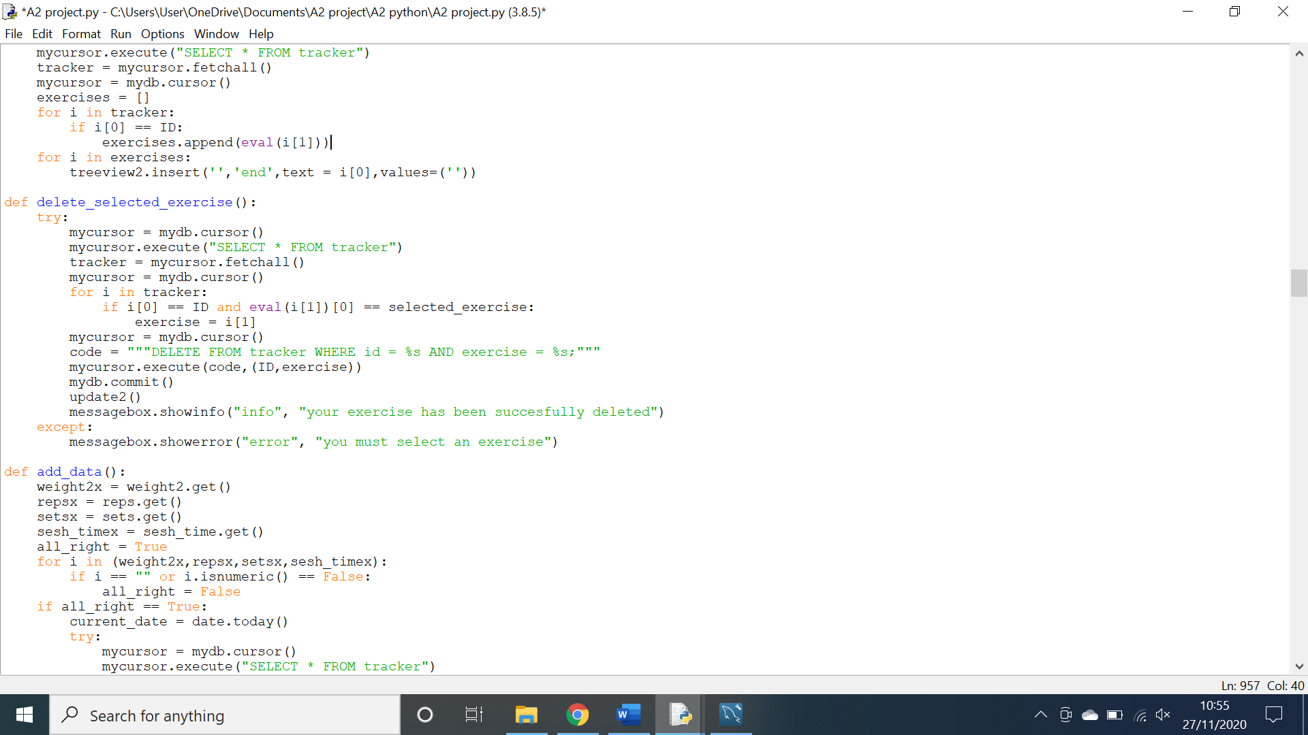

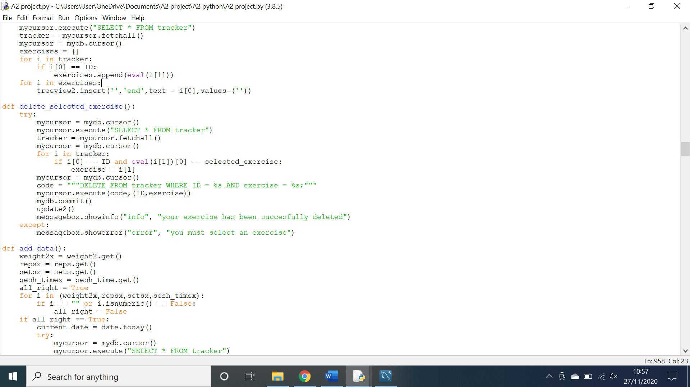The code above is responsible for deleting selected exercises. The problem is that in the SQL statement I have used lowercase letters for “id”, when it should in fact be “ID”.

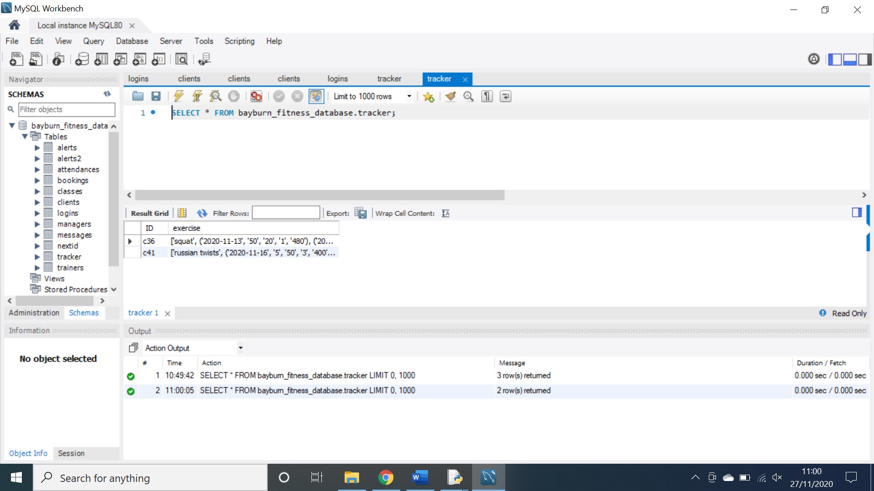Above is the amended code and it can successfully delete a selected exercise as demonstrated below.

**Testing The updating of the messages treeview:**

**Action:** I navigated to the message board on the manager screen.

**Expectation:** The board would be fully populated with messages.

**Outcome:** The board was empty.

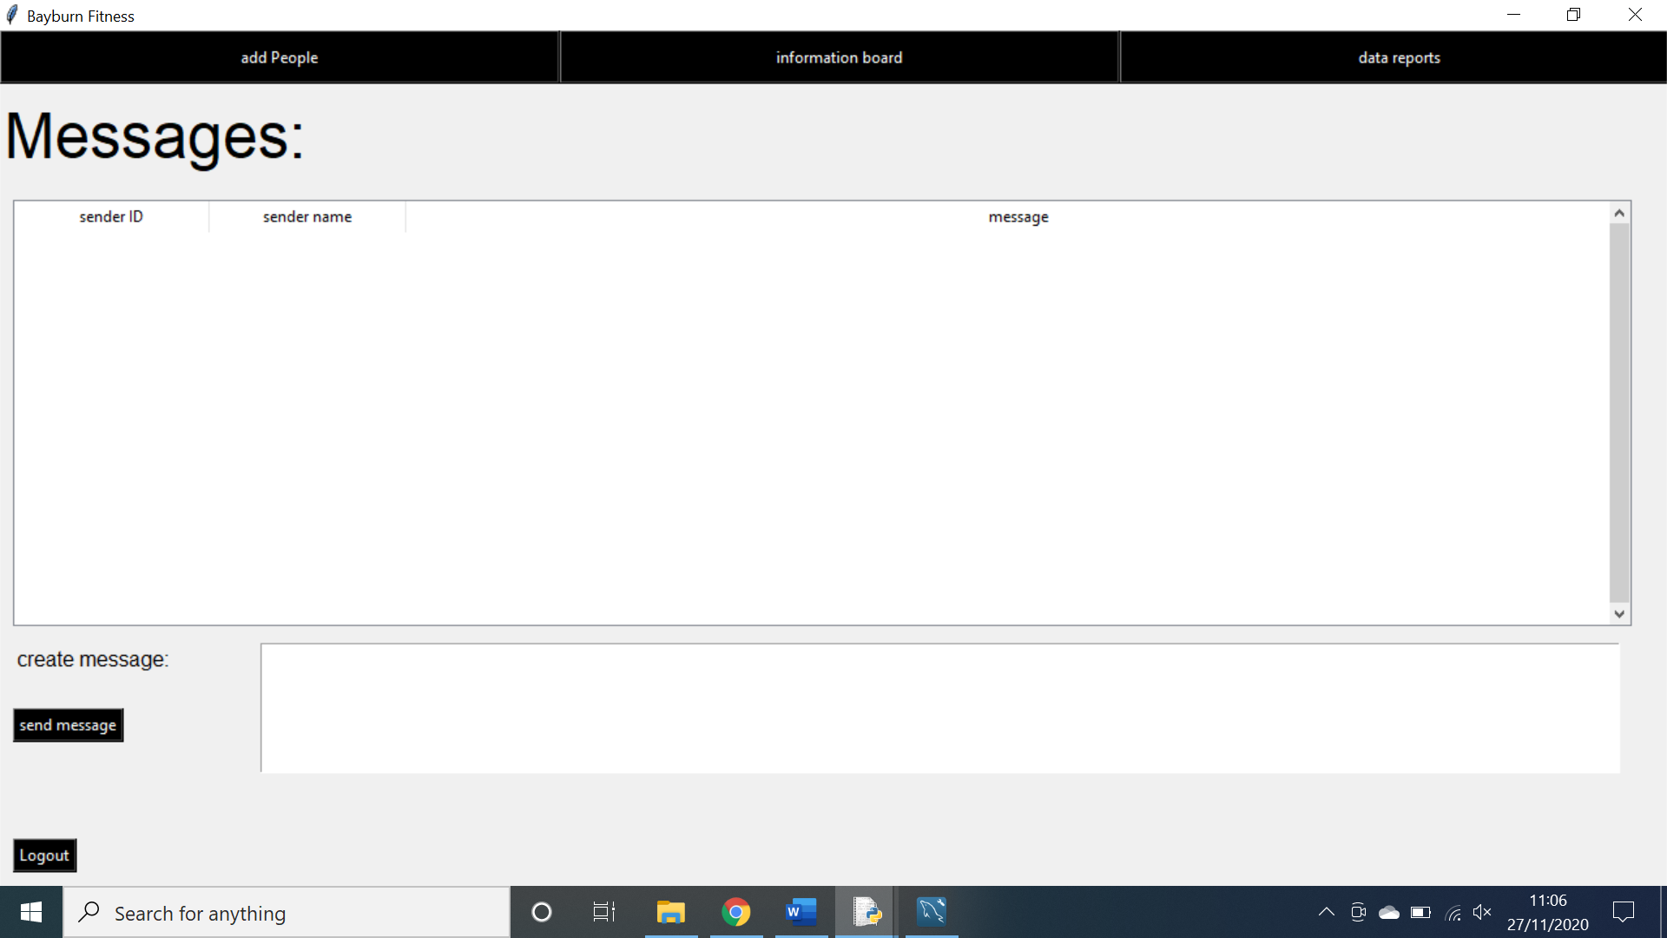

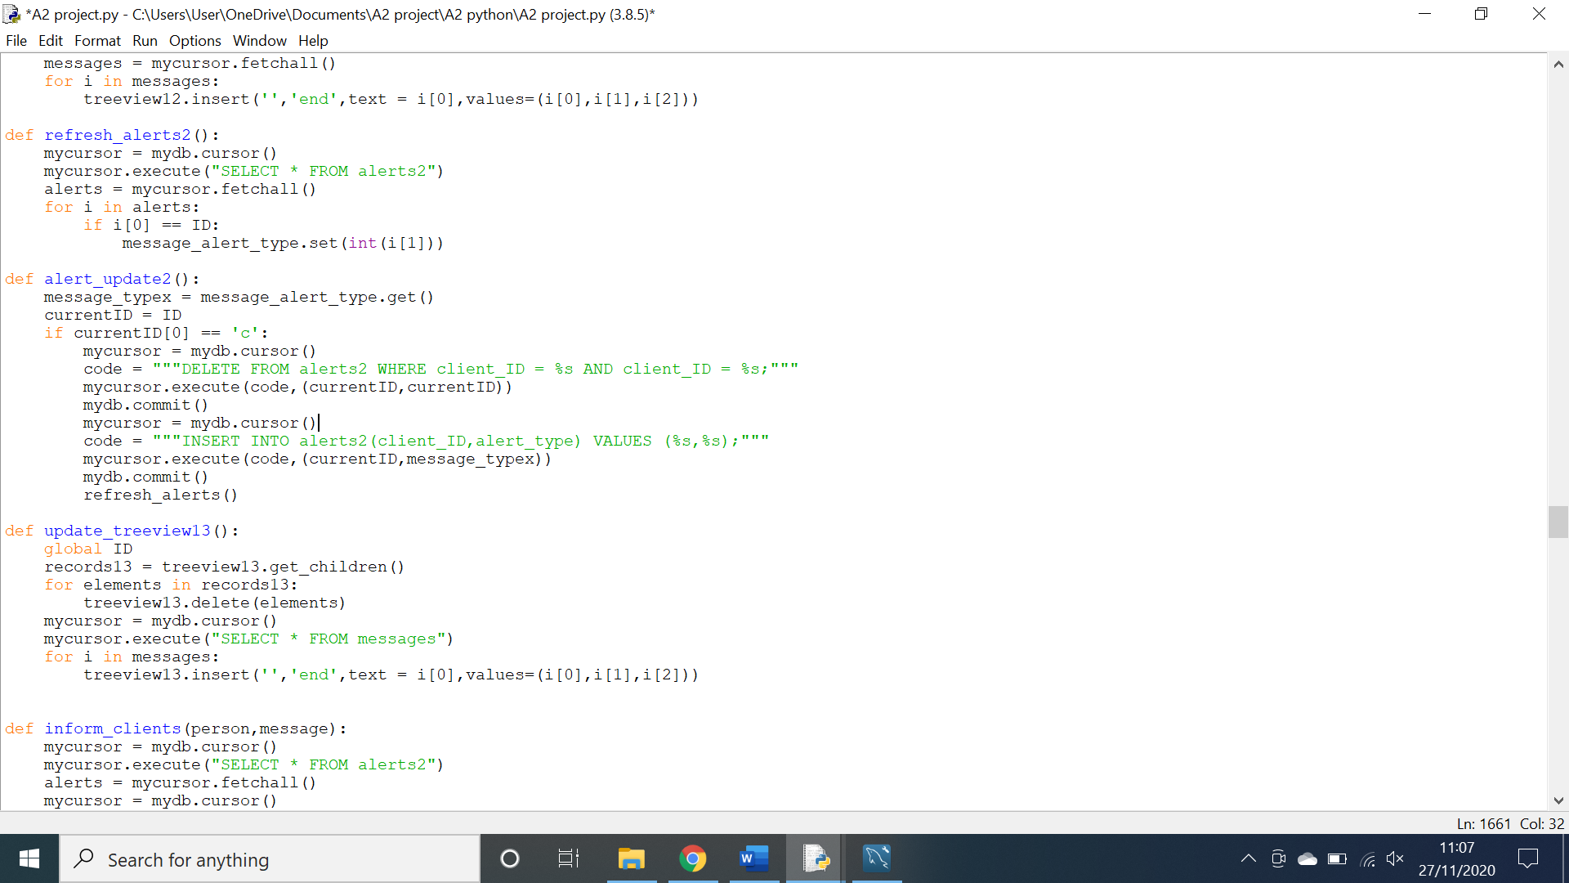As shown above, there are no messages displayed in the treeview despite there being messages in the database. This is bad as it means people cannot view or delete messages which could cause miscommunication.

The code above is responsible for populating the treeview with messages. The problem is that I have not added the retrieved data to a list. This is amended in the code below.

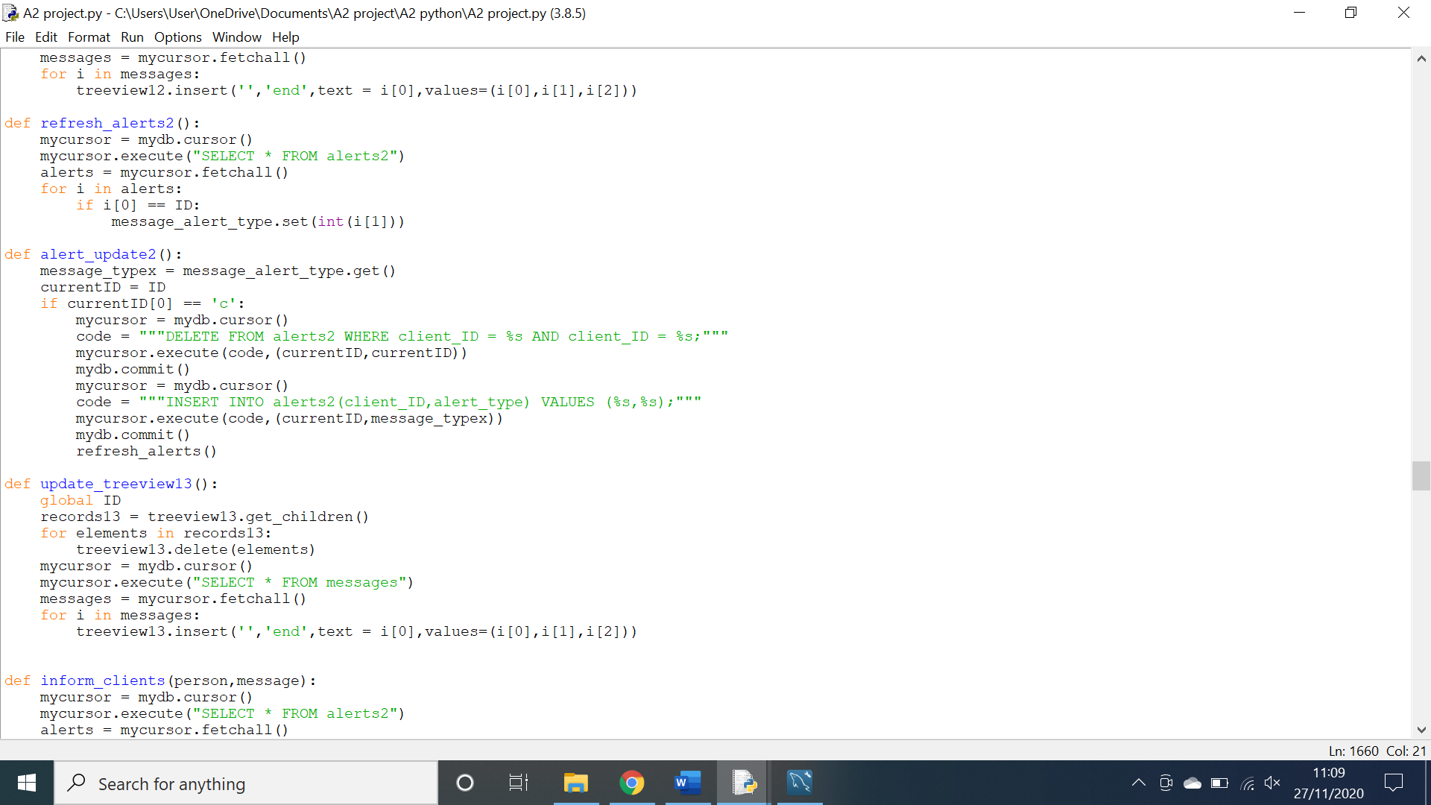

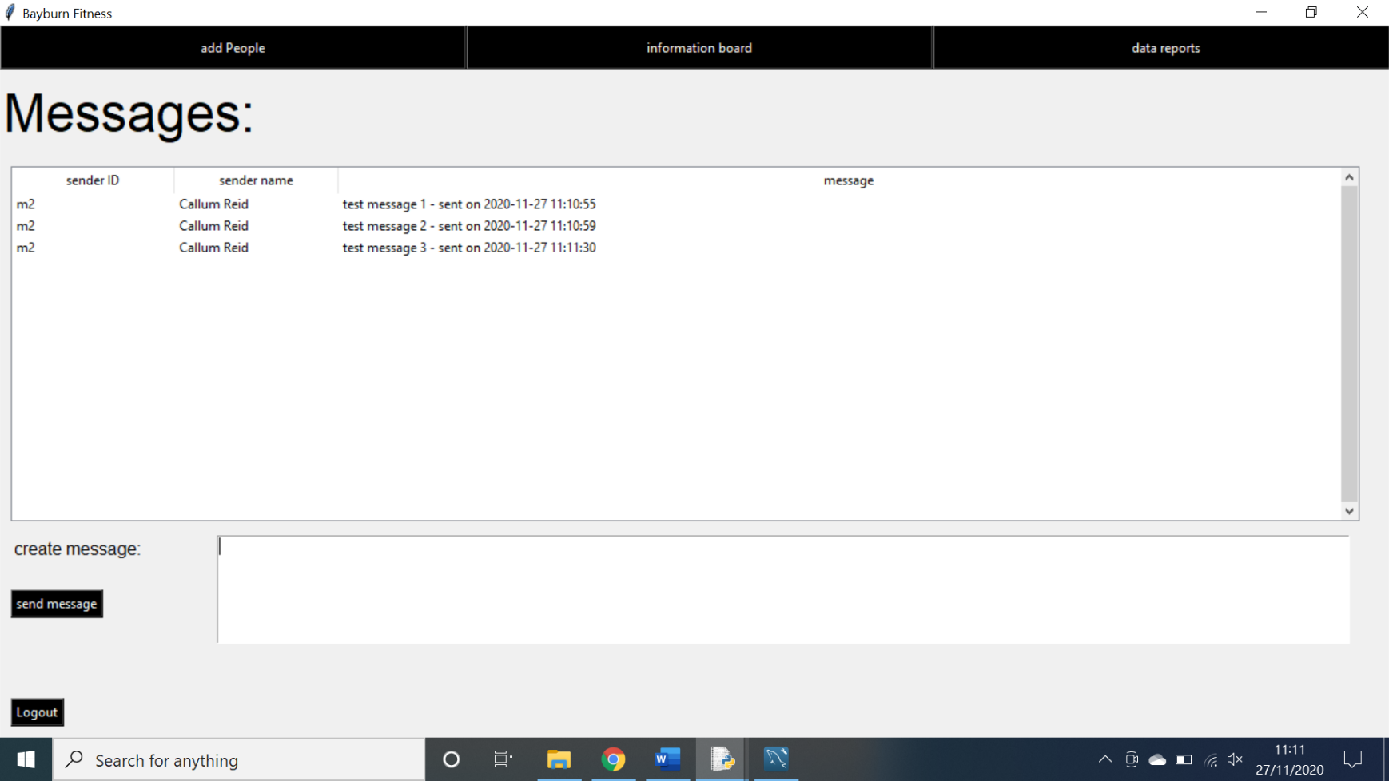The code shown above is the amended code that is fully capable of populating the treeview with messages as shown below.

**Testing the selection of an exercise in the fitness tracker.**

**Action:** An exercise was clicked on the treeview.

**Expectation:** The exercise would be selected to be manipulated in some way.

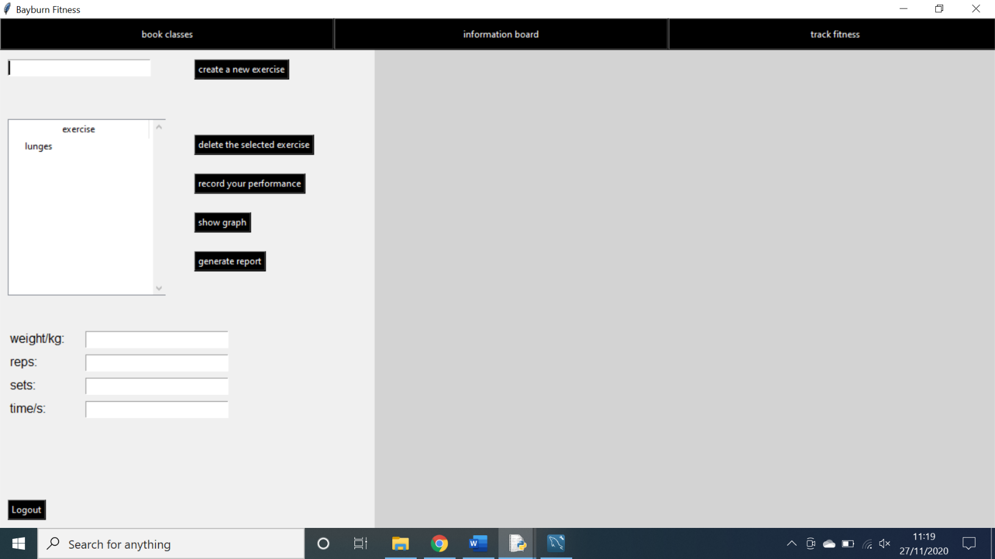**Outcome:** The exercise was not selected.

As shown above, the exercise has been clicked on the treeview however it has not been selected.

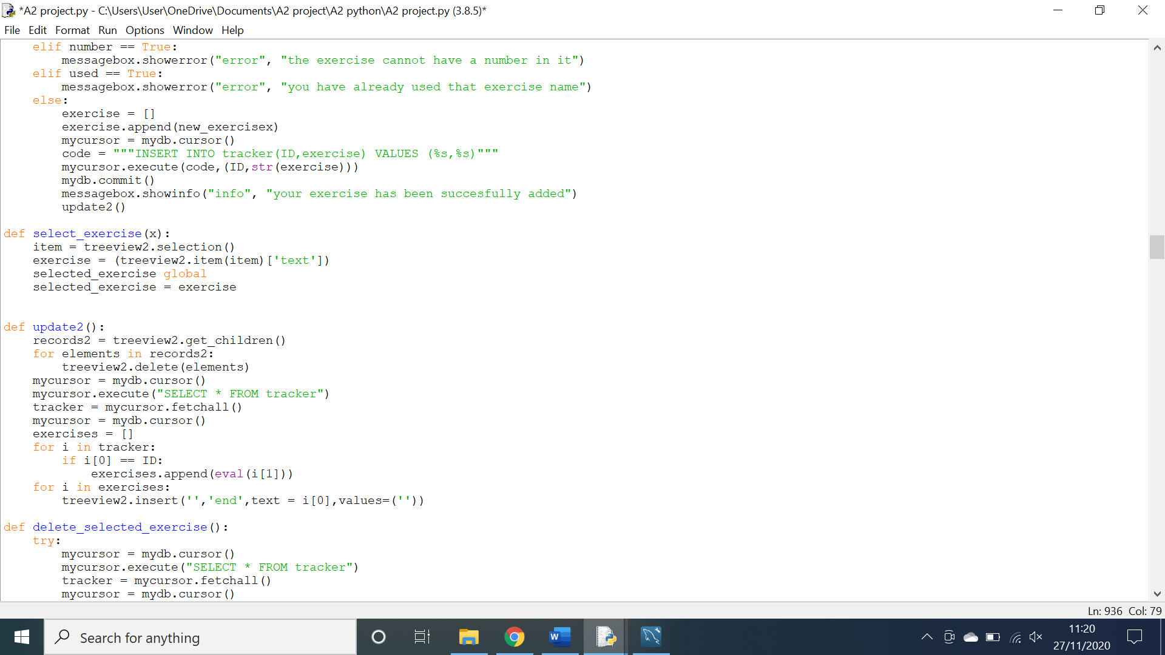

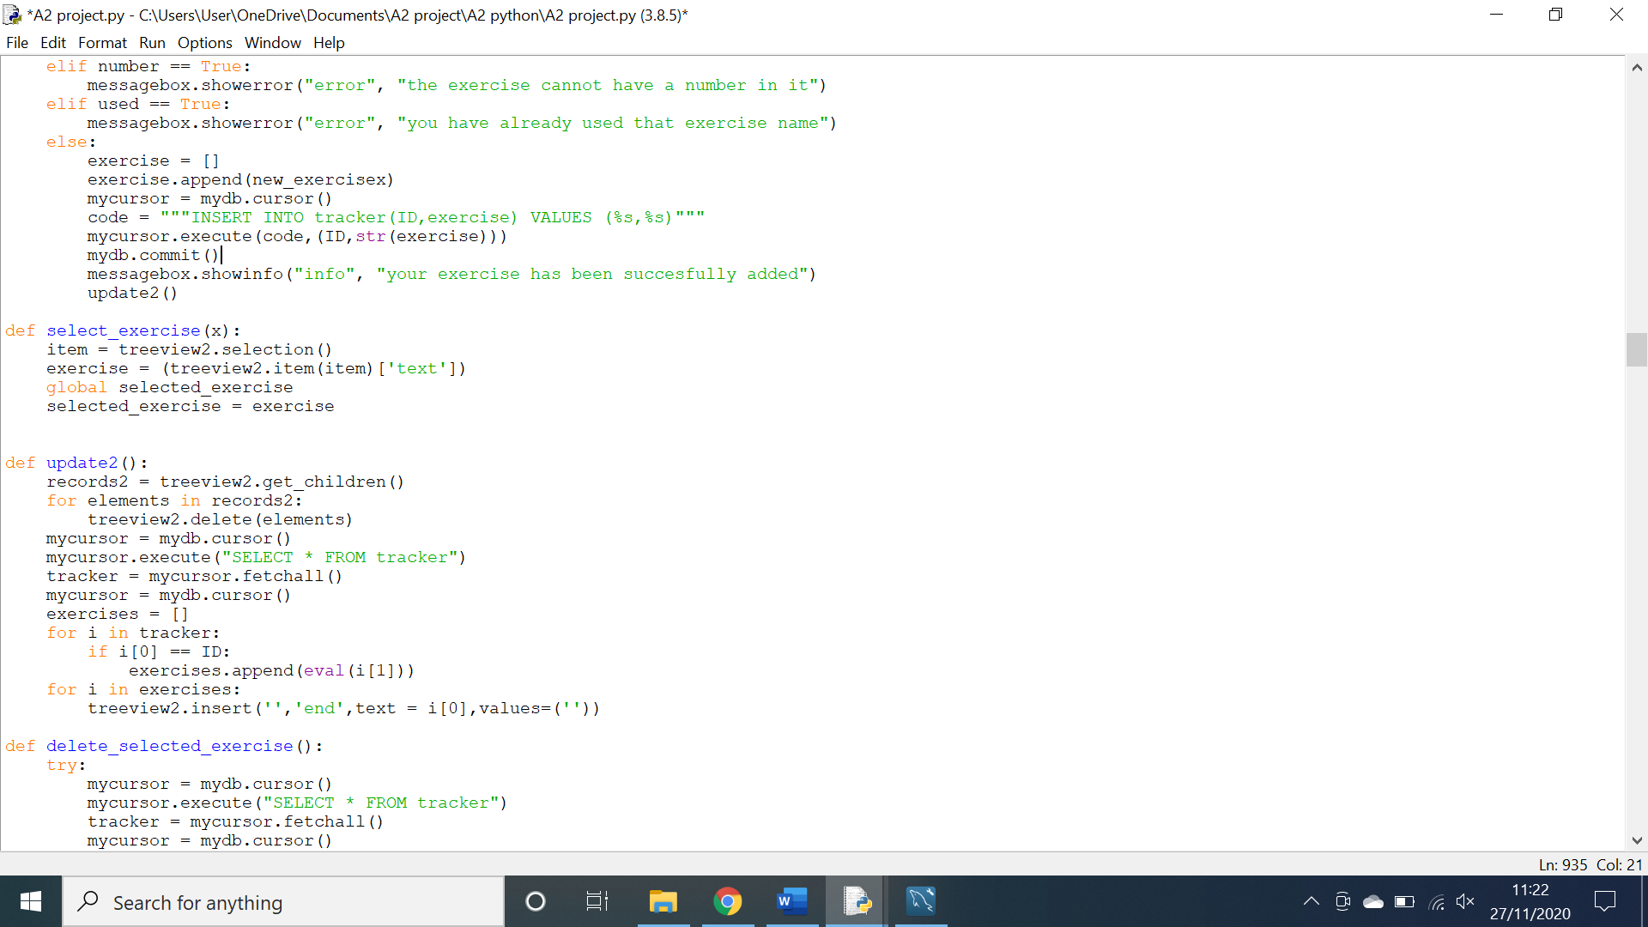Above is the code responsible for selecting an exercise, the problem Is that the global variable is defined incorrectly. This is easily remedied in the code below.

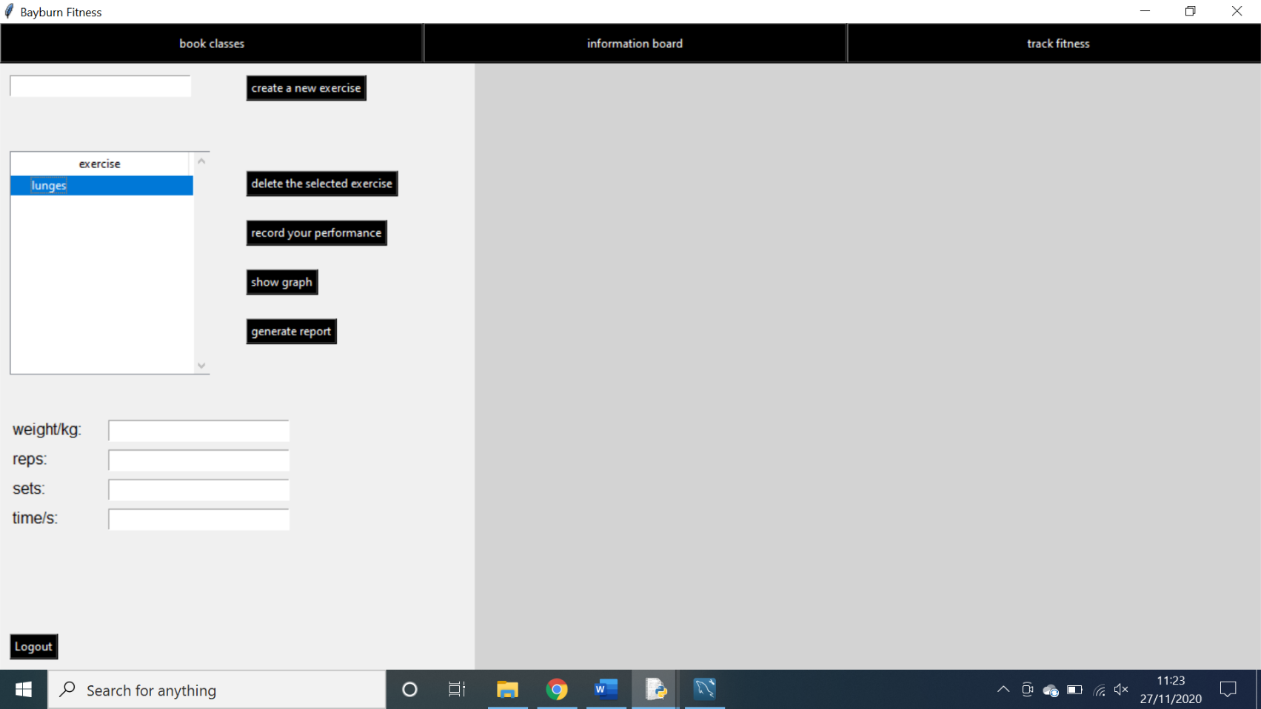This successfully selects the exercise as shown below.

**Testing the saving of a file:**

**Action:** a report was generated by the manager.

**Expectation:** the file would be generated once a file location was selected.

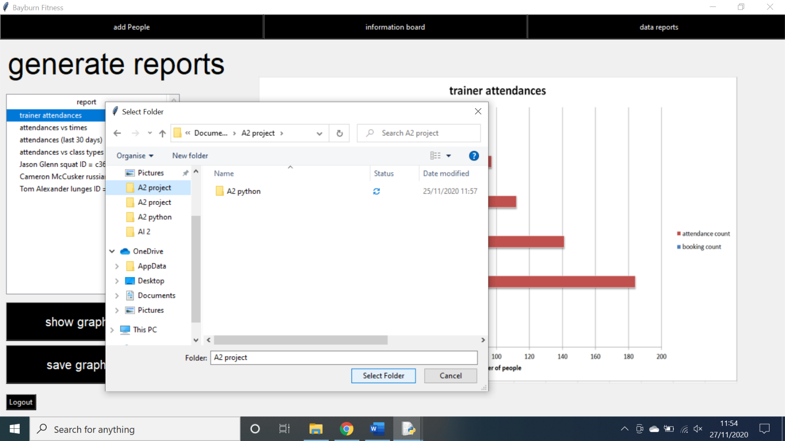**Outcome:** No file was saved.

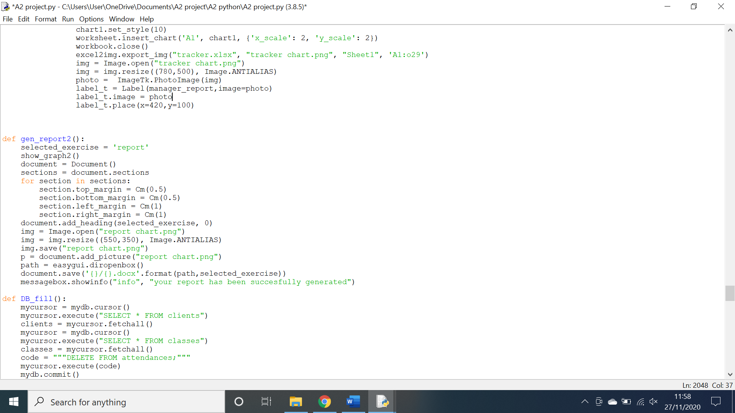As shown above, the file location was selected and the select folder button was pressed however no file was saved to that location. This is bad as it means that managers cannot save important graphs to their files.

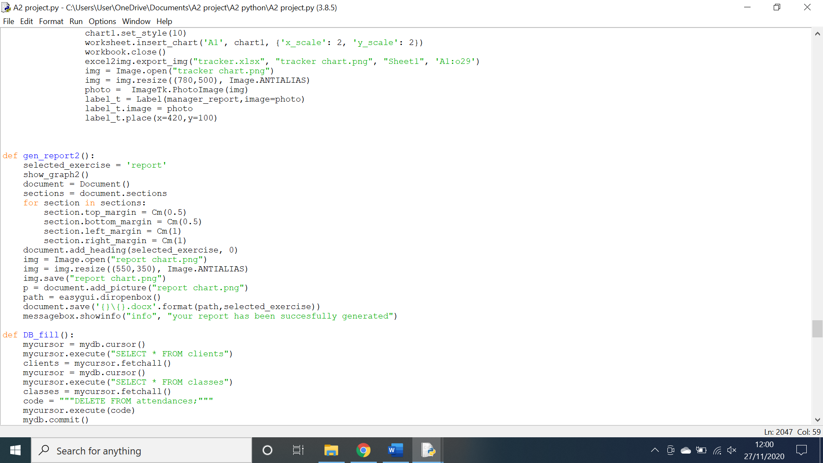The code above is responsible for generating and saving the file in the appropriate area. The problem is when saving I use a forward slash instead of a back slash to link the file path to the name. this is amended in the code below.

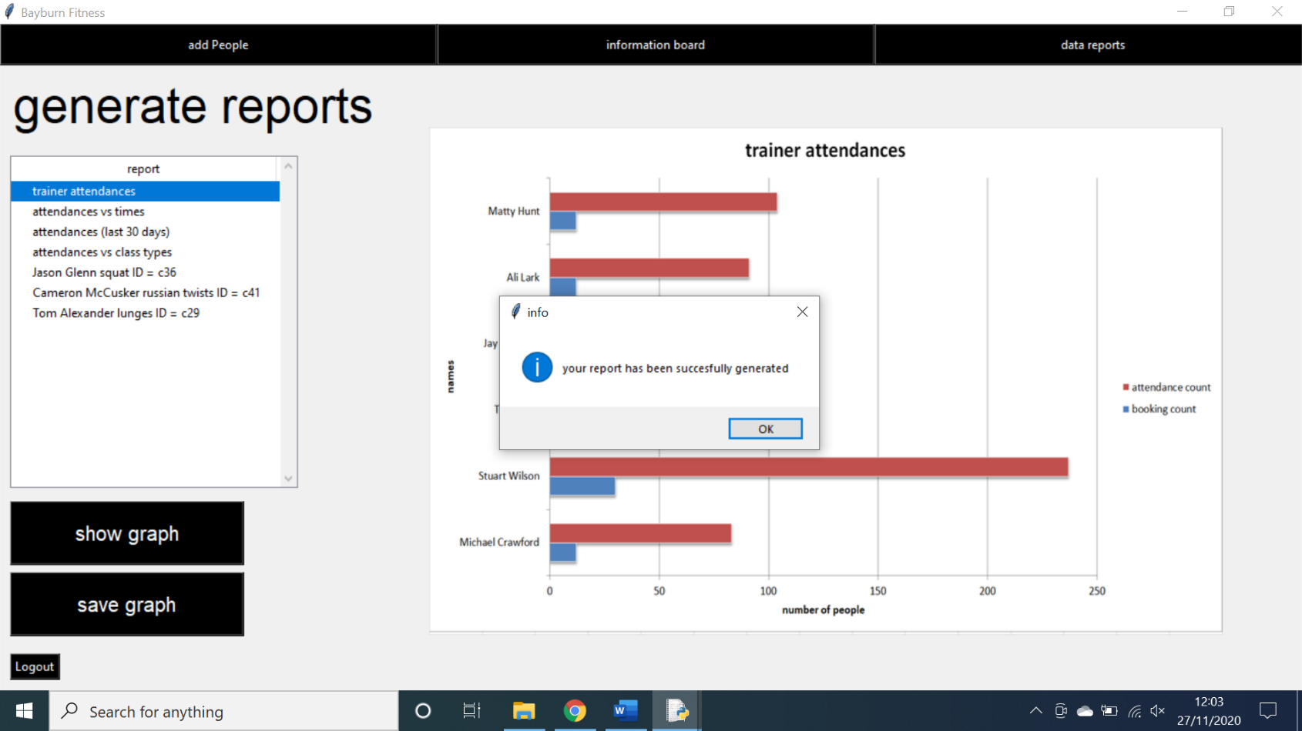The code above is fully capable of saving a file to the selected file destination as shown below.